Complete the following steps to plan, build, and test your improved RLC filter circuit for Project 1.
Submit your completed worksheet to your instructor before the start of Week 5 Studio.
- Draw the circuit diagram of your improved RLC filter in the space below, including all of your chosen values for your circuit components.

- Build your circuit in Multisim.

- Connect a multimeter over the output and set it to measure AC voltage. Test your circuit by running it at different frequencies as specified in the table below, recording your calculations for output voltage and magnitude ratio.
Input frequency  (kHz) | Output voltage  (Vrms) | Magnitude Ratio  MR = Vout/Vin
1
2
3
9
10
11

- Add a Bode Plotter to your circuit to measure the performance of your circuit over a range of frequencies. Connect the inputs and outputs to Vin and Vout, respectively, in your circuit (the negative terminals can be connected directly to ground).
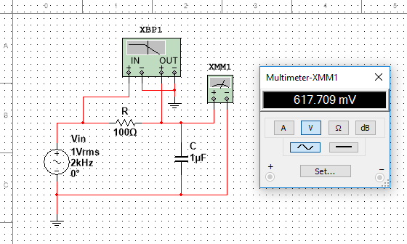
- Set the Bode Plotter to sweep between 20 Hz and 20 kHz, with a linear magnitude range from 0 to 1.5 (see the figure below).
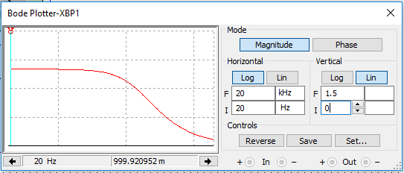
- Run the simulation and capture the results of the Bode Plotter. Attach the results to this worksheet.

