Purdue University Fort Wayne
Department of Engineering
ENGR 128 Studio
Example Technical Report

Project: Simple Circuit Design

Name: Jason Barnes
Date: February 4, 2020
Introduction
The purpose of this design was to provide a circuit to deliver 20 mA of current to a 100 Ω resistor for the customer. The resulting design features a power supply and resistor to set the appropriate current level, along with an LED to display the operational state. Simulation of a Multisim model shows that the design performs as requested. The next steps of design include developing a circuit prototype and understanding the allowable variation on the current specification.
Methods
The circuit design requirements are:
- Supply 20 mA of current into a 100 Ω resistor.
- Turn on an LED when the 100 Ω resistor is connected.
The first design requirement came directly from customer specification, while the second requirement was a feature added during design iteration to alert the user when the design is operational.
The conceptual circuit design is shown in Figure 1. The layout includes a voltage supply ($V_{S}$) and a resistor ($R_{S}$) to set the current level. When using the available LED with a forward voltage of $V_{f}$ = 1.8 V, the performance of the circuit is defined by the following equation:
$V_{S}=I_{S}R_{S}+I_{S}R_{L}+V_{f}=\left(\text{20 mA}\right)R_{S}+\text{3.8V}$ (1)
where:
$V_{S}$ is the supply voltage,
$R_{S}$ is the series resistance,
$I_{S}$ is the desired current of 20 mA,
$R_{L}$ is the customer specified load resistance of 100 Ω, and
$V_{f}$ is the forward voltage of the LED at 1.8 V
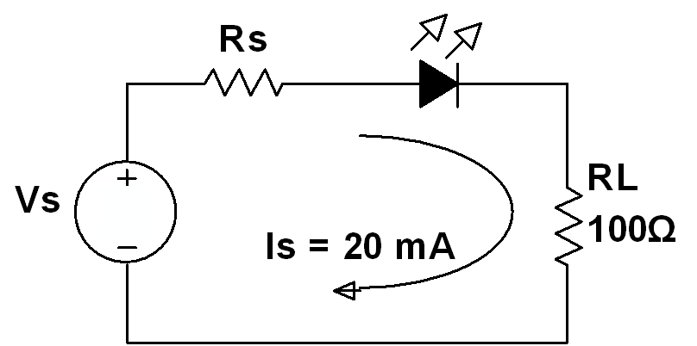
Figure 1: Simple circuit design chosen for the project
The value of the series resistor was chosen to be $R_{S}$ = 470 Ω due to part availability. The resulting value of the supply voltage is $V_{S}$ = 13.2 V.
Results
A model of the circuit was built and tested in Multisim. The completed model is shown in Figure 2.
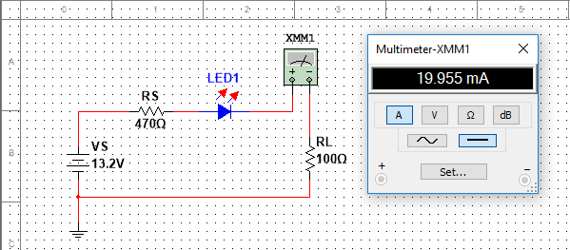
Figure 2: Multisim circuit with LED on and current measurement
Based on the circuit model, the LED functioned as expected and the current was measured at 20.0 mA, which met the two design requirements.
Conclusions
- The design meets both requirements and should now be built as a circuit prototype. The prototype will introduce more variation in part values and circuit noise.
- The first requirement for current does not include a tolerance, so the allowable variation away from 20 mA is uncertain. Before continuing, the design team should ask the customer about the allowable range of performance.

