Complete the following steps to plan, build, and test your RC filter circuit for Project 1.
Submit your completed worksheet to your instructor before the start of Week 3 Studio.

$R$ =
$C$ =
- Choose resistor and capacitor values for your circuit and
record the values. Be prepared to explain how you chose these specific values and justify your design choice.

- Build your circuit in Multisim.

For the source, use an AC power supply. Set the voltage to 1V RMS (this will make the calculations easier). You will adjust the frequency as you test the circuit. The phase can be left at 0°.

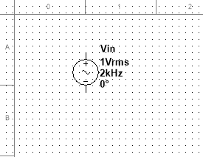
Group: Sources
Family: POWER_SOURCES
Component: AC_POWER

- Connect a multimeter to the output of your circuit (in parallel with the capacitor).
Set the meter to measure AC voltage.

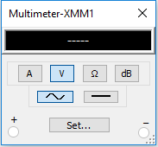

- Test your circuit by running it at different frequencies as specified in the table below, recording your calculations for output voltage and magnitude ratio.

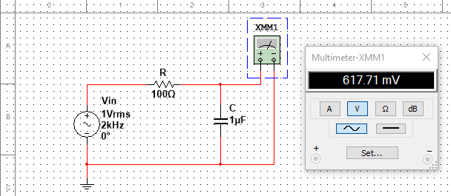
Input frequency  (kHz) | Output voltage  (Vrms) | Magnitude Ratio  MR = Vout/Vin
1
2
3
9
10
11

- Write a memo to the instructor describing your design and results, addressing the following topics:

  - Explain your method for choosing the resistor and capacitor for your design, including equations as necessary.

  - Summarize your circuit build and test results. Include a figure of your Multisim model and a table of your measurements and magnitude ratio calculations.

  - Assess whether or not your circuit met the requirements. If the circuit did not meet the requirements, determine what should change: the building and testing method, the resistor and capacitor values, or the circuit design entirely.
Attach the completed memo to this worksheet before submission.

