Follow along with the example design in Studio by completing this worksheet.  
Submit your completed worksheet to your instructor before the start of Week 2 Studio.

1. Determine values for $V_{S}$ and $R_{S}$ for the circuit below so that $I$ = 20 mA.  
   Label the figure with your values and include your calculations below.



$$I$$

$R_{S}$**=**

$R_{L}$**=**

$V_{S}$**=**

Next you will create your circuit and analyze it in Multisim, a circuit analysis program. Because of the limited number of computers, work with your neighbors to share the machine and help each other.

1. Launch the program *NI Multisim 14.0* from the Windows Start Menu.
2. Start building your circuit by using *Place > Component…* from the program menu. The components you need are shown in the diagram below.

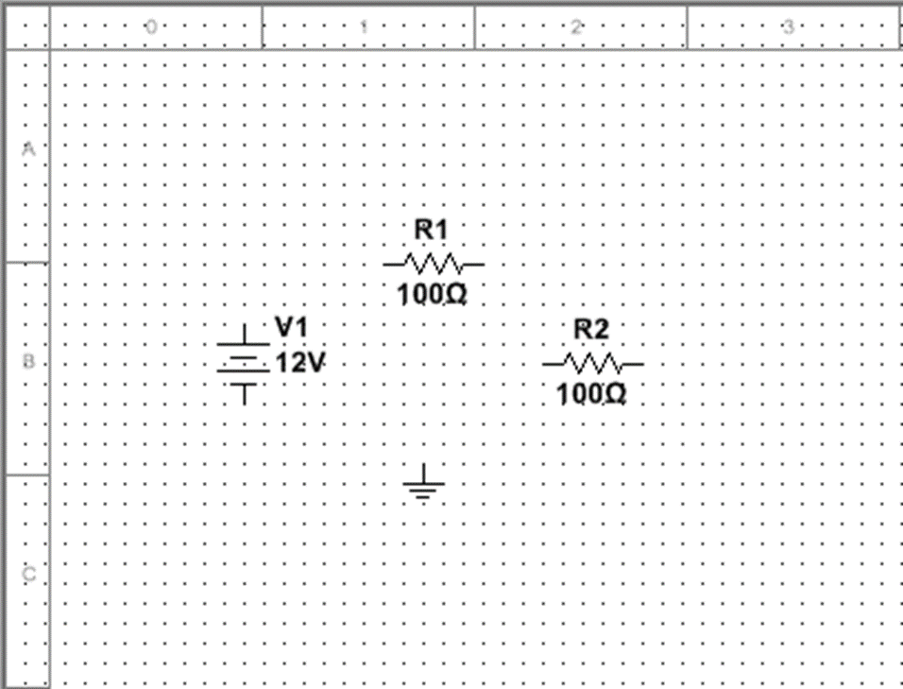

Group: Basic  
Family: RESISTOR  
Component: 100

Group: Sources  
Family: POWER_SOURCES  
Component: DC_POWER

Group: Sources  
Family: POWER_SOURCES  
Component: GND

1. Double click the DC_POWER supply to change the voltage. On the *Value* tab, change the voltage to match your choice of $V_{S}$. You can also change the label to “Vs” on the *Label* tab. Click *OK*.
2. Double click one of the resistors to change the resistance. On the *Value* tab, change the resistance to match your choice of $R_{S}$. You can also change the label to “Rs” on the *Label* tab. Click *OK*.
3. Right click on the other resistor and select *Rotate 90° clockwise* to prepare the shape for wiring.
4. 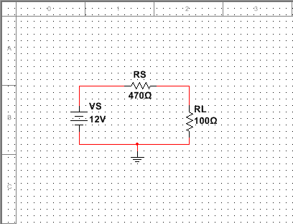Wire the parts together to match the layout of the schematic below. Left click on the unconnected wires of the components to start a wire. Connecting the ground will be important for simulation.
5. Add a multimeter to measure current. Delete one of the wires since the current must flow through the meter for proper measurement and rewire the circuit with the meter inline.

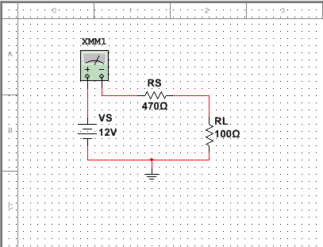

The multimeter is available by clicking the top icon on the right-side toolbar.



1. Setup the multimeter to measure constant current. Double click the meter and select *A* for amperes (current measurement) and the straight line for constant (DC) current.
2. 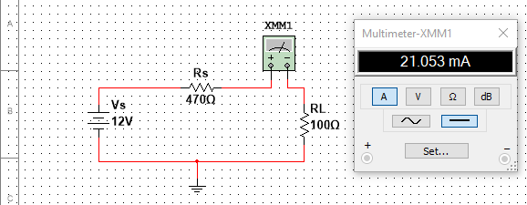Press F5 (or click the green triangle) to *Run* the simulation with default settings. Capture your circuit and multimeter measurement with a screenshot and attach it to this worksheet.