III. Assignment
Boolean Logic – Bboard Challenge
- Challenge: Using only logical operators, set up the logic on the Bboard interface so that:
1) Bottom light: on if any number of the buttons are on (i.e., = 1)
2) Top light: on if and only if all three buttons are on
3) Middle light: on if any two buttons or more are on.
Turn in: A screen capture of the Bboard with this setup

- Truth Table: Write a commented script to create a truth table for these cases in the Bboard Challenge. The truth table and Bboard should match.
Turn in: The script & the execution result.

Conditional Programs
- Make even Program (based on Figure 2)
Write a function that will carry out the logic in the Figure 2 flowchart for integer input.
Turn in: a. The flow chart for this program created I Visio using techniques from the Flowcharts Basic Tutorial available on the website. b. Complete commented code (step #5) and validation (step #6). Use provided test cases for the validation.

- QC Program: Develop and Validate the QC prototype function outlined in section IV.3 above.
Turn in: A complete Function Development worksheet for the setup, coding, and validation

Solutions

- Boolean Board Challenge 1: Setup the logic in the boxes so:
1) Bottom light: on if any number of the buttons are on (i.e., = 1)
2) Top light: on if and only if all three buttons are on
3) Middle light: on if any two buttons or more are on.
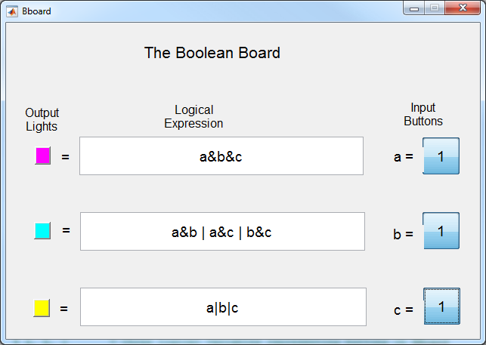
Note: any logic which will meets the challenge requirements is acceptable.

- Write a script to create a truth table for the middle case in Bboard Challenge 1.
This solution does all three lights only the middle light is required.
Script
%% Program Bchallenge1.m
% This script prepares a truth table for Boolean Challenge 1
%
% Scott Moor March 2016

% Variables
% a, b, c = three logical variables representing buttons on BBoard
% L1, L2, L3 = conditional logic for Lights 1,2 and 3 respectively
% Ttable = the resulting truth table

%% Set up input variables, Buttons 1, 2 and 3
a = [1 1 1 1 0 0 0 0]';
b = [1 1 0 0 1 1 0 0]';
c = [1 0 1 0 1 0 1 0]';

% Logic Calculations for Lights 1, 2 and 3
L1 = a & b & c;
L2 = (a&b) | (b&c) | (a&c);
L3 = a | b | c;

%% Calculate and display Truth Table
disp('Truth Table for Boolean Challenge 2')
disp('Variable order: Buttons 1, 2 and 3, Lights 1, 2 and 3')
Ttable = [a b c L1 L2 L3]

Execution
>> Bchallenge1
Truth Table for Boolean Challenge 2
Variable order: Buttons 1, 2 and 3, Lights 1, 2 and 3
Ttable =
1 1 1 1 1 1
1 1 0 0 1 1
1 0 1 0 1 1
1 0 0 0 0 1
0 1 1 0 1 1
0 1 0 0 0 1
0 0 1 0 0 1
0 0 0 0 0 0

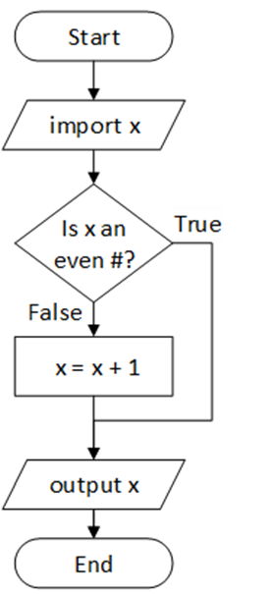
- Make even Program (based on Figure 2) Write a function that will carry out the logic in the Figure 2 flowchart for integer input.
Turn in: a) The flow chart for this program created I Visio using techniques from the Flowcharts Basic Tutorial available on the website.

b) Complete commented code (step #5) and validation (step #6). Use provided test cases for the validation.

Function Code:
function x = MakeEven(x)
% This function forces an integer input to be even by increasing any odd
% number by one.
% S. Scott Moor March 2015
%
% function x = MakeEven(x)
% input: x = any integer
% output: x = an even integer (same as input or one higher)

% Conditional tests if the input is even and adds one if it is not
if rem(x,2) ~= 0
x = x + 1;
end

Input | Expected Output
2 | 2
3 | 4
-4 | -4
-3 | -2
Validation:
>> MakeEven(2)
ans =
2
>> MakeEven(3)
ans =
4
>> MakeEven(-4)
ans =
Matches expected results (shown above)
-4
>> MakeEven(-3)
ans =
-2
- QC Program: Develop and Validate the QC prototype function outlined in section II.3 above.
Turn in: A complete a Function Development worksheet for the setup, coding and validation

Problem ID ___QC Function Programmer ___S. Scott Moor __ ____

Set Up/ Planning Type of Program: Script Function
- Problem Statement:
Create a simple program to detect if a part is within the QC specification for diameter (9.95 to 10.05 mm). Program is to return a 1 if the part is between the specified limits and a 0 if it is outside those limits.

- Inputs: (full name, variable to be used, units)
Variable Name | Description | Units or Values | Input Source*
d | Diameter of the part | mm | Command line

- Output: (full name, variable to be used, units)
Variable Name | Description | Units or Values | Output type*
Qflag | Quality flag (1 for in spec.) | 1 or 0 | Command line

- Solution Steps (order of these two parts may be varied):
- Perform calculation on test case(s) (2) Identify the steps/equations to be used in code
(select a test case if one is not given, avoid answers of 0 or 1)

- Test Cases: (2) Steps:
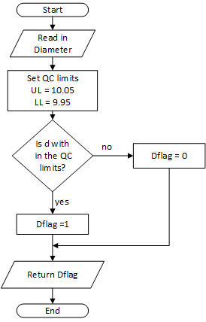
Diameter (mm) Result (1 = in spec)
9.96 1
9.94 0
10.5 1
10.7 0
5. Code (I usually cut, paste and edit for this page)
Note: Program steps will most likely be presented as a list instead of a flow chart. This is fine (we have barely introduced flow charts at this point). However, the flow chart is ideal and some description of steps is expected.

% This function will test if a part diameter is with in the needed
% specification limits. Limits can be adjusted in the program
% Scott Moor March 2016
%
% function Dflag = QCdiameter(d)
% Input Variable: d = the diameter of the part (mm)
% Output Variable: Dflag = an output flag: 1 = in spec, 0 = out of spec.

% Internal variables
% UL = Upper Limit on the quality specification (mm)
% LL = Lower Limit on the quality specification (mm)

function Dflag = QCdiameter(d)
% Set Quality Limits
UL = 10.05;
LL = 9.95;

% Determine if value is with in the limits and return appropriate flag.
if d>=LL && d<= UL
Dflag = 1;
else
Dflag = 0;
end

6. Validation:
Prove that the function is working correctly. Generally the function should be run on the test case from step 4 and on a wider range of cases.

>> QCdiameter(9.96)
These cases match earlier test calculations and cover values that are high, low and in spec
ans =
1
>> QCdiameter(9.94)
ans =
0
>> QCdiameter(10.05)
ans =
1
>> QCdiameter(10.07)
ans =
0

