CE 45000: Transport Policy and Planning
Due Tuesday, October 22, 2019

Problem 1: Can you go node 1 to node 12 in 10 hours? Prove. Use Minimum Path Algorithm. (30 points)
4
150
165
145
275
155
340
95
260
85
130
110
45
130
285
200
330
65
130
12
11
10
9
8
7
6
5
2
3
1

Problem 2: Determine the minimum path for node 1 in the following figure. Sketch the final tree. Also, determine the number of trips on each link using the minimum path trips shown in table below. (50 points)
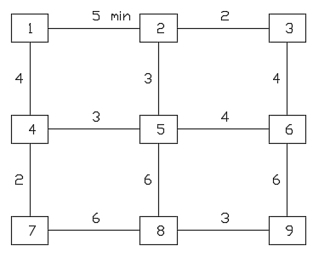
From | To | Trips
1 | 2 | 50
 | 3 | 75
 | 4 | 80
 | 5 | 100
 | 6 | 125
 | 7 | 60
 | 8 | 30
 | 9 | 90

Problem 3: Answer following questions and provide supporting documents or source: (20 points)
- Provide the study area limits for a shopping center of 150,000 sq. ft. and a fast-food restaurant?
- What is the guideline in terms of trips whether you need to conduct a traffic impact study or not?
- What is approximate horizon years for a development greater than 1,000 peak-hour trips?
- How do you identify that there is an impact at an intersection due to a new development?

