In-class Activity 1: Identify the segment with most crashes using sliding window method:

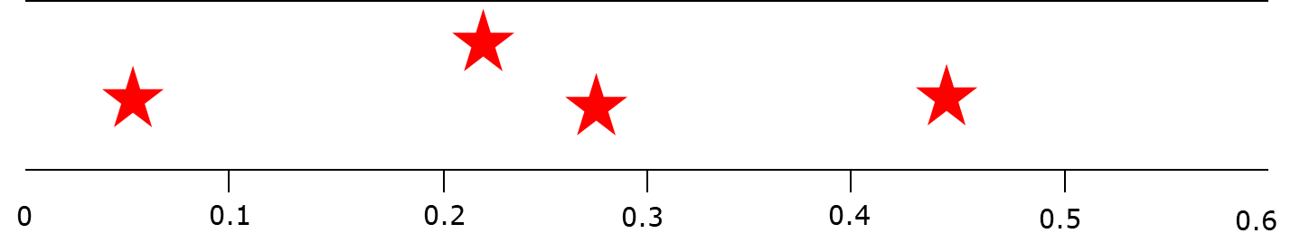
Figure 1: Location of 4 crashes on a 0.6 mile long roadway segment

In-class Activity 2: Calculate crash rate at intersection 2 using the information provided in table below:

Intersections | Traffic Control | Number of Approaches | Major AADT | Minor AADT | Year 1 Crash | Year 2 Crash | Year 3 Crash
1 | Signal | 4 | 30100 | 4800 | 9 | 8 | 5
2 | TWSC | 4 | 12000 | 1200 | 9 | 11 | 15
3 | TWSC | 4 | 18000 | 800 | 9 | 8 | 6
4 | Signal | 4 | 11200 | 10900 | 8 | 2 | 3
5 | Signal | 4 | 30700 | 18400 | 3 | 7 | 5

$$Intersection Crash Rate=\frac{N_{observed}}{MEV}$$

$$MEV=\frac{TEV*n*365}{1,000,000}$$

In-class Activity 3: Calculate EPDO at intersection 2 using the crash cost below:

Table: Societal Crash Cost Assumptions
Severity | Comprehensive crash cost (2001 Dollars)
Fatal (K) | $4,008,900
Injury crashes (A/B/C) | $82,600
PDO (O) | $7,400

