Problem 1: Consider a traffic analysis zone (TAZ) that is located in a suburban area of a city. The population and income data for the zone are as follows:
Number of dwelling units: 60 (20% have 1 car, rest have 2+)
Average income per dwelling unit: $44,000
$Trips per HH=0.5+0.35*\frac{HHIncome}{1000}$ for 1 car
$Trips per HH=0.9+0.8*\frac{HHIncome}{1000}$ for 2+ cars
Determine the number of trips per day generated in this zone.

Problem 2: A multiple regression analysis shows the following relationship for the number of trips per household:
$T=0.82+1.3P+2.1A$;
Where $P and A$ are the persons per household and autos per household respectively?
If a particular TAZ contains 250 households with an average of 4 persons and 2 autos for each household, determine the average number of trips per day in that zone.

Problem 3: Consider a roadway segment highlighted in red box in the following figure. Traffic counts (AADT) can be seen as 41,500 in 2018. Estimate AADT of the segment in 2040 considering traffic growth 2%.
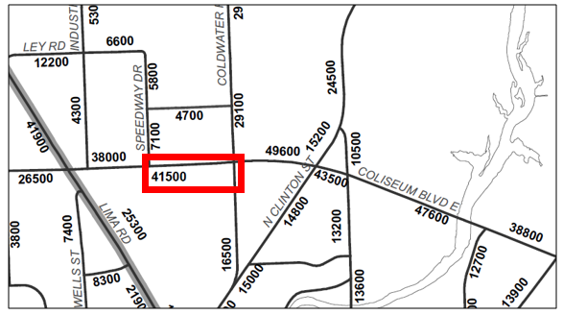

Problem 4: In TAZ 235, you have following socioeconomic data;
Households (HH): 23,000
Average Annual Income per HH: $30,000
Average cars per HH: 1.4
Size (Average number of people per HH): 2.1
Average number of workers per HH: 1.4
Total Office Space: 2,000,000 ft^2
Total Retail Space: 5,000,000 ft^2
Estimate zone productions?

$$TripProductions= 0.3 + 0.82*Workers+0.0024*size+0.041Cars+0.0000047*Income$$

Problem 5:
Number of trips per household size by auto ownership obtained from regional study can be seen below:
 |  | Auto ownership
 |  | 0 |  | 1 |  | 2+
 |  | HH | Trips | HH | Trips | HH | Trips
Household size | 1 | 1200 | 2520 | 2560 | 6144 | 54 | 130
 | 2 | 874 | 2098 | 3456 | 9676 | 5921 | 20165
 | 3+ | 421 | 1137 | 2589 | 8026 | 8642 | 33704

Forecasted number of households in the same study zone by auto ownership and size can also be seen below.
 |  | Auto ownership
 |  | 0 | 1 | 2+
Household size | 1 | 25 | 125 | 3
 | 2 | 32 | 175 | 254
 | 3+ | 10 | 89 | 512

Estimate total trip generated from that zone?

Problem 6: Balance trip production and attractions for the following scenario.
 | Unbalanced NHB Trips
 | NHB Productions | NHB Attractions
1 | 100 | 240
2 | 200 | 400
3 | 300 | 160
Total | 600 | 800

Problem 7: Travel characteristics between two zones can be seen in following table.
Variable | Auto | Transit
$$A_{k}$$ | -0.46 | -0.07
$$t_{1}$$ | 20 | 30
$$t_{2}$$ | 8 | 6
C | 320 | 100

$$U = a_{k}– 0.35{*t}_{1} – 0.08*t_{2} – 0.005c$$
Trip distribution: total of 12,450 trips going from A to B

