In-class Activity
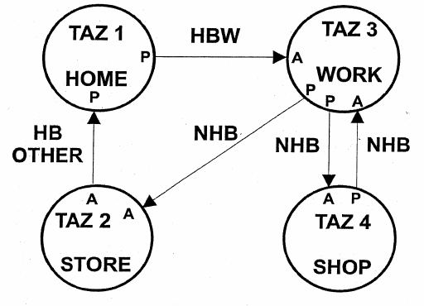

 | HBO |  | HBW |  | NHB
 | P | A | P | A | P | A
1 |  | 1 | 1
2 | 1 |  |  |  |  | 1
3 |  |  |  | 1 | 2 | 1
4 |  |  |  |  | 1 | 1
Total | 1 | 1 | 1 | 1 | 3 | 3

