CE 450 Transport Policy and Planning
Final Exam
Open Book: 100 points

Student Name: __________________

Instructions: Read questions carefully. Be sure to show clearly organize all your work. To receive full points, show all work, box solutions.

- List 3 key questions that you would like to answer from a traffic impact analysis? (6 points)

- What are the thresholds that might trigger to conduct a traffic impact study? (4 points)

- List two performance measures that you use to evaluate traffic impact. (5 points)

- List 5 performance measures to identify high risk locations related to traffic crashes. (5 points)

- In a transportation safety improvement project, three safety countermeasures can be implemented as shown in the table below. The crash modification factors (CMF) are given for each of them. Using the information below, which combination of safety countermeasures will provide you maximum crash reduction with minimum cost? (10 points)

Selected Safety Countermeasure | CMF | Implementation Cost
1. Portable rumble strips (PRS) | 0.89 | $ 5,000
2. Speed Feedback Display | 0.863 | $ 5,600
3. Automated Speed-Camera Enforcement | 0.83 | $ 10,000

- According to FHWA, the comprehensive crash costs for different crash severity are provided in the table below. Let’s say, in the city of Fort Wayne, 75% crashes are PDO, 23% Injury and remaining fatal. On an average day, in the city of Fort Wayne, there are total 10 crashes. Estimate the overall crash costs. (10 points)
Crash Severity Level | Average Crash Cost
Fatal | $ 4,509,991
Injury | $ 220,000
Property damage only (PDO) | $ 8,325.00

- Calculate existing pavement serviceability index (PSI) of a roadway segment starts point A and ends B? What would be the next year PSI? The PCI of this segment is 75. A typical pavement deterioration data is given in the table below. (15 points)
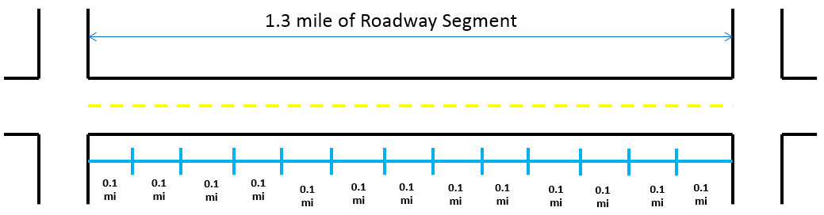
A
B
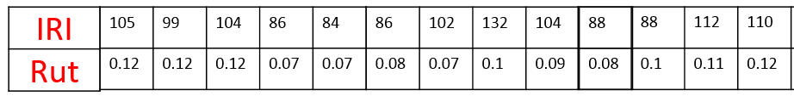

Year | PSI
1 | 4.5
2 | 4
3 | 3.5
4 | 3.25
5 | 2.5
6 | 2
7 | 1.25
8 | 1
$$PSI=5.35e^{-0.0058*IRI} -4RUT^{2}-3\left(1-\left(\frac{PCI}{100}\right)\right)$$

4. A transit agency is evaluating alternatives for a light rail line construction. Three alternatives are evaluated for five different criteria (see following table). Evaluate the alternatives using ranking method, select which one is the best. (15 points)
No | Criterion (MOE) | Ranking | Alt 1 | Alt 2 | Alt 3
1 | Daily ridership (1000s) | 1 | 25 | 23 | 20
2 | Annual return on investment (%) | 2 | 13 | 14 | 11
3 | Length of line (mi) | 4 | 8 | 7 | 6
4 | Passengers seated in peak hour (%) | 3 | 25 | 35 | 40
5 | Auto drivers diverted (1000s) | 5 | 3.5 | 3 | 2

5. Let’s say, you are working for NIRCC in Fort Wayne as a Transportation Planner. Your responsibility is to measure the congestion of each roadway segment in city boundary. As an example, the average AM and PM traffic volume is given on Interstate 469 from Maplecrest to Interstate 69 in the table below. Determine whether this roadway segment is congested or not. (10 points)
Street | from street | to street | AM Peak Vol (2 lanes) | PM Peak Vol  (2 lanes) | Length
Inter 469 | Maplecrest | Inter 69 | 3500 | 3700 | 2.26

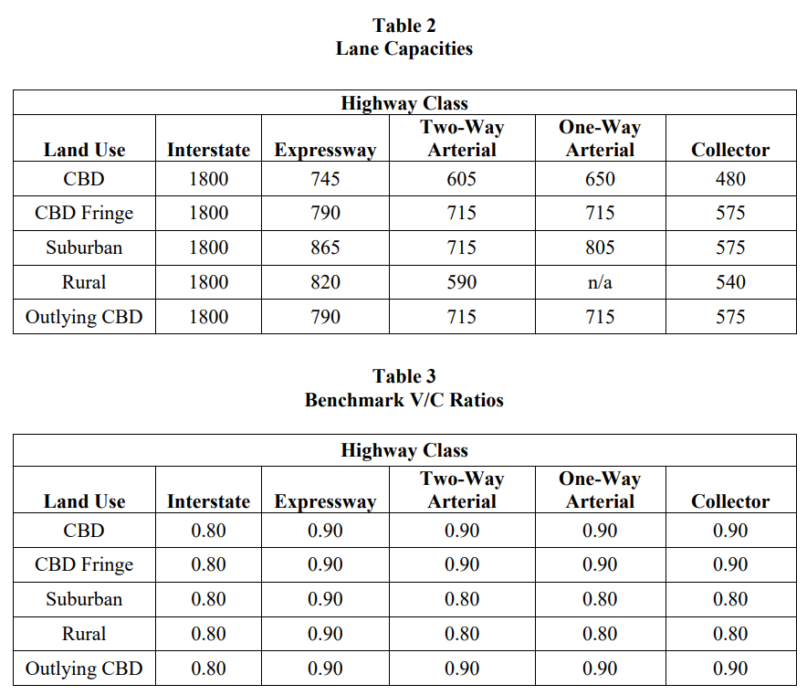

- List the sources of transportation revenues and highway expenditures by type. (10 points)

- What are the common environments issues with transportation improvement project? How do you mitigate issues related to water resource? (10 points)

