Problem 1. Calculate existing pavement serviceability index (PSI) of a roadway segment starts point A and ends B? What would be the next year PSI? The PCI of this segment is 75. A typical pavement deterioration data is given in the table below.
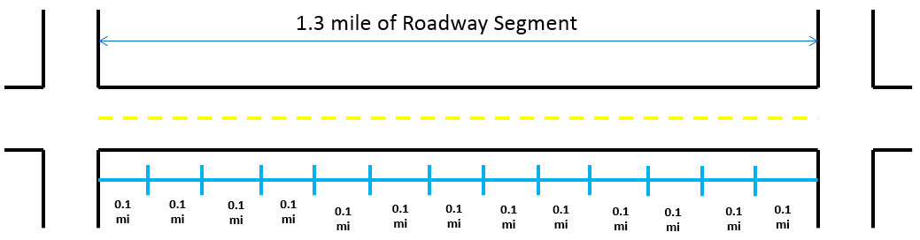
A
B
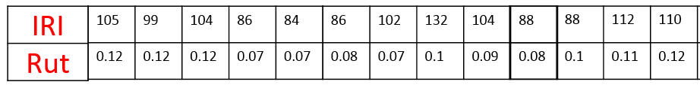

Year | PSI
1 | 4.5
2 | 4
3 | 3.5
4 | 3.25
5 | 2.5
6 | 2
7 | 1.25
8 | 1
$$PSI=5.35e^{-0.0058*IRI} -4RUT^{2}-3\left(1-\left(\frac{PCI}{100}\right)\right)$$

Problem 2. Develop a pavement deterioration model applying Markovian probabilistic technique using the data below.

Road No | PSI
 | Year1 | Year1+1
1 | 4.5 | 4.18
2 | 3.7 | 3.60
3 | 3.5 | 3.22
4 | 2.5 | 2.08
5 | 3.5 | 3.22
6 | 3.5 | 3.22
7 | 2.5 | 2.08
8 | 1.5 | 1.35
9 | 2.5 | 2.08
10 | 3.8 | 3.70
11 | 1.5 | 1.35
12 | 4.5 | 4.18
13 | 1.5 | 1.35
14 | 2.5 | 2.08
15 | 1.5 | 1.35
16 | 3.5 | 3.22
17 | 3.5 | 3.22
18 | 4.5 | 4.18
19 | 3.5 | 3.22
20 | 4.6 | 4.55
21 | 2.9 | 2.51
22 | 1.6 | 1.51
23 | 1.7 | 1.65
24 | 3.5 | 3.22
25 | 3.5 | 3.22
26 | 4.5 | 4.18
27 | 1.8 | 1.65
28 | 2.5 | 2.08
29 | 3.5 | 3.22
30 | 1.5 | 1.35

Problem 3: Using the data below, estimate balanced trip productions and attractions for all zones?

Table: Socioeconomic and Employment Data from the US Census
Zone | Households | Income | Cars | Size | Workers per HH | Office space (ft²) | Retail space (ft²)
1 | 23,000 | 30,000 | 1.4 | 2.1 | 1.4 | 2.00E+06 | 5.00E+06
2 | 35,000 | 25,000 | 1.8 | 2.2 | 1.6 | 3.00E+06 | 1.50E+07
3 | 75,000 | 55,000 | 2.5 | 2.3 | 1.5 | 1.00E+07 | 1.00E+07

Trip Generation model, trip productions per HH = 0.3+0.75*workers per HH
Zone attraction model for work trips: $Trip attractions=2,500+\frac{AnnualIncome}{3000}+\frac{OfficeSpace (ft^{2})}{250}$

Problem 4: Using the data below, estimate trip distribution for TAZ 4.
Travel time (min) | Friction Factor
3 | 87
4 | 45
7 | 29
10 | 18
15 | 10
20 | 6
25 | 4

TAZ | Productions | Attractions
1 | 234 | 972
2 | 76 | 478
3 | 602 | 68
4 | 432 | 42
5 | 472 | 74
ZONE DISTANCES (Minutes)
 | 1 | 2 | 3 | 4 | 5
1 | 4 | 15 | 15 | 25 | 10
2 | 15 | 4 | 25 | 15 | 7
3 | 15 | 25 | 4 | 15 | 7
4 | 25 | 15 | 15 | 4 | 20
5 | 5 | 10 | 7 | 7 | 4

