Exam 1

Open Book: 70 points (70%)

1. What is the equation to calculate Vehicle-Miles Traveled (VMT)? For the given data below (Table 1), calculate VMT of a roadway corridor in 2017, which is 10 miles long. Also, calculate following daily volume parameters? **(10 points)**

* Average annual daily traffic
* Average annual weekday traffic
* Average annual weekend traffic

**Table 1: Yearly Average Traffic Volume for Days of Week, 2017**

|  |  |
| --- | --- |
| **Days of a week** | **Yearly Average Traffic Volume** |
| Saturday | 1500 |
| Sunday | 2000 |
| Monday | 5000 |
| Tuesday | 5500 |
| Wednesday | 5600 |
| Thursday | 5200 |
| Friday | 4800 |

1. A speed study was conducted on the roadway segment. The speed data were summarized to get the frequency of vehicles at specific speed range as shown in Table 2. Calculate the 50 and 85 percentile speed of this roadway segment. Explain the values. **(20 points)**

**Table 2: Speed Data**

|  |  |
| --- | --- |
| *Speed Range, mph* | *Frequency* |
| 15-17 | 0 |
| 17-19 | 0 |
| 19-21 | 5 |
| 21-23 | 0 |
| 23-25 | 0 |
| 25-27 | 11 |
| 27-29 | 25 |
| 29-31 | 10 |
| 31-33 | 5 |
| 33-35 | 1 |
| 35-37 | 1 |
| 37-39 | 0 |
| 39-41 | 0 |
| 41-43 | 0 |
| 43-45 | 1 |
| 45-47 | 3 |
| 47-48 | 0 |

1. Let’s say, you have two hazardous locations for safety improvements. Crash statistics and costs are provided in Table 3 and 4 respectively. Because of very limited funding, you can improve only one hazardous location. Which one you would pick. Use Equivalent Property Damage Only technique. **(15 points)**

**Table 3: Crash Data**

|  |  |
| --- | --- |
| Hazardous Location 1 | Hazardous Location 2 |
| Fatal Crashes: 0  Injury Crashes: 4  PDO Crashes: 50  Length: 1 mile | Fatal Crashes: 0  Injury Crashes: 7  PDO Crashes: 20  Length: 1 mile |

**Table 4: Societal Crash Costs**

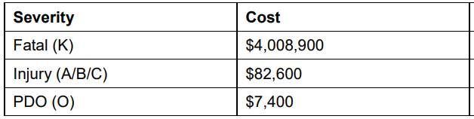

1. Calculate benefits to cost (B/C) ratio associated with a safety improvement by installing a countermeasure (roundabout) selected for a 4-leg Intersection over 5 years in service life. The following data was given: **(25 points)**

Major / minor AADT: 10,000 /1,000

The Crash Modification Factor (CMF) for roundabout: 0.5 for total crashes

Annual traffic growth: 2%

Discount rate: 2%

Crash summary: 20% fatal and injury

Costs for roundabout: $700,000

**Table 5: Societal Crash Costs**





