**In-class Activity 1:** A state DOT is considering three alternatives for improvement of a particular urban facility. The objectives are to improve travel speeds, increase safety and reduce operating costs for users. The annual dollar values of savings, as well as additional construction and maintenance costs for each alternative compare to Do-Nothing (DN) are given in the following table. If N = 50 years and I = 3%, determine the best alternative.

|  |  |  |  |  |  |
| --- | --- | --- | --- | --- | --- |
| **Alternatives** | **Construction**  **cost** | **Annual savings in crash costs** | **Annual travel time benefits** | **Annual  operating savings** | **Annual additional maintenance costs** |
| I | $185,000 | $5,000 | $3,000 | $500 | $1,500 |
| II | $220,000 | $5,000 | $6,500 | $500 | $2,500 |
| III | $310,000 | $7,000 | $6,000 | $2,800 | $3,000 |

**Formula to convert uniform annual benefits to a present value**

$\left(P | A, i,y\right)=\frac{{\left(1+i\right)}^{y}-1 }{i*{\left(1+i\right)}^{y} }$ Where $i$ = discount rate, $y$ = year in the service life of the countermeasure

**In-class Activity 2:** A transit agency is evaluating alternatives for a light rail line construction. Five alternatives are evaluated for five different criteria. Evaluate the alternatives using the rating and ranking method.



**In-class Activity 3:** Let’s say, you are working for NIRCC at Fort Wayne as a Transportation Planner. Your responsibility is to measure the congestion of each roadway segment in the congestion management network within the boundary. As an example, the average AM and PM traffic volume is given on Interstate 469 from Maple crest to Interstate 69 (see Figure 1). Determine whether this roadway segment is congested or not.

|  |  |  |  |  |  |
| --- | --- | --- | --- | --- | --- |
| **Street** | **from street** | **to street** | **AM Peak Vol** | **PM Peak Vol** | **Length** |
| Inter 469 | Maplecrest | Inter 69 | 2542 | 2522 | 2.26 |

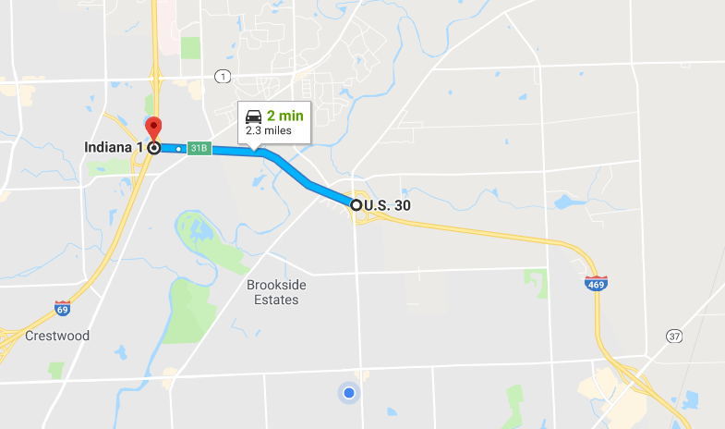

Figure 1: Interstate 469 from Maplecrest to Interstate 69

