Example 15.1: A crest vertical curve is to be designed to join a +3% grade with a -2% grade at a section of a two-lane highway. Determine the minimum length of the curve if the design speed of the highway is 60 mph, S<L, and a perception-reaction time of 2.5 sec. The deceleration rate for braking (a) is 11.2 ft/sec².

Example 15.2: An existing vertical curve on a highway joins a +4.4% grade with a -4.4% grade. If the length of the curve is 275 ft, what is the maximum safety speed on this curve? What speed should be posted if 5 mph increments are used? Assume a= 11.2 ft/sec², perception-reaction time = 2.5 sec, and S<L.
Example 15.3: A sag vertical curve is to be designed to join a -5% grade to a +2% grade. If the design speed is 40 mph, determine the minimum length of the curve that will satisfy all criteria. Assume a = 11.2 ft/sec² and perception-reaction time = 2.5 sec.
Example 15.4: A crest vertical curve joining a +3% and a -4% grade is to be designed for 75 mph. If the tangents intersect at station (345+60.00) at an elevation of 250 ft, determine the stations and elevations of the BVC and EVC. Also, calculate the elevations of intermediate points on the curve at the whole stations. A sketch of the curve is shown in Figure 15.16.

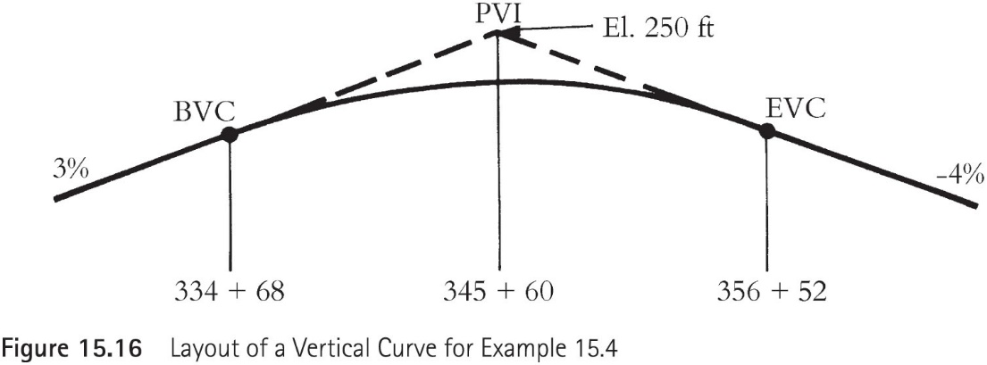

Example 15.5: A sag vertical curve joins a -3% grade and a +3% grade. If the PVI of the grades is at station (345+50) and has an elevation of 235 ft, determine the station and elevation of the BVC and EVC for a design speed of 70 mph. Also, compute the elevation on the curve at 100-ft intervals. Figure 15.17 shows a layout of the curve.

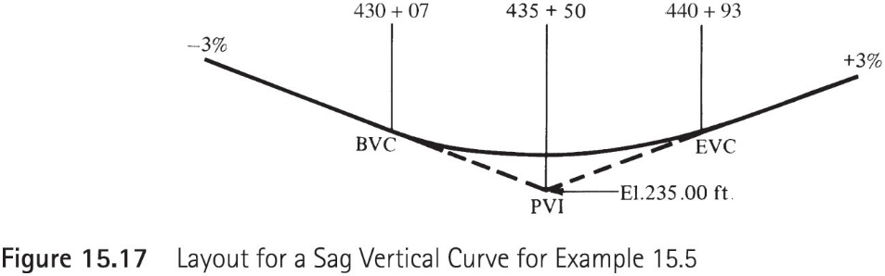

Example 15.6: The intersection of a 4⁰ curve is 55⁰25’, and the PC is located at station 238+44.75. Determine the length of the curve, the station of the PT, the deflection angles, and the chord lengths for setting out the curve at whole stations from the PC. Figure 15.21 illustrates a layout of the curve.

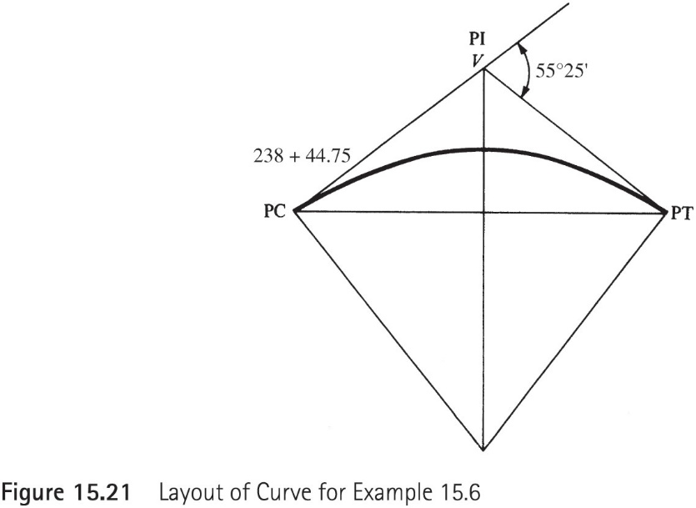

Example 15.7: Figure 15.23 illustrates a compound curve that is to be set out at a highway intersection. If the point of compound curve (PCC) is located at station (565+35), determine the deflection angles for setting out the curve.

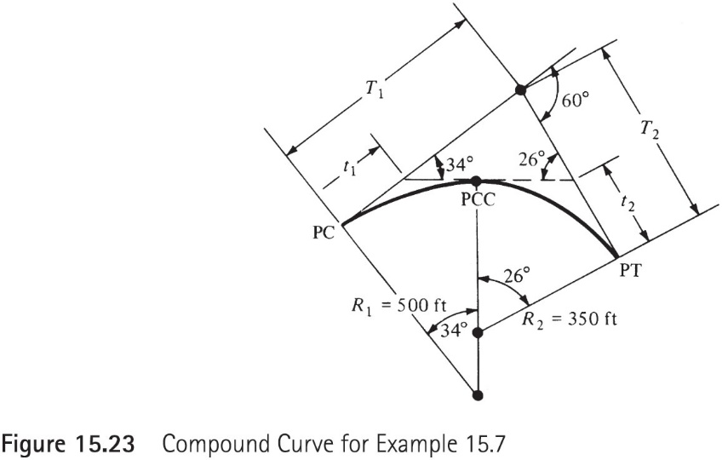
Example 15.8: A horizontal curve with a radius of 800 ft. connects the tangents of two-lane highway that has a posted speed limit of 35 mph. If the highway is not superelevated, e=0, determine the horizontal sightline offset (HSO) that a large billboard can be placed from the centerline lane of the curve, without reducing the required SSD. Perception-reaction time is 2.5 sec, and f=0.35.

