Example 6.1: Figure 6.3 shows vehicles traveling at constant speeds on a two-lane highway between section x and y with their positions and speeds obtained at an instant of time by photography. An observer located at point x observes the four vehicles passing point x during a period of t sec. the velocities of the vehicles are measured as 45, 45,40, and 30 mph respectively. Calculate the flow, density, time mean speed and space mean speed. [Ans. $\frac{14400}{T}$veh/h, 70.4 veh/mi, 40 mi/h, 39 mi/h]
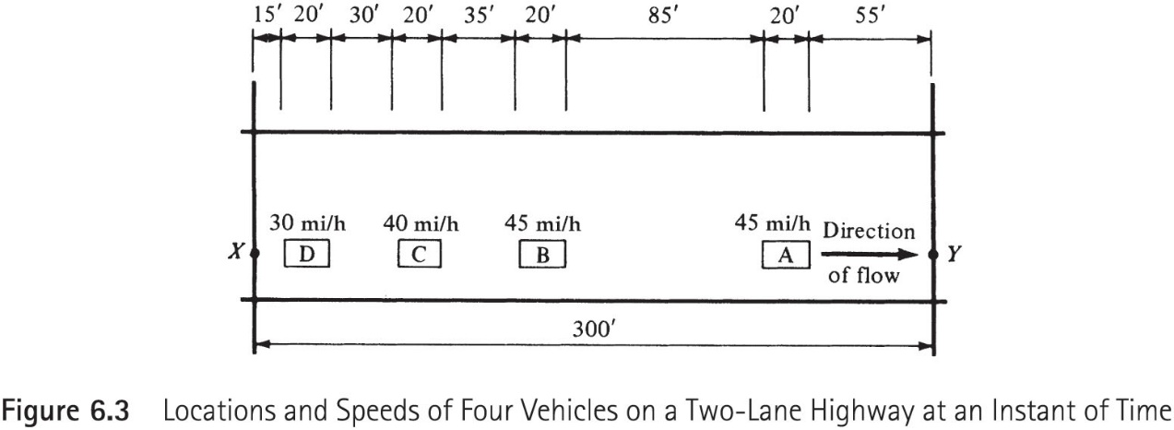

Example 6.2: Columns 1, 2, 3 of table 6.1 give data obtained on vehicles on a lane traversing a detection zone as recorded by a presence detector. If the length of the detector zone is 6 ft.:
- Determine the density on the lane without assuming that the lengths of the vehicles are approximately the same. [Ans. 14.61 veh/mi]
- Determine the density on the lane assuming the lengths of the vehicles are approximately the same. [Ans. 14.995 veh/mi]
- Comment on the results.

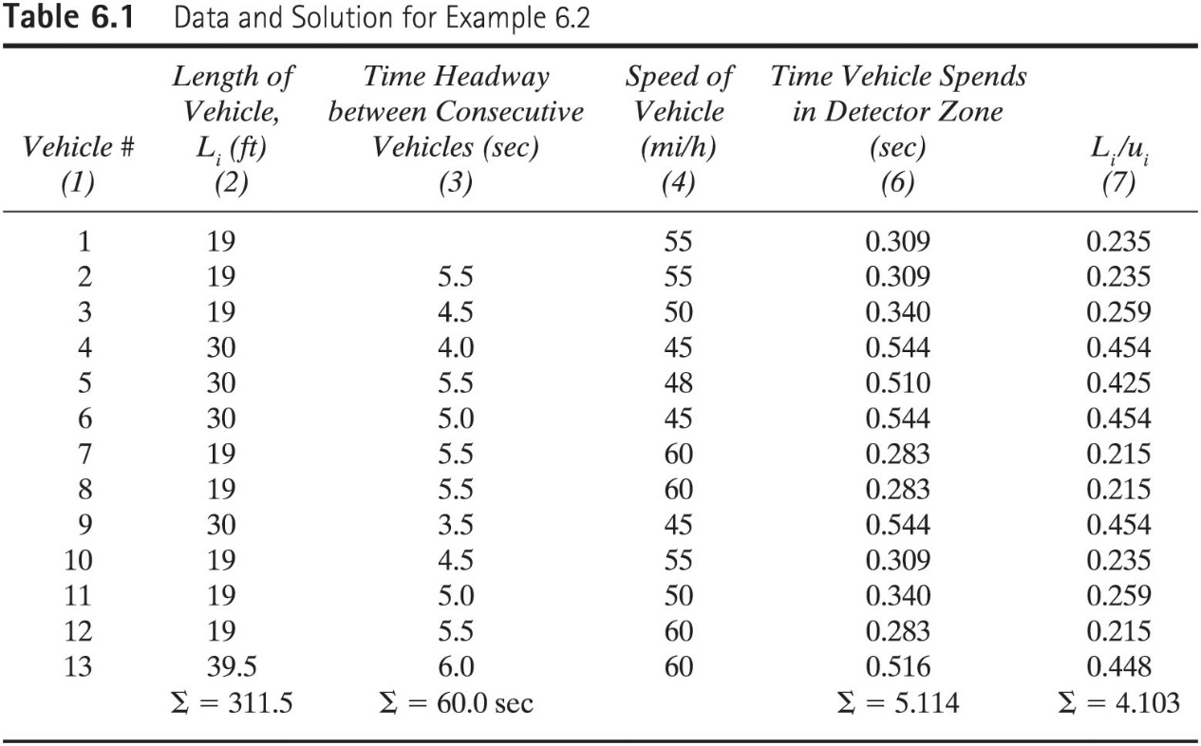

Example 6.3 and 6.4: Let us now use the data shown in table 6.2 (columns 1 and 2) to demonstrate the use of the method of regression analysis in fitting speed and density data to the macroscopic models discussed earlier.
The data in Table 6.2b can also be fitted into the Greenberg model.

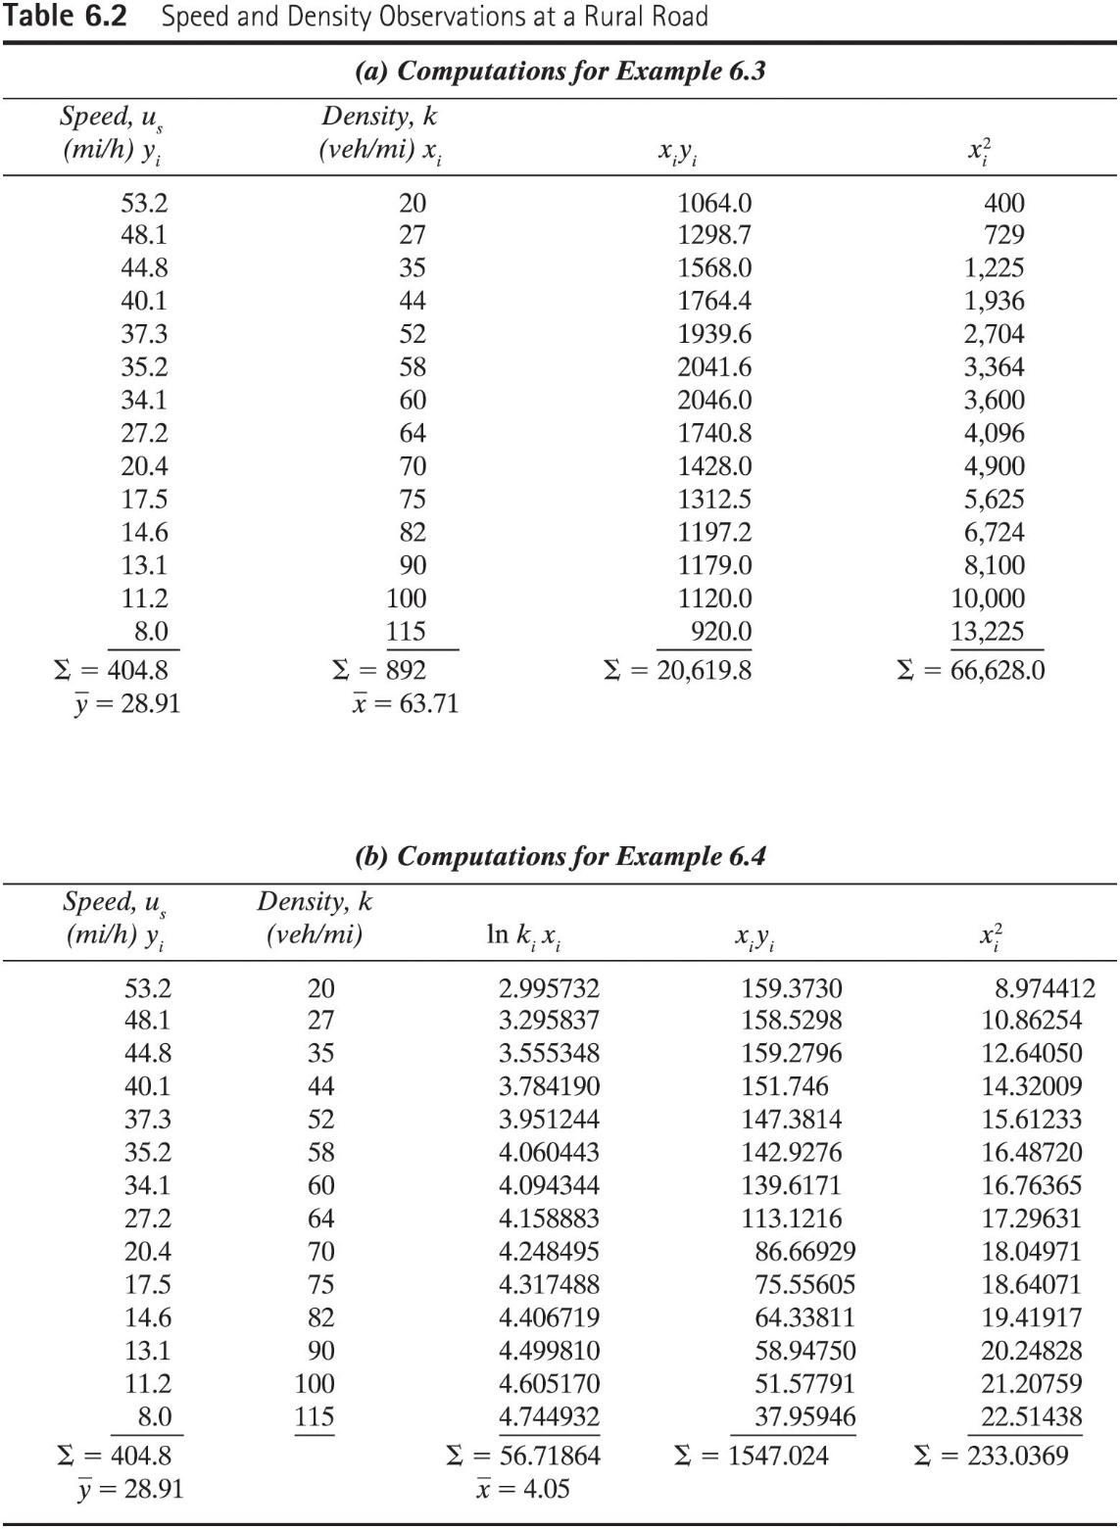

Example 6.5: The southbound approach of a signalized intersection caries a flow of 1000 veh/h/ln at a velocity of 50 mph. The duration of the red signal indication for this approach is15 sec. if the saturation flow is 2000 veh/h/ln with a density of 75 veh/ln , the jam density is150 veh/mi, determine the following:
- The length of the queue at the end of the red phase
- Speed of backward recovery wave velocity
- The maximum queue length.
[Ans. 169.65 ft., -39.2 ft/sec., 238.45 ft.]

Example 6.6: The volume at a section of a two-lane highway is 1500 veh/h in each direction and the density is about 25 veh/ mi. A large dump truck loaded with soil from an adjacent construction site joins the traffic stream and travels at a speed of 10 mph for a length of 2.5 mi along the upgrade before turning off onto a dump site. Due to the relatively high flow in the opposite direction, it is impossible for any car to pass the truck. Vehicle just behind the truck therefore have to travel at the speed of the truck which results in the formation of a platoon having a density of 100 veh/h and a flow of 1000 veh/ h. Determine how many vehicles will be in the platoon by the time the struck leaves the highway. [Ans. 420 vehicles]

Example 6.7: Studies have shown that the traffic flow on a single lane approach to a signalized intersection can be described by the green shield model. If the jam density on the approach is 130 veh/mi, determine the velocity of the stopping wave when the approach signal changes to red if the density of the approach is 45 veh/mi and the space mean speed is 40 mph. At the end of the red interval, what length of the approach upstream from the stop line will be affected if the red interval is 35 sec. [Ans. 1090.7 ft.]

Example 6.10: A 3 lane Expressway (One Direction) is carrying a total volume of 4050 veh/h when an incident occurs resulting in the closure of two lanes. If it takes 90 minutes to clear the obstruction determine the following:
  - the maximum queue length that will be formed [Ans. 3075 veh.]
  - The total delay [Ans. 4731 h.]
  - The number of vehicles that will be affected by the incident [Ans. 6075 veh.]
  - The average individual delay [Ans. 0.779 h.]
Assume that the capacity of the highway is 2000 veh/h/ln

