CE 34500: Transportation Engineering
Homework 6

Problem 1: A +2 % grade intersects with a 1 % grade at station (535+24.25) at an elevation of 300 ft. If the design speed is 65 mph, determine:
- The minimum length of vertical curve using the rate of vertical curvature. Then using the length found in part (a), find:
- The stations and elevations of the BVC and EVC
- The elevation of each 100-ft. station
- The station and elevation of the high point
Solution:
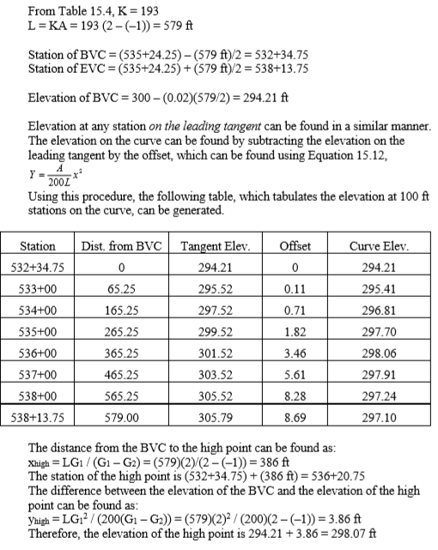
Problem 2: Determine the minimum length of a crest vertical curve, using the minimum length based on SSD criteria if the grades are +4% and -2%. Design speed is 70 mph. State assumptions used.
Solution:
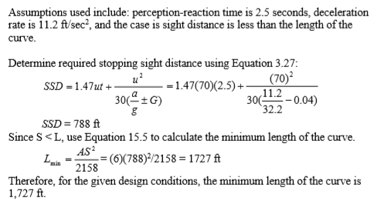
Problem 3: Determine the minimum length of a sag vertical curve if the grades are -4% and +2%. Design speed is 70 mph. State assumptions used. Consider the following criteria: stopping sight distance, comfort, and general appearance.
Solution:
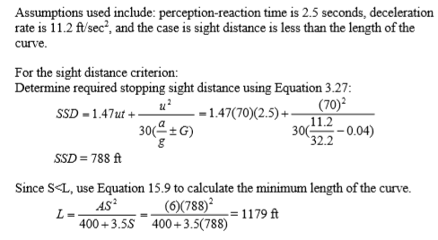
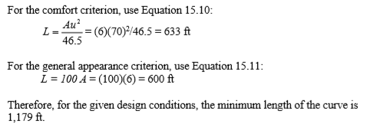

Problem 4: Given a sag vertical curve connecting a -1.5 % grade with a +2.5% grade on a rural arterial highway, use the rate of vertical curvature, and a design speed of 70 mph to compute the elevation of the curve at 100 ft. stations if the grades intersect at station (475+00) at an elevation of 300 ft. Identify the station and elevation of the low point.
Solution:
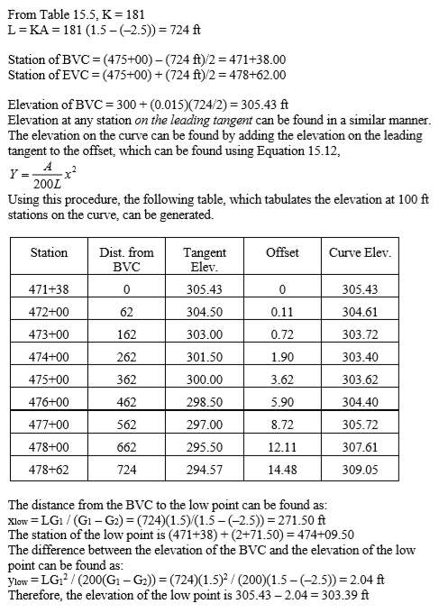

Problem 5: A crest vertical curves connects a +4.44% grade and a -6.87% grade. The PVI is at station 43+50.00 at an elevation of 1240.00 ft. The design speed is 30 mph.
- The length of the vertical curve using the AASHTO method (“K” factors)
- The stations of the BVC,
- The elevation of the BVC,
- The stations of the EVC,
- The elevation of the EVC,
- The stations of the high point,
- The elevation of the high point,
- The elevation of station 44+23.23
Solution:
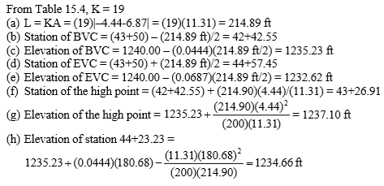
Problem 6: A horizontal curve is to be designed for a two-lane road in mountainous terrain. The following data are known: intersection angle 40 degrees, tangent length 436.76 ft., and station of $PI: 2700+10.65, fs=0.12, e=0.08.$Determine:
- Design speed
- Station of the PC and
- PT
- Deflection angle and chord length to the first 100 ft. station
Solution:
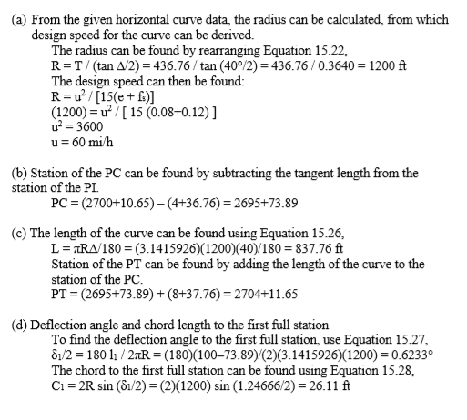

Problem 7: Given a sample circular curve with the following properties: $D =11°$, bearing on incoming (back) tangent is $N 89°27'25'' E$, bearing on outgoing (forward) tangent is $S 60°10'05''E$. The station of the PI = 22+69.77. Determine
- The intersection angle
- Radius
- Tangent
- The external distance
- The middle ordinate
- The long chord
- The length of the curve
- Station of the PC
- and PT
Solution:
