CE 34500: Transportation Engineering
Homework 4

- A minor road carrying 75 veh/h on each approach for eight hours of an average day crosses a major road carrying 145 veh/h on each approach for the same eight hours, forming a four-leg intersection. There are an average of two crashes per year that may be corrected by a multiway stop control. Determine whether a multiway stop sign is justifies at this location. If not justified, estimate when do you need the stop sign based on traffic volume? Assume traffic growth rate is 2%.

- The table below shows 15-minute volume counts during the peak hour on an approach of an intersection. Determine the PHF and the design hourly volume of the approach.
Time Volume
6-6:15 pm 375
6:15-6:30 pm 380
6:30-6:45 pm 412
6:45-7:00 pm 425
7:00-7:15 pm 390
7:15-7:30 pm 350

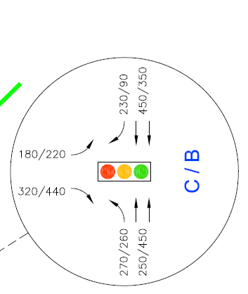
- Using Webster method, determine a suitable signal timing for the following intersection. Traffic volume are given during AM/PM peak hour. Assume PHF=0.95, Saturation flow for left turn is 1615 veh/hour and through/right 3700 veh/hour. Assume numbers if not given using your engineering judgement.

A PM Peak hour
A AM Peak hour

