CE 34500: Transportation Engineering
Spring 2020
Homework 2

- Two sets of students are collecting traffic data at two sections, xx and yy, of a highway 1500 ft. apart. Observations at xx show that five vehicles passed that section at intervals of 3, 4, 3, and 5 sec, respectively. If the speeds of the vehicles were 50, 45, 38, 35, and 30 mi/hr respectively, draw a schematic showing the locations of the vehicles 20 sec after the first vehicle passed section xx. Also determine (a) the time mean speed, (b) the space mean speed, and (c) the density on the highway.
Answer:
The distance traversed by each vehicle 20 seconds after crossing section x-x is calculated as follows:
Vehicle A: $X_{A}=50*1.47*20=1470 ft.$
Vehicle B: $X_{B}=45*1.47*(20-3)=1125 ft.$
Vehicle C: $X_{C}=38*1.47*(20-3-4)=726 ft.$
Vehicle D: $X_{D}=35*1.47*(20-3-4-3)=515 ft.$
Vehicle E: $X_{E}=30*1.47*(20-3-4-3-5)=221 ft.$

X-X E D C B A Y-Y
221’ 515’ 726’ 1125’ 1470’

a) Time mean speed= $\frac{50+45+38+35+30}{5}=39.6$ mph
b) Space mean speed = $\frac{5}{\frac{1}{50}+\frac{1}{45}+\frac{1}{38}+\frac{1}{35}+\frac{1}{30}}=38.3$ mph
c) Density =$\frac{5 veh}{3+4+3+5}*\frac{3600}{38.3}=31.3 veh/mi$

- The following dataset consists of 30 observations of vehicle speed and length taken from a 6-ft by 6-ft inductive loop detector during a 60-second time period. Determine the occupancy, density, and flow rate.
Vehicle | Speed, mph | Length, ft.
1 | 61 | 18
2 | 66 | 17
3 | 62 | 19
4 | 70 | 21
5 | 65 | 16
6 | 69 | 26
7 | 72 | 21
8 | 66 | 19
9 | 65 | 20
10 | 64 | 20
11 | 67 | 25
12 | 68 | 70
13 | 65 | 35
14 | 66 | 20
15 | 71 | 65
16 | 64 | 24
17 | 59 | 23
18 | 58 | 22
19 | 64 | 65
20 | 64 | 30
21 | 68 | 24
22 | 58 | 21
23 | 66 | 56
24 | 57 | 21
25 | 64 | 20
26 | 61 | 50
27 | 69 | 19
28 | 63 | 23
29 | 63 | 17
30 | 66 | 18

Answer:
Vehicle | Speed, mph, u | Length, ft., L | Time Vehicle Spends  in Detector Zone
1 | 61 | 18 | 0.27
2 | 66 | 17 | 0.24
3 | 62 | 19 | 0.27
4 | 70 | 21 | 0.26
5 | 65 | 16 | 0.23
6 | 69 | 26 | 0.32
7 | 72 | 21 | 0.26
8 | 66 | 19 | 0.26
9 | 65 | 20 | 0.27
10 | 64 | 20 | 0.28
11 | 67 | 25 | 0.31
12 | 68 | 70 | 0.76
13 | 65 | 35 | 0.43
14 | 66 | 20 | 0.27
15 | 71 | 65 | 0.68
16 | 64 | 24 | 0.32
17 | 59 | 23 | 0.33
18 | 58 | 22 | 0.33
19 | 64 | 65 | 0.75
20 | 64 | 30 | 0.38
21 | 68 | 24 | 0.30
22 | 58 | 21 | 0.32
23 | 66 | 56 | 0.64
24 | 57 | 21 | 0.32
25 | 64 | 20 | 0.28
26 | 61 | 50 | 0.62
27 | 69 | 19 | 0.25
28 | 63 | 23 | 0.31
29 | 63 | 17 | 0.25
30 | 66 | 18 | 0.25
Total= |  |  | 10.75
Average |  | 28.2

Occupancy = $\frac{10.75}{60}=17.92\%$
Density= $\frac{Occupancy}{L_{mean}+d}=\frac{0.1792}{.28.2+6}=0.0052\frac{veh}{ft}=27.66 veh/mile$ (assuming similar lengths of vehicles)
Flowrate= $n*\frac{3600}{T}= 30*\frac{3600}{60}=1800\frac{veh}{hr}$

- The data shown below were obtained by time-lapse photography on a highway. Use regression analysis to fit these data to the Greenshields model and determine (a) the mean free speed, (b) the jam density, (c) the capacity, and (d) the speed at maximum flow.
Speed, mph | Density, veh/mi
14.2 | 85
24.1 | 70
30.3 | 55
40.1 | 41
50.6 | 20
55 | 15

Answer:

When density =0; Speed=62.8= Free flow speed
When speed=0, density=110.5 = jam density
Speed at max flow= 62.8/2= 31.4
Capacity=$62.8*\frac{110}{4}=1727 veh/hr$

- Traffic on the eastbound approach of a signalized intersection is traveling at 35 mi/hr, with a density of 46 veh/mi/ln. The duration of the red signal indication for this approach is 30 sec. If the saturation flow is 1900 veh/h/ln with a density of 52 veh/mi/ln, and the jam density is 125 veh/mi/ln, determine the following:
(i) The length of the queue at the end of the red phase
(ii) The maximum queue length
(iii) The time it takes for the queue to dissipate after the end of the red indication.

Answer:
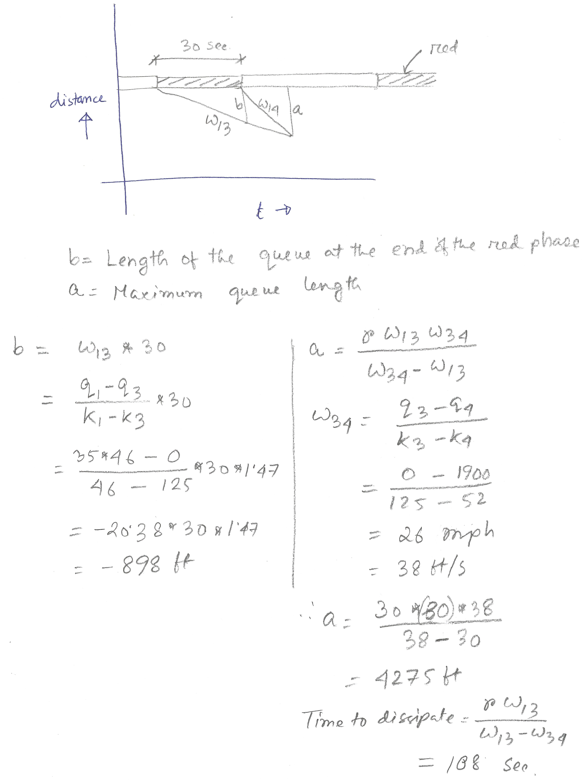

5. If a traffic stream is modeled using Greenshields model, prove that the space mean speed at which the volume is maximum is equal to half the free mean speed. Similarly, the density at which the volume is maximum is equal to half the jam density.
Answer:
