CS 160 – Eclipse Installation Tutorial

Downloading & Installing Eclipse
Step 1: Navigate to https://www.eclipse.org/downloads/packages/installer:
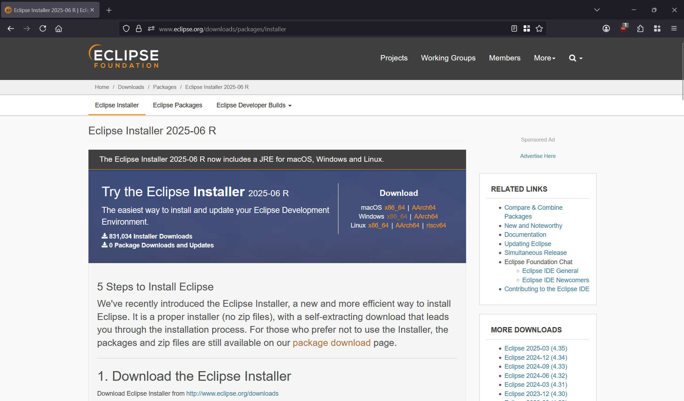
Step 2: Click on the link to download the Eclipse Installer for your operating system (in my case, I will be using the 64-bit Windows version):
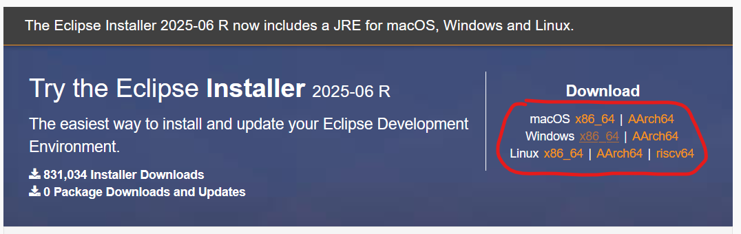
Step 3: On the page it redirects you to, click the “Download” button:
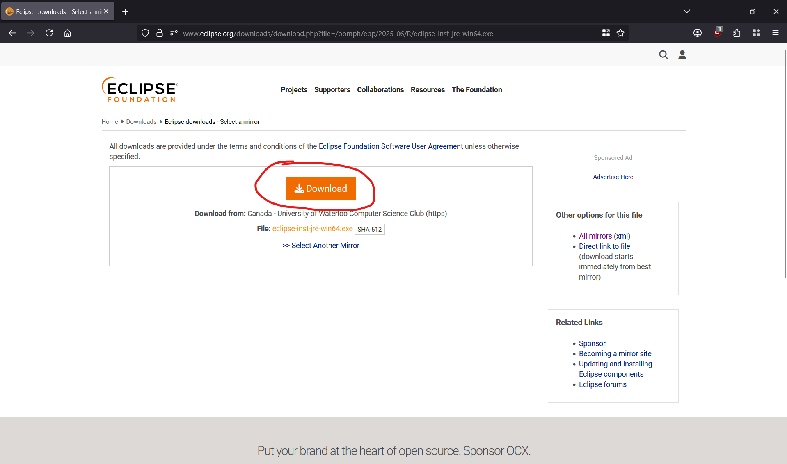
This will redirect you to another page. You should not need to do anything on this page—the installer should automatically download:
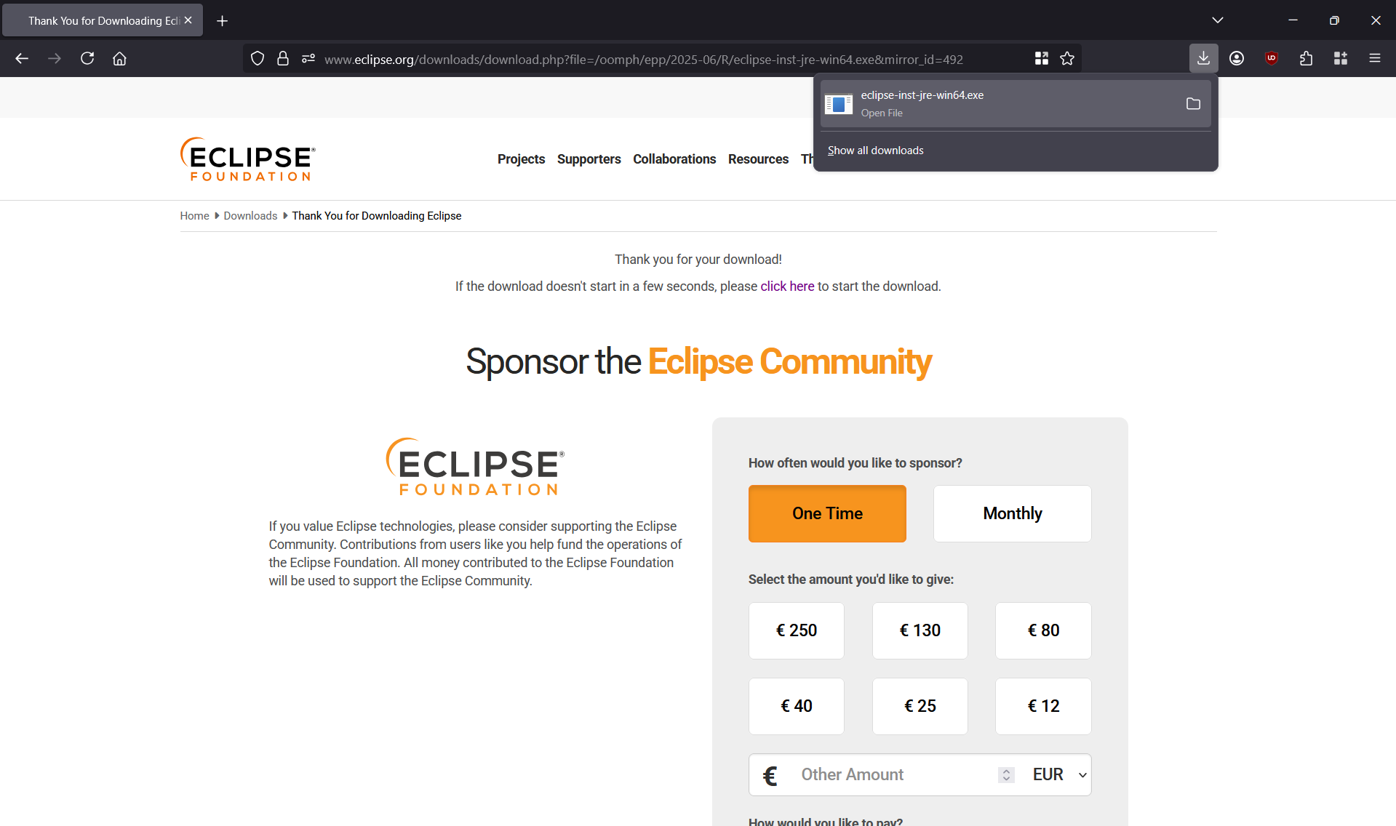
Step 4: Once the installer is downloaded, navigate to its location and run the file:
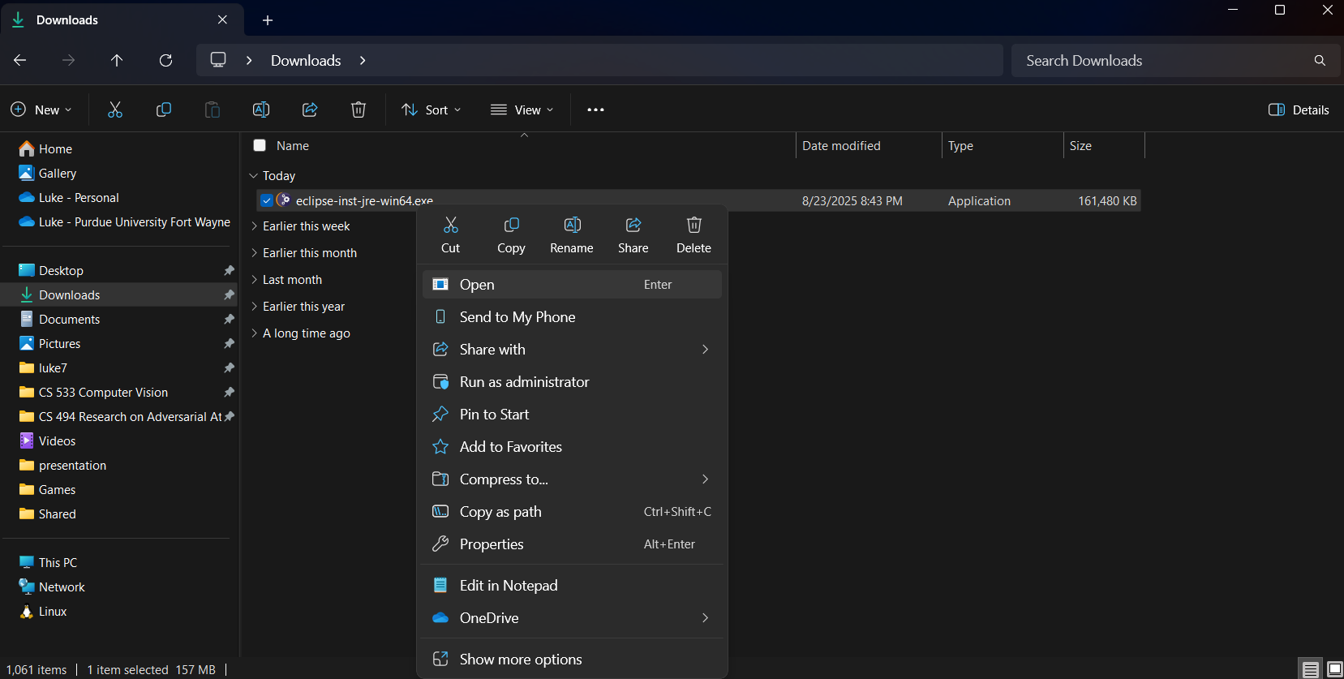
Step 5: This should eventually open a new application. After it loads, click on the option that reads, “Eclipse IDE for Java Developers”:
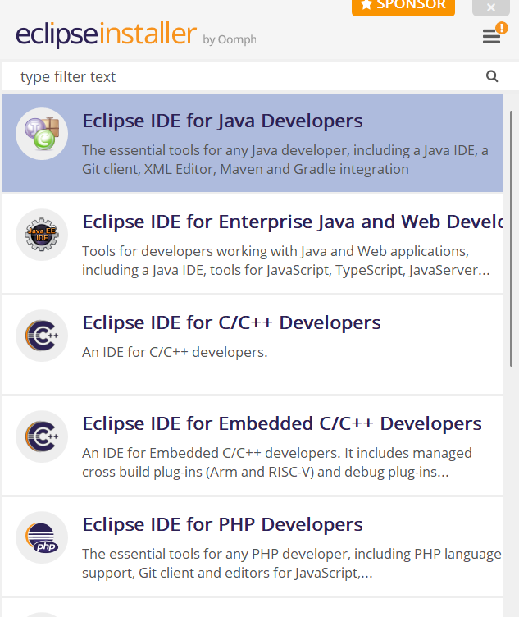
Step 6: On the next screen, make sure the JRE 21.X.X option is selected for the “Java 21+ VM” field:
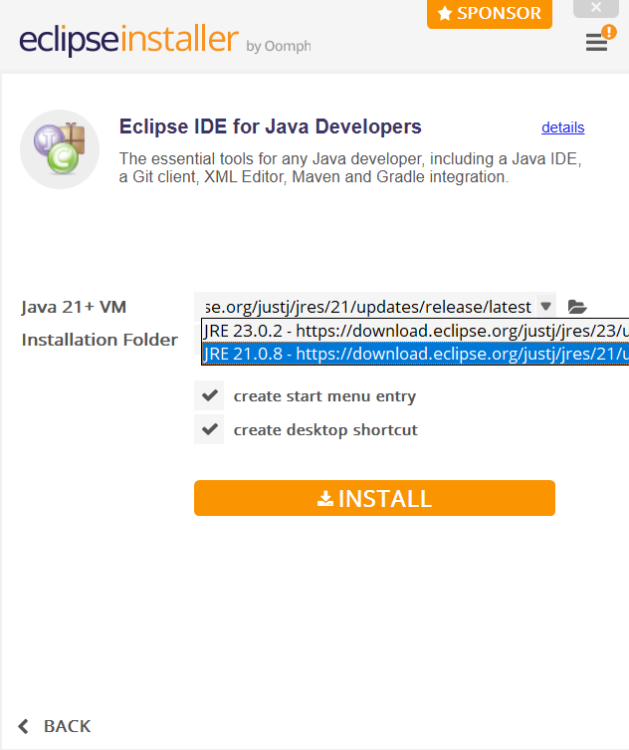
For the other options on the same screen, the default options should work just fine. You can check/uncheck the options for “create start menu entry” and “create desktop shortcut” depending on your preferences (I will leave them checked):
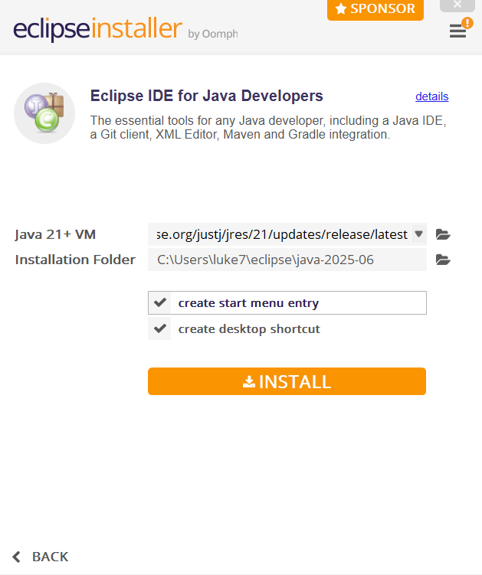
Step 7: Click on the “INSTALL” button:
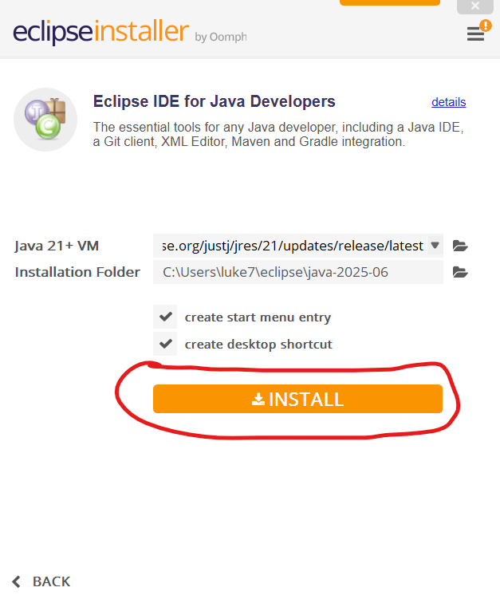
Step 8: A new window should appear prompting you to accept the Eclipse Foundation Software User Agreement. Accept the license by clicking the “Accept Now” button at the bottom:
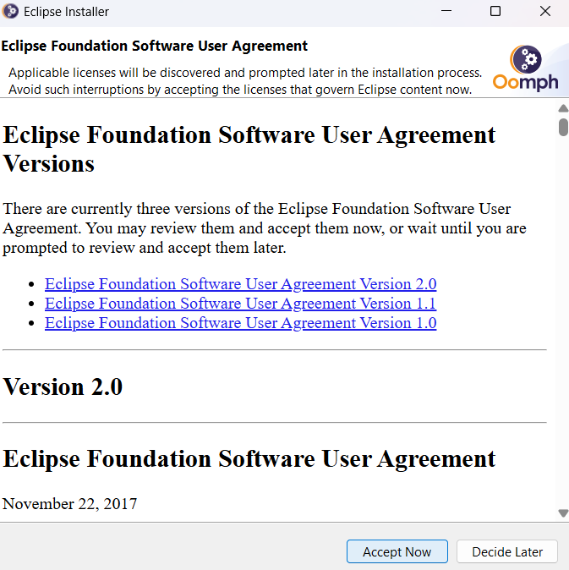
Step 9: After accepting the license, wait for the installation process to complete:
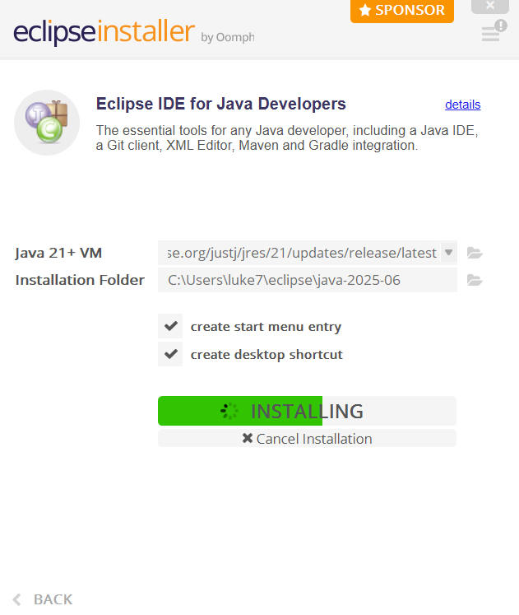
Eventually, the installation should complete (it could take a couple of minutes), and a notification should appear for a short time communicating that Eclipse was successfully installed. After the notification disappears, your screen should look something like this:
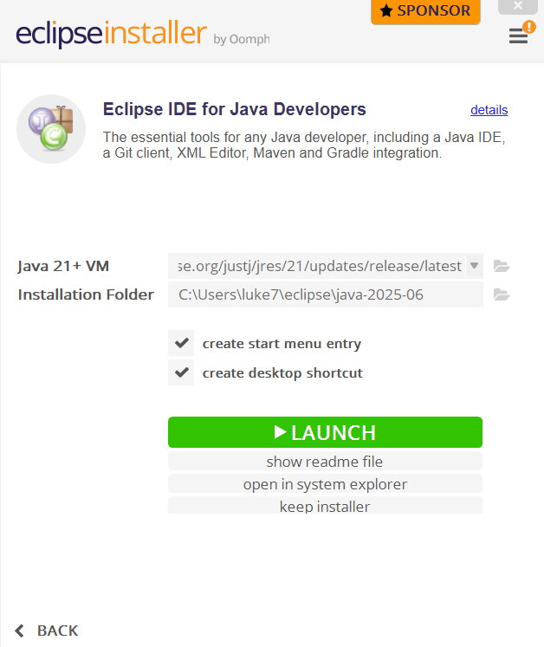
Step 10: Launch Eclipse via the “LAUNCH” button. (Also, at this point, you should be able to launch Eclipse anytime from the Desktop shortcut or from the start menu as long as those options were checked before.)
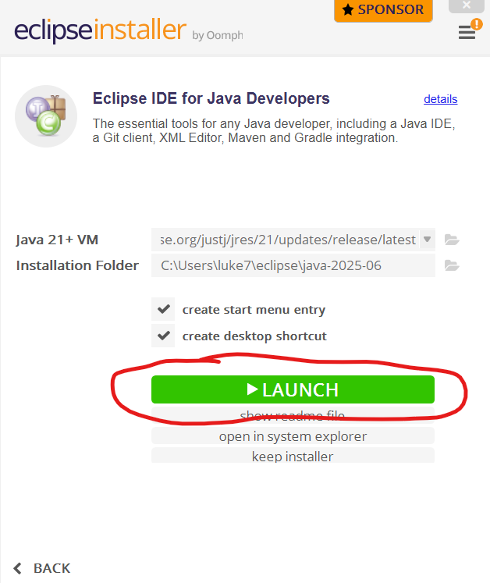
Eventually, a window like this should appear:
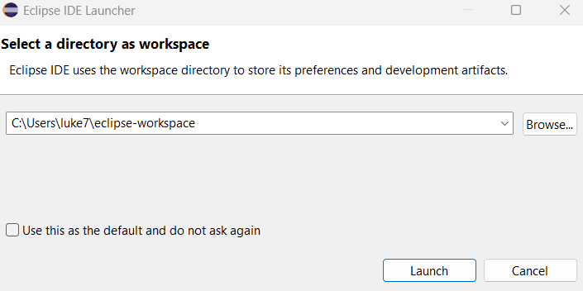
Step 11: Put this new window to the side for now and create a new folder to hold Java projects. For your coursework, you might name this folder something like “cs160-eclipse-workspace”, but for the sake of this tutorial, I will name the folder “install-tutorial-workspace”:
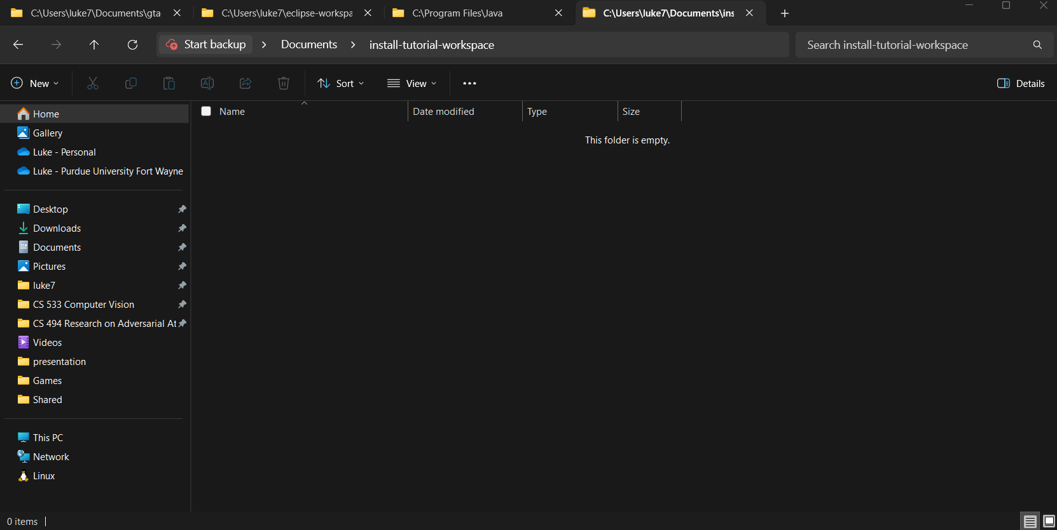
Step 12: Go back to the Eclipse window, select the “Browse…” button, and select the folder you just created in the previous step:
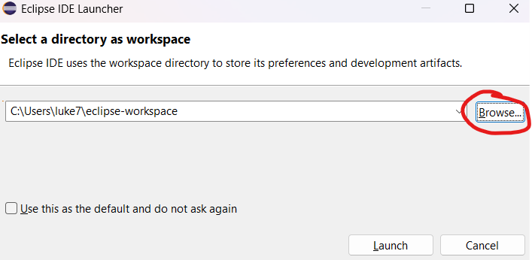
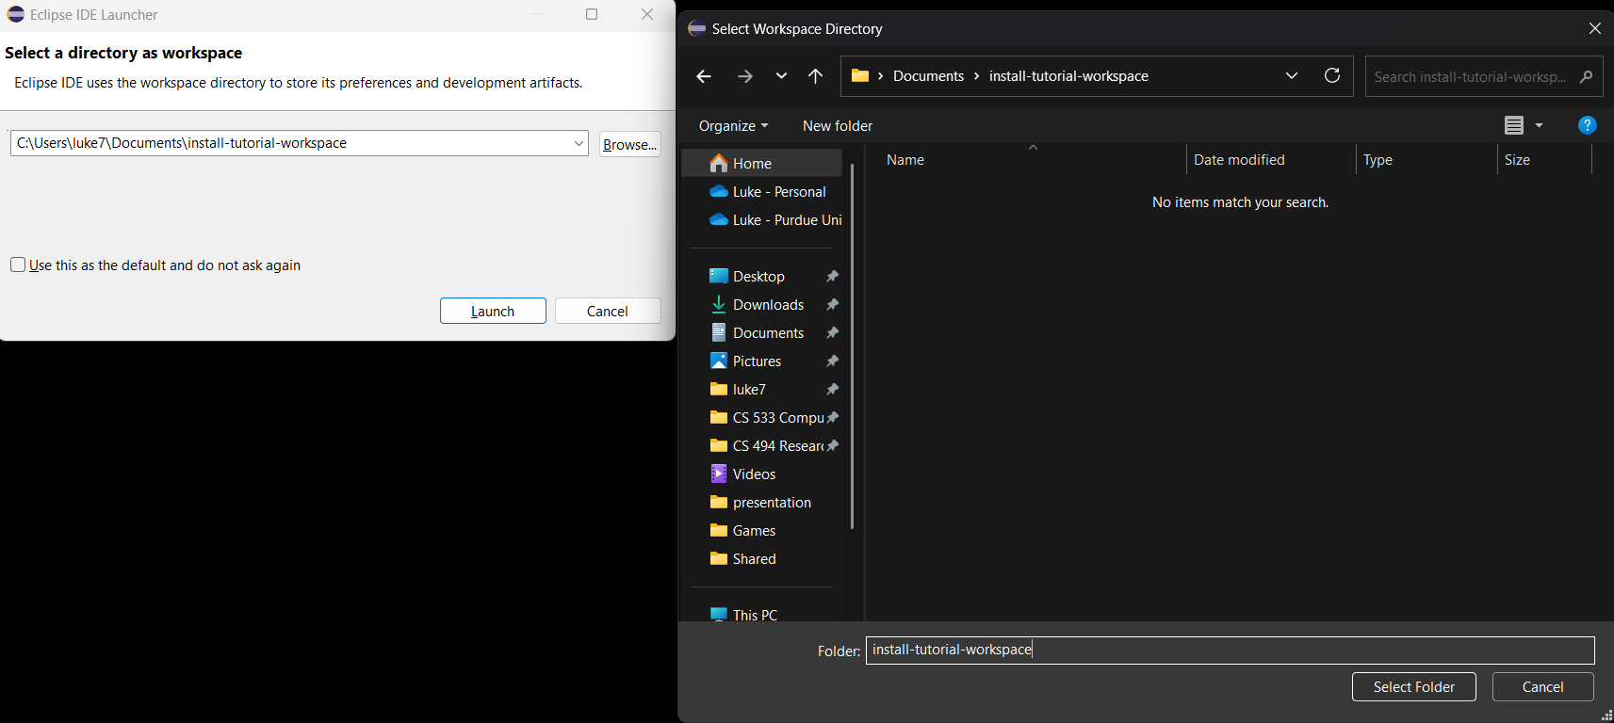
Step 13: Click the “Launch” bottom at the bottom of the Eclipse window:
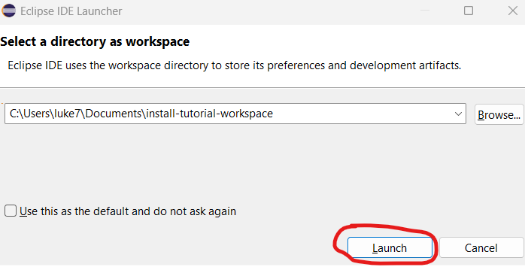
This should open up a window that looks like this:
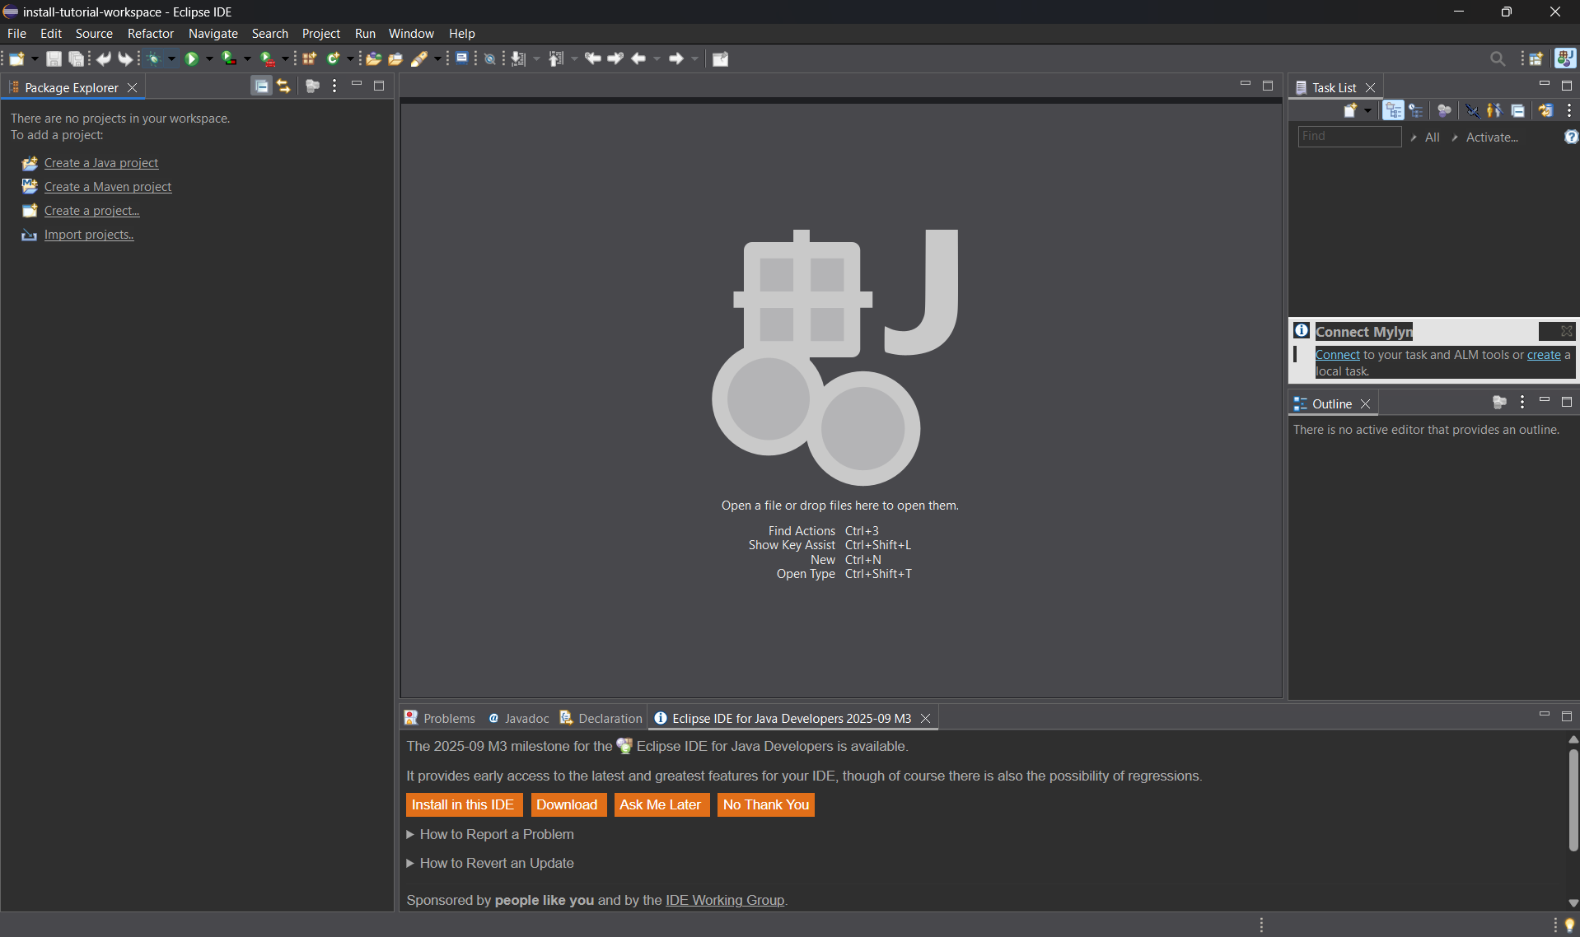
It may also open up a new tab in your web browser asking you to sponsor the Eclipse Platform and IDE. You can ignore or close this tab.
Step 14: Ensure Java JDK 8 is installed.
Now that Eclipse is installed, we need to tell it to specifically use Java Development Kit (JDK) 8 to run Java programs built in Eclipse. However, before we do that, we need to make sure Java JDK version 8 is already installed on our machine.
Step 14.1: Click on the “Window” tab at the top of the window, and select the “Preferences” option in the drop-down menu:
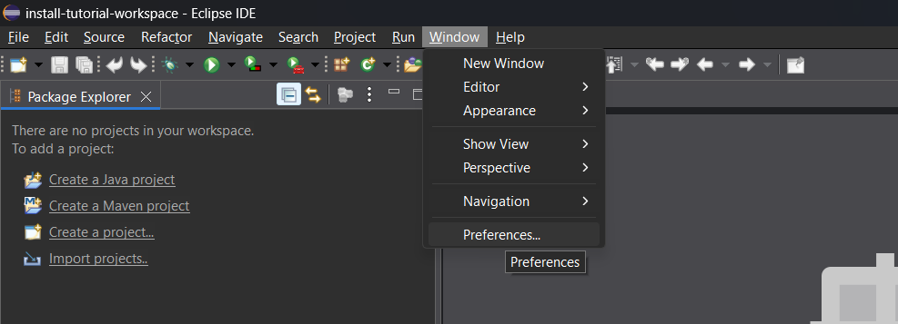
Step 14.2: A new window should appear. In the left pane of this new window, drop down the “Java” option and click on the entry (not the arrow) labeled “Installed JREs”. The window should then look something like this:
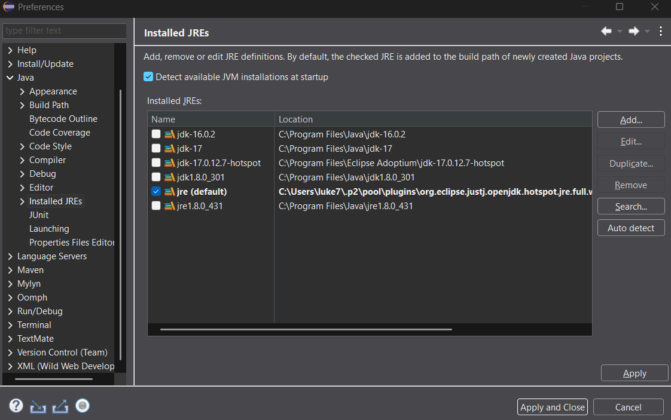
Depending on your situation, you may have just one entry in the right pane (if you have not installed Java before), or you may have several (if you have installed version(s) of Java before). We are specifically looking for an entry who’s name starts with “jdk1.8” or “jdk-8”. If you do not see an entry that looks like this, then you need to follow the next steps to download and install Java JDK 8.
NOTE: it needs to start with “jdk”, not “jre”. If you have and entry that starts with “jre1.8” but not “jdk1.8” or “jdk-8”, then you still need to follow these next steps.

Downloading and Installing Java JDK 8 (Step 15)
- Navigate to https://adoptium.net/temurin/releases/?version=8:
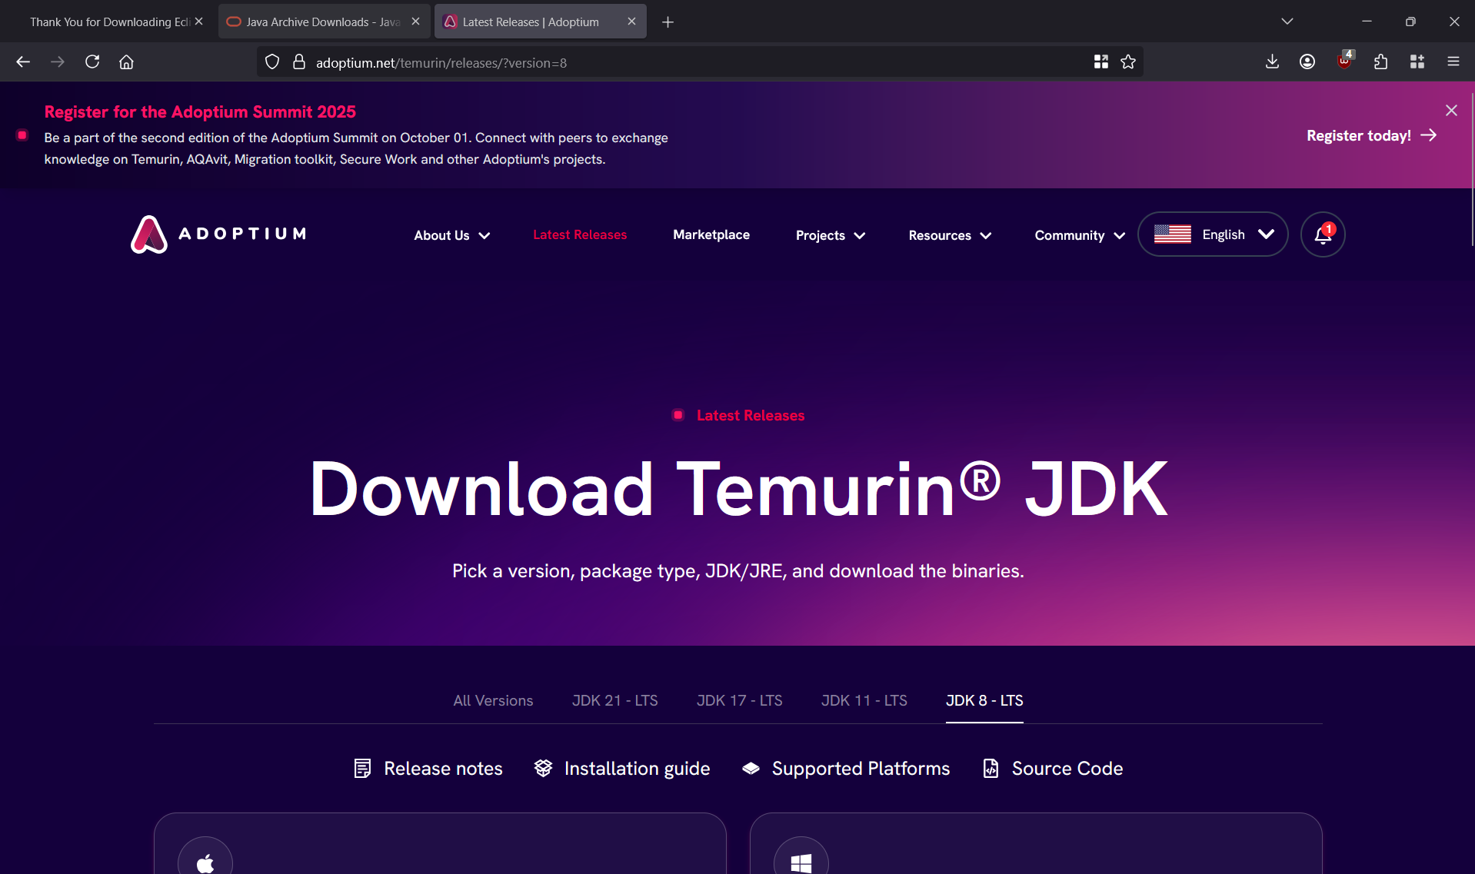
- Scroll down until you see the installer version for your operating system. In my case, I will choose the 64-bit Windows .MSI installer:
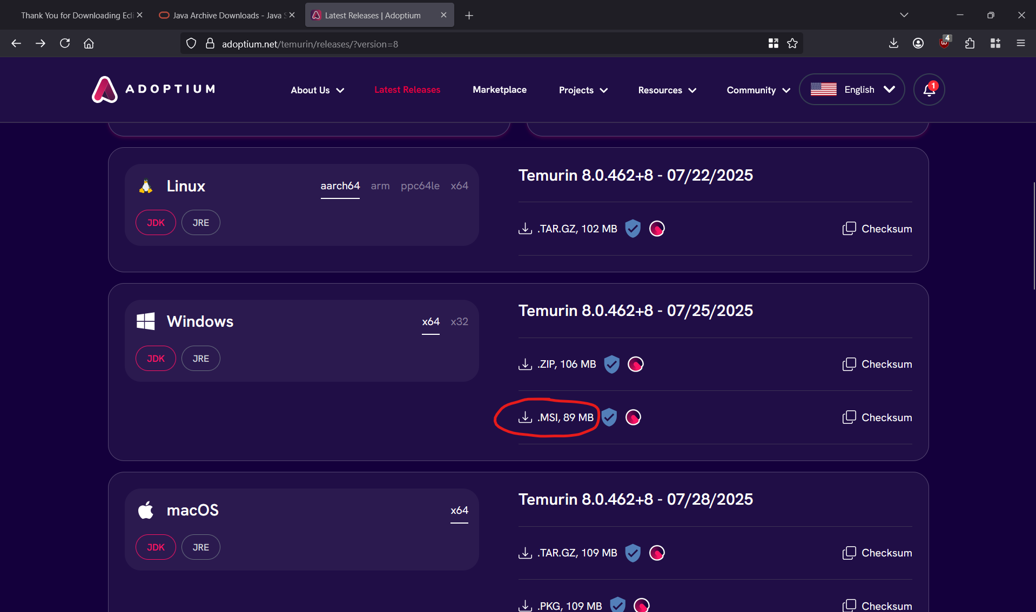
- Once the installer is downloaded, navigate to its location and run the file:
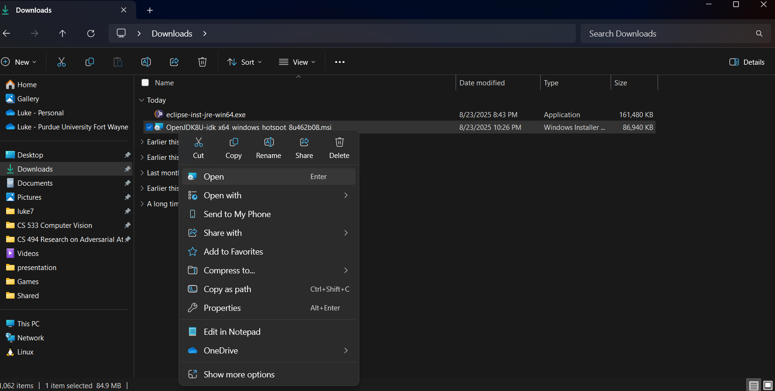
- This should open a new application. Select the “Next” button:
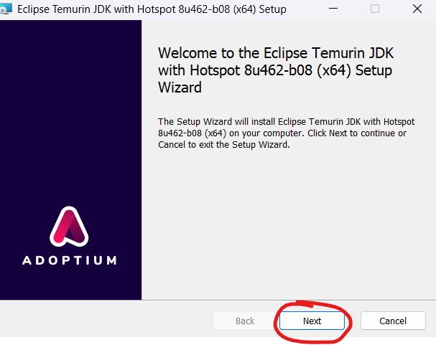
- The next screen will ask you to accept the End-User License Agreement. After accepting it, click on the “Next” Button:
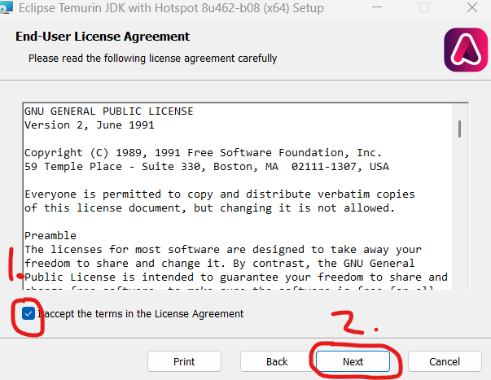
- In the next screen, select your installation scope (default should work just fine) and click the “Next” button:
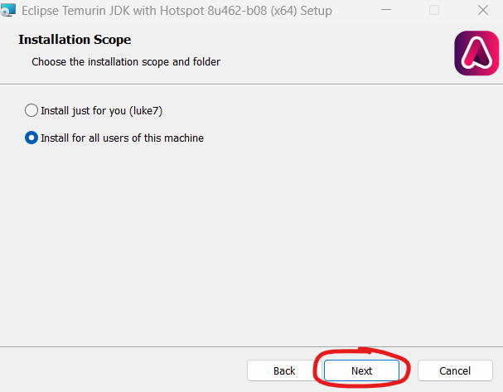
- On the next screen, the default settings should work just fine. Click the “Next” button:
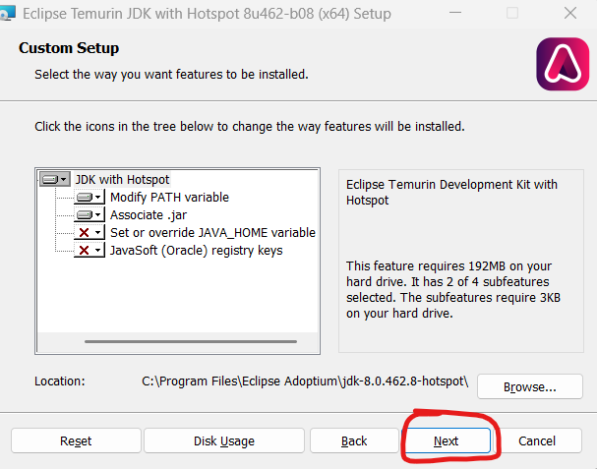
- On the next screen, click the “Install” button:
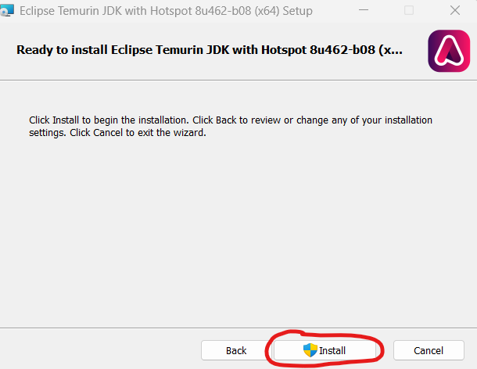
It may prompt you for administrator privileges (at least, it does for me since I am on Windows). Give it the necessary privileges to run.
- Wait for the installer to finish, then click the “Finish” button:
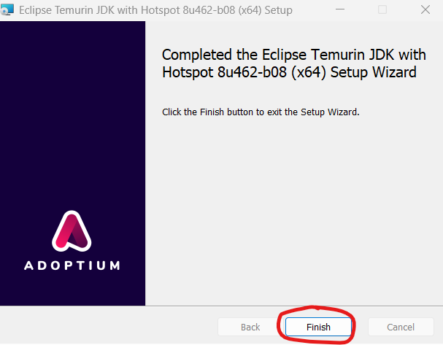
- Now, Java JDK 8 should be installed! You can check by navigating to the folder that the installer specified it would be installed in. It should look something like this:
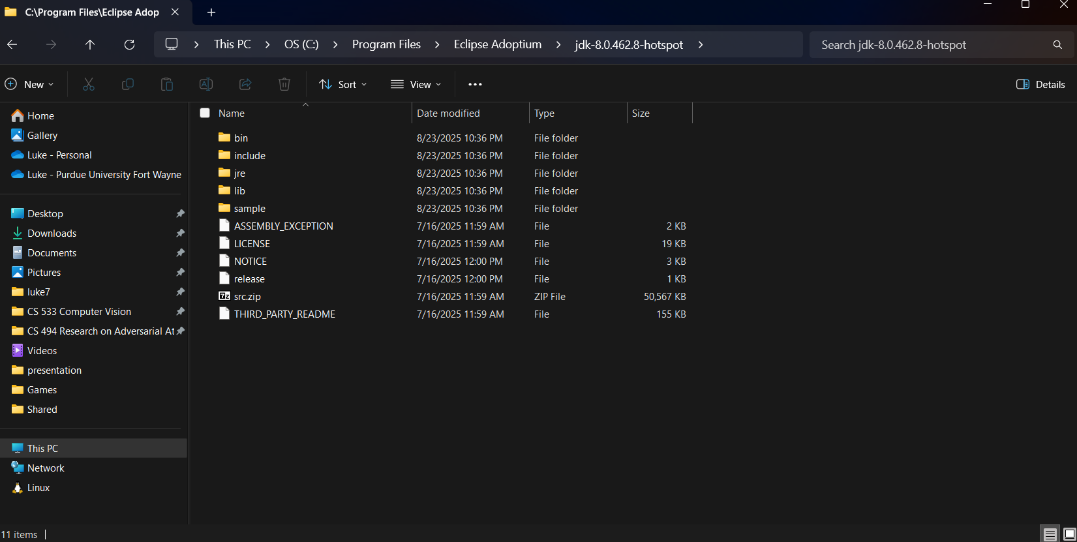

Downloading & Installing Eclipse Continued
Step 16: In Eclipse, make sure you are still on this window:
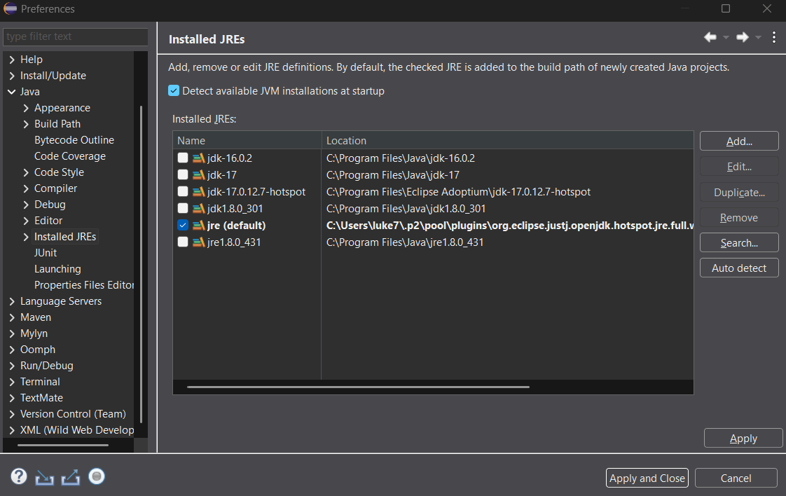
If it was closed, open it back up by going to Window > Preferences > Java > Installed JREs.
Step 17: Click the “Add…” button:
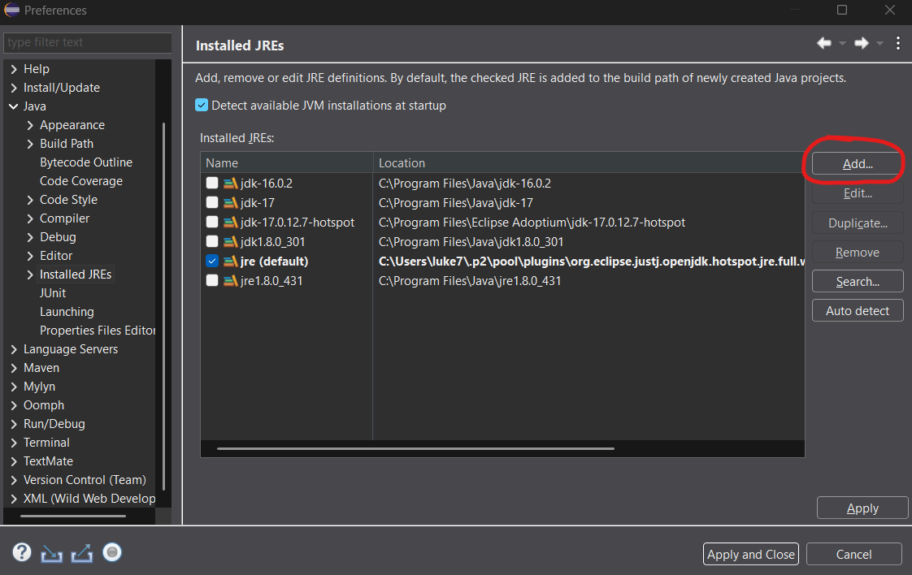
Step 18: A new window should appear. Make sure “Standard VM” is selected, then click the “Next” button:
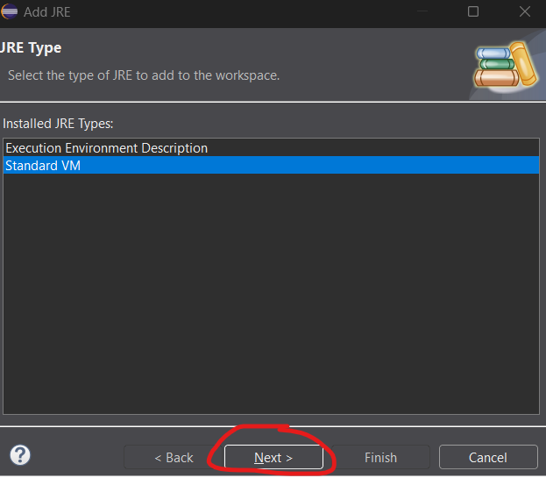
Step 19: In the next screen, click the “Directory…” button next to the “JRE home” field and select the folder containing your Java JDK 8 installation:
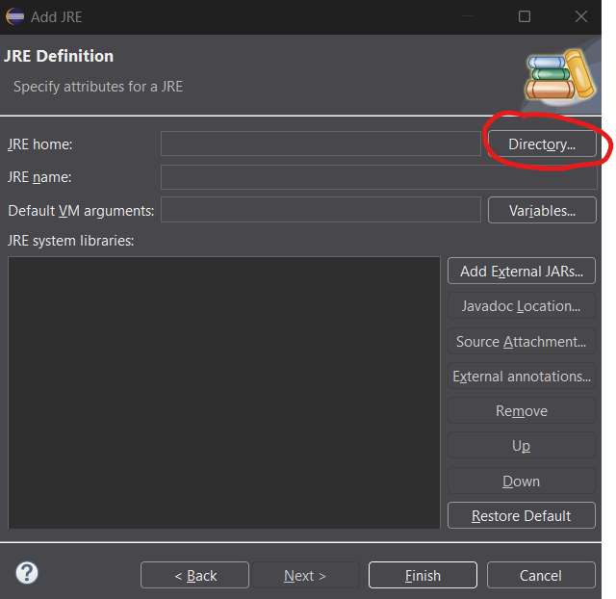
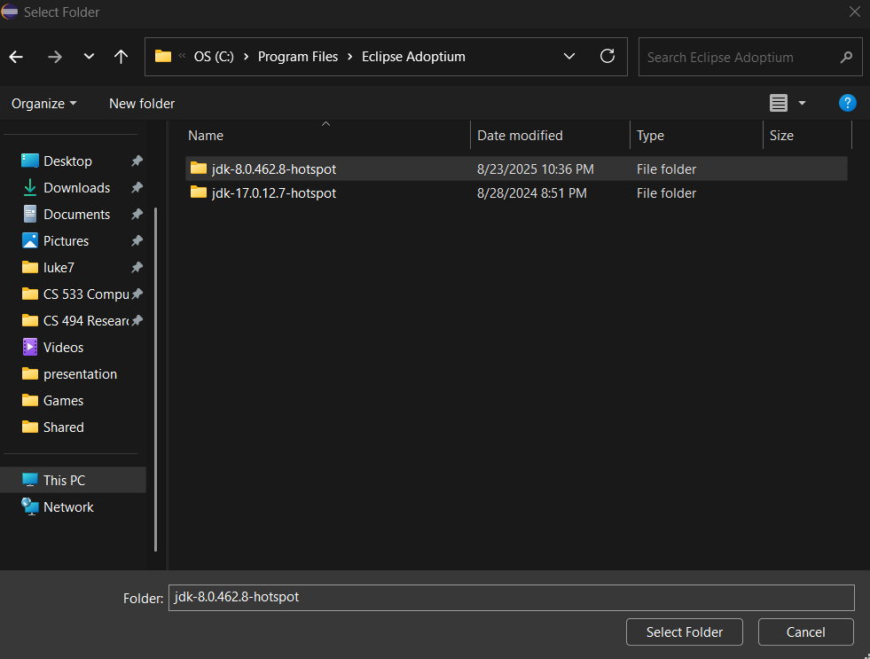
NOTE: Please make sure you do NOT select any of the folders inside the ”jdk-8…” folder. It will only work if you select the folder starting with “jdk-8”.
Step 20: After selecting the folder, back in Eclipse, click the “Finish” button:
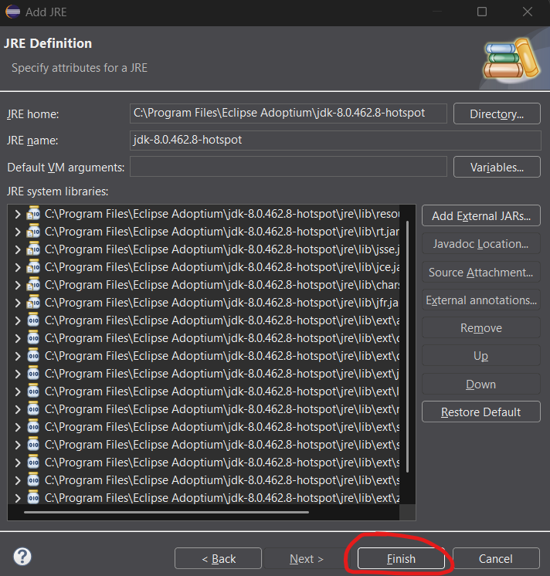
Step 21: Back in the “Installed JREs” window, you should now see an entry for Java JDK 8. Unselect the currently selected entry, and select the JDK 8 entry:
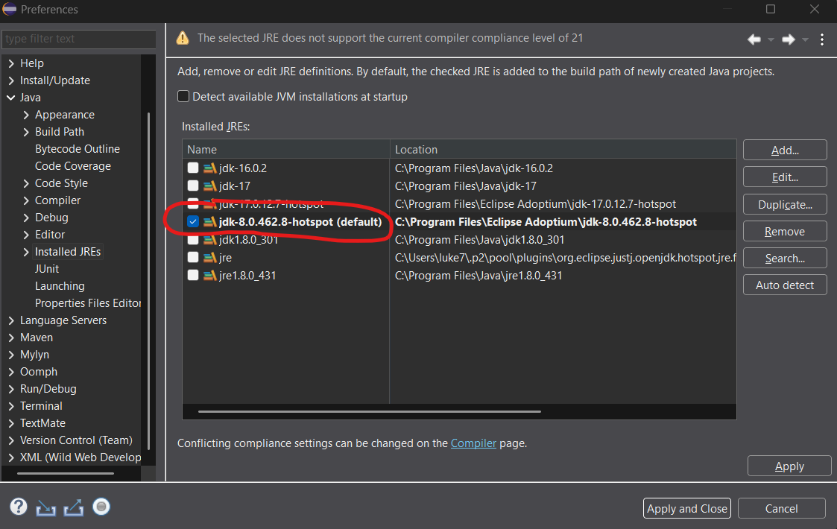
NOTE: You may see a warning at the top about compiler compliance. Ignore this for now—we will fix this shortly.
Step 22: Click the “Apply” button:
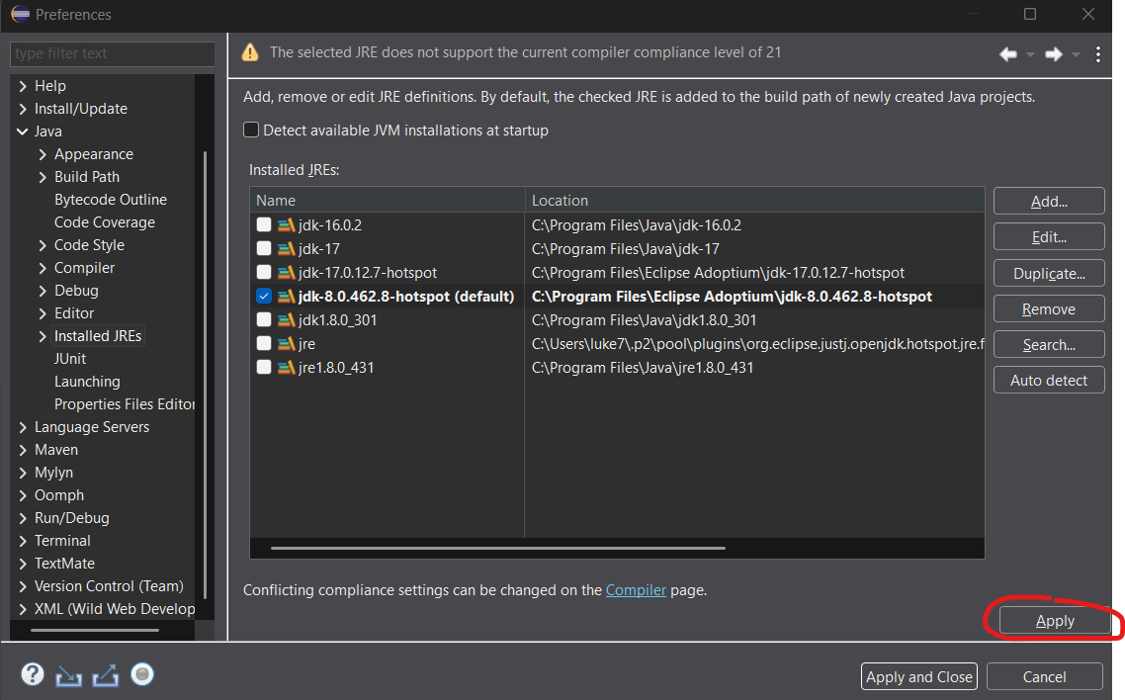
Step 23: In the left pane under “Java”, select the “Compiler” option:
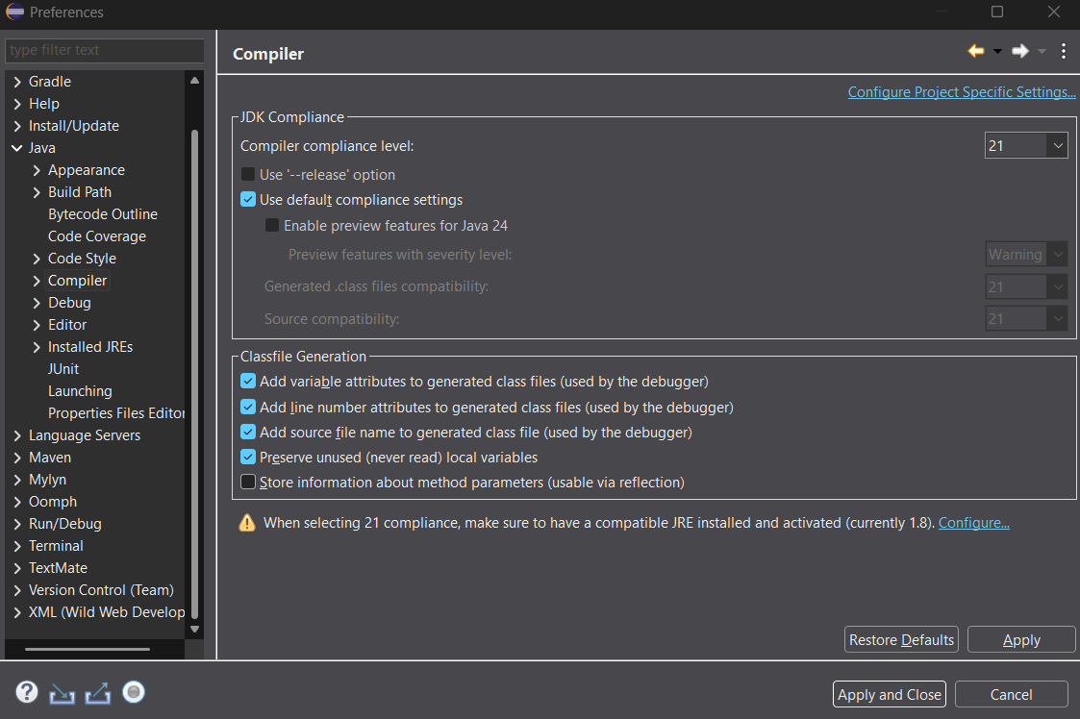
Step 24: If the “Use ‘--release' option” is checked, uncheck it. Then, in the drop-down menu for “Compiler compliance level”, select “1.8”:
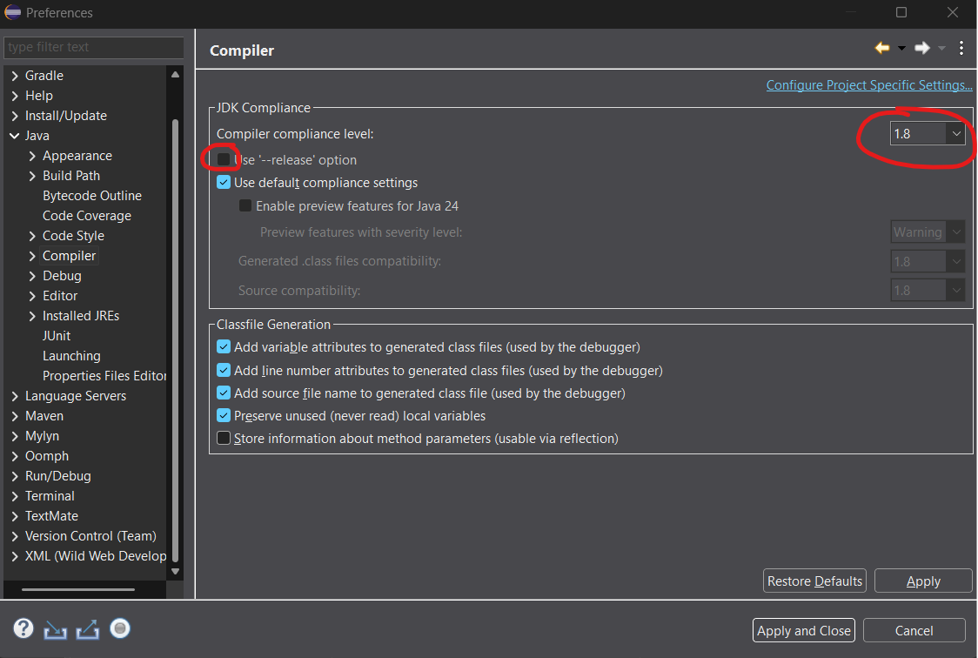
Step 25: Click the button “Apply and Close”:
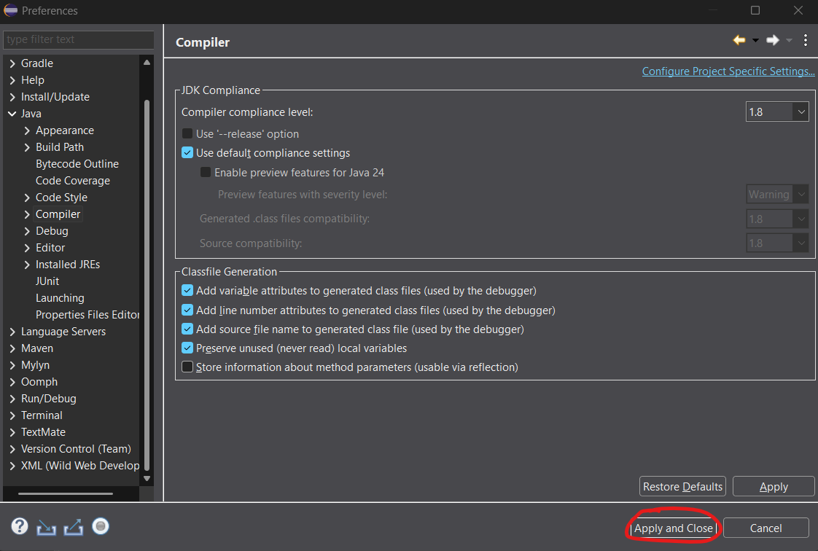
Now, your Eclipse should be all set up for Java programming!

Test That Eclipse Works
Step 26: Go to File > New > Java Project:
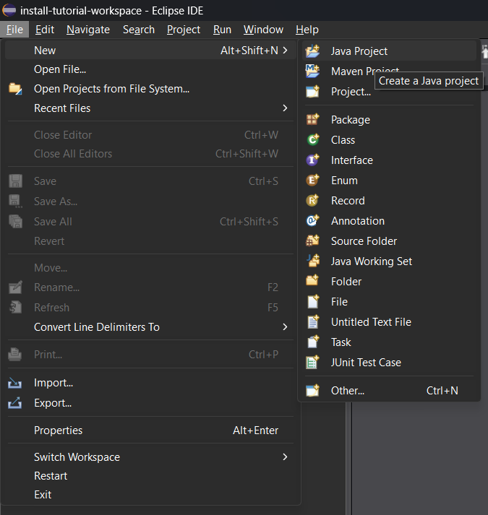
Step 27: A new window should appear. Give the new project a name, and make sure the correct JRE is selected. Then, click the “Finish” button:
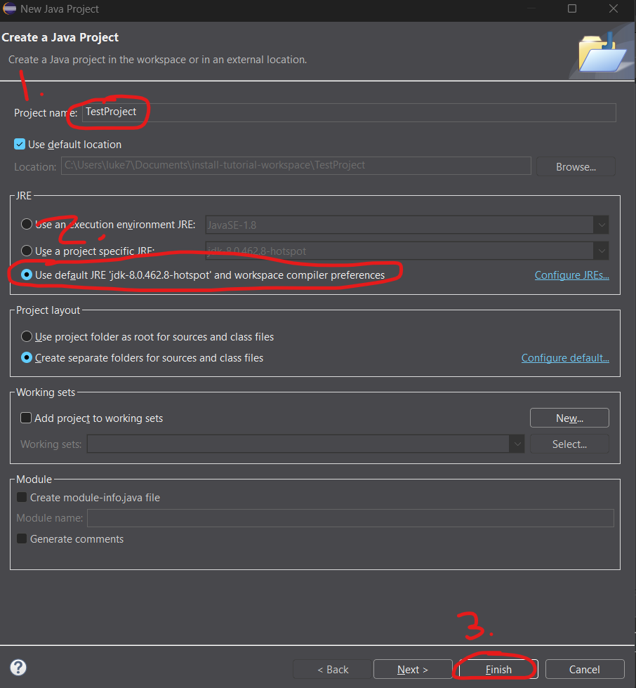
Step 28: Back in the main Eclipse window, in the left “Package Explorer” pane, drop down the project folder. Then, right-click the “src” folder and select New > Class:
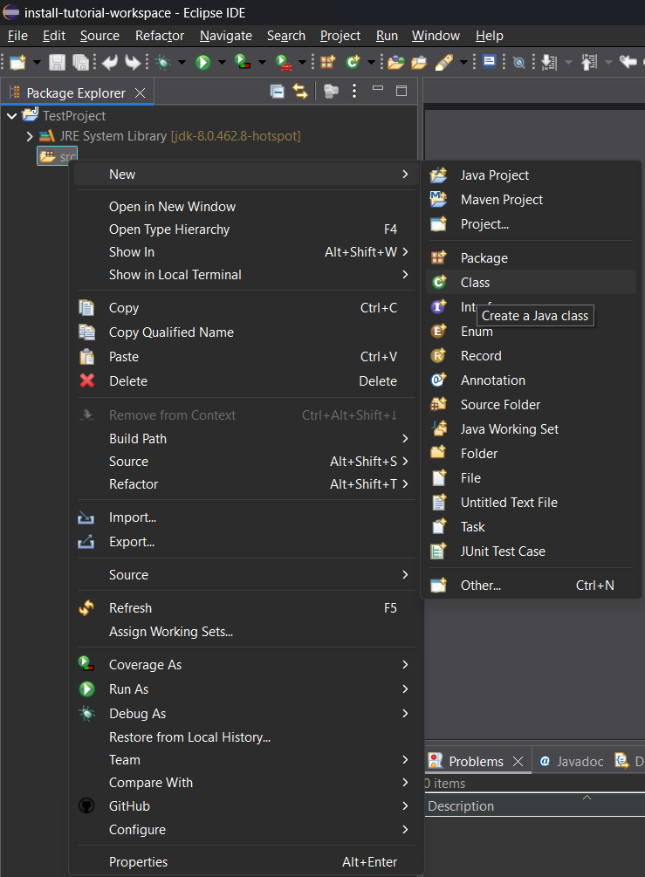
Step 29: In the new window that appears, give the class the name “Main”, check the checkbox next to “public static void main(String[] args)”, and click the “Finish” button:
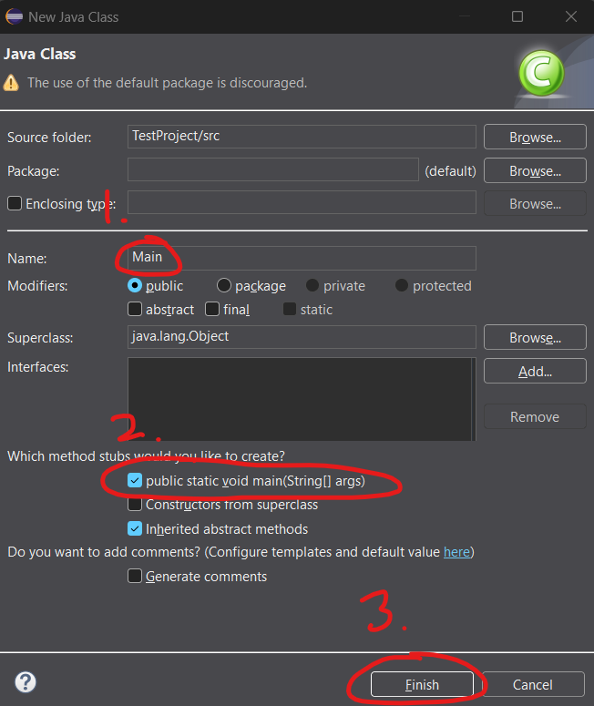
Step 30: The main Eclipse window should now look like this:
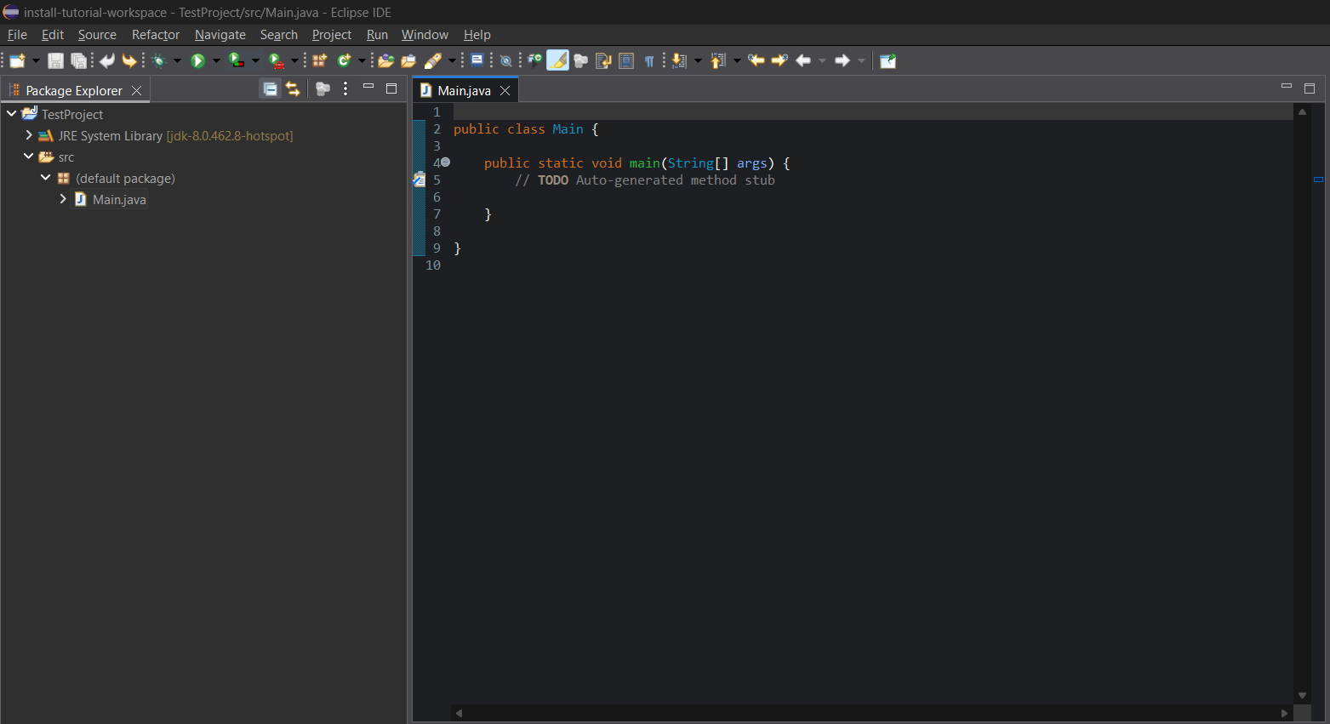
On the line below the line starting with “// TODO”, copy and paste the following line there:
System.out.println("Hello, World!");
So, your Main.java file should now look like this:
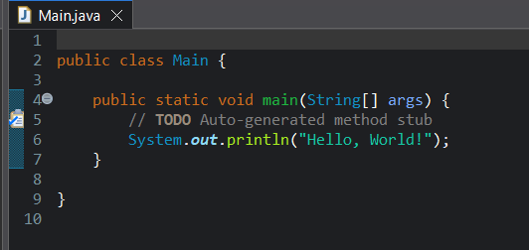
Step 31: Save the file (via File > Save) and click on the green “play” button at the top to run the program:
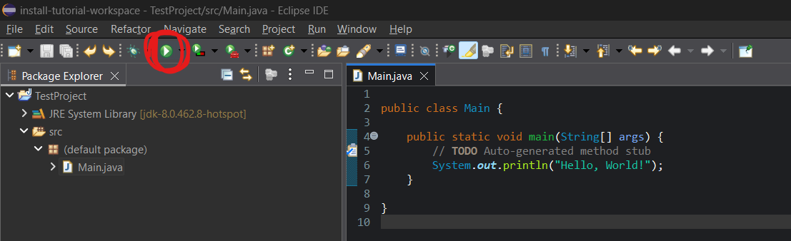
If you have done everything correctly, you should see a “Console” pane appear at the bottom of the window, showing the text “Hello, World!”:
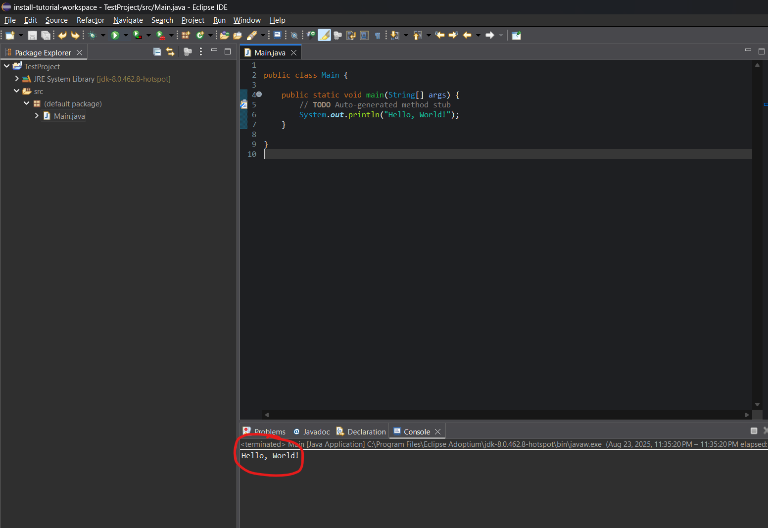

(Optional) Switch Between Light & Dark Themes
- In the main Eclipse window, go to Window > Preferences > General > Appearance:
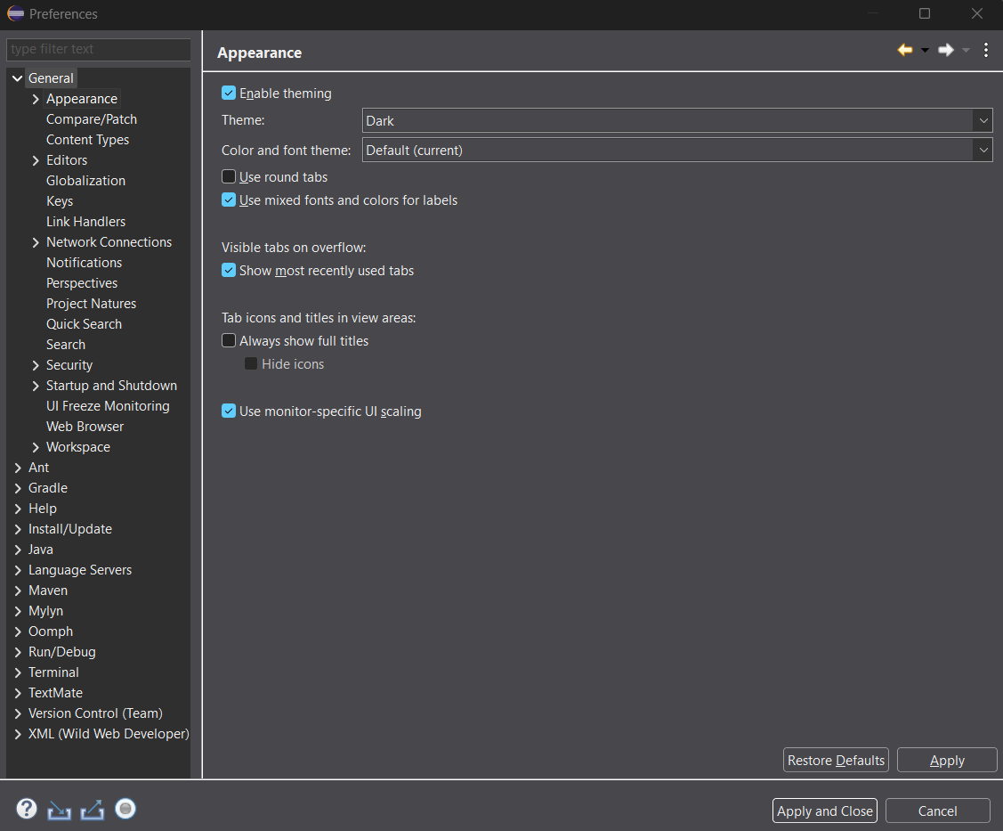
- Select the theme you desire in the drop-down menu associated with the “Theme” Field:
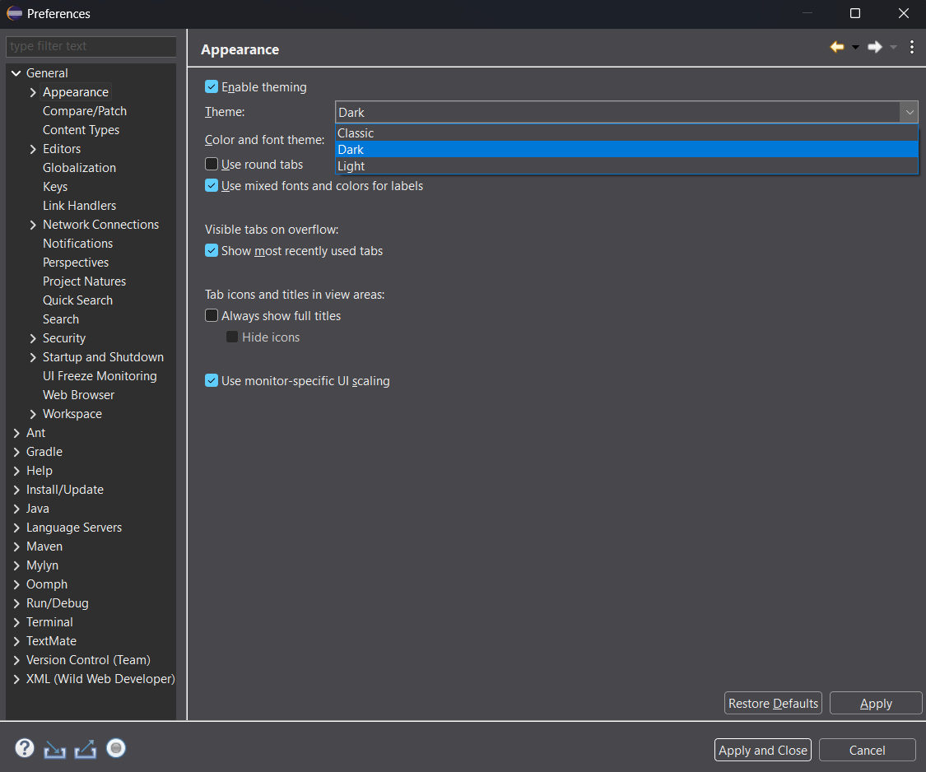

Having Trouble?
Feel free to reach out to the GTA (Luke Bushur, email: bushla03@pfw.edu) if you run into any trouble.

