*84* Ways To Find Equations Of Graphs*

T3 International Conference  
Dallas, Texas

Saturday, March 29, 2025  
11:10 am – 12:30 pm   
Level 2, Arts District 6

John LaMaster, National T³ Instructor  
Purdue University at Fort Wayne  
Department of Mathematical Sciences  
Fort Wayne, IN 46805  
[lamaster@pfw.edu](mailto:lamaster@pfw.edu)

Stuart Moskowitz, National T³ Instructor  
Cal Poly Humboldt   
Department of Mathematics, Retired  
Arcata, CA  95521  
[stuart@humboldt.edu](mailto:stuart@humboldt.edu)

Download this handout as a Word or PDF at [**https://users.pfw.edu/lamaster/technology/**](https://users.pfw.edu/lamaster/technology/)as well as the spreadsheet data and the lists used. You are encouraged to adapt these activities to best fit your students.  
*84 is used as a nominal number as opposed to cardinal.

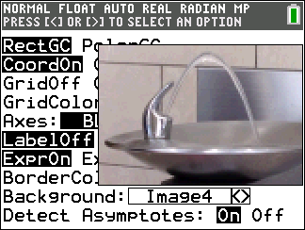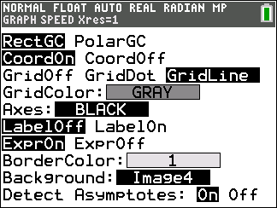**Activity 1: Use an image and QuickPlot&Fit-EQ to create an equation; then use a grid to create additional equation models and compare representations**

1. Prepare your calculator as follows

**a**. Press y..  
Use arrow keys to select each  
and then press Í:

* + GridLine
  + GridColor: Gray
  + Background: Image4

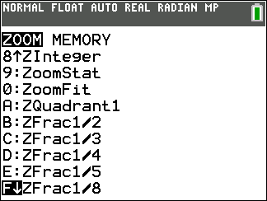**b**. Press q.

* Select ZoomFrac1/8 (press }}) and press Í to display a  
  preset window which is ***friendly*** (pixels are D*x* = Dy = {"mathml":"<math style=\"font-family:stix;font-size:9px;\" xmlns=\"http://www.w3.org/1998/Math/MathML\"><mstyle mathsize=\"9px\"><mfrac><mn>1</mn><mn>16</mn></mfrac></mstyle></math>","origin":"MathType for Microsoft Add-in"} apart   
  when the arrow keys are pressed as you navigate across the screen)   
  as well as ***square*** (producing a true geometric perspective.)
* If GridLine is selected, a square window with Xscl = Yscl will  
  display a square grid instead of an oblong rectangular grid.

**c**. Assume the path of the water fountain passes through (2, 0) and has an axis of symmetry *x* = −1.  
Complete the boxes in the coordinates below with integers. Utilize symmetry.

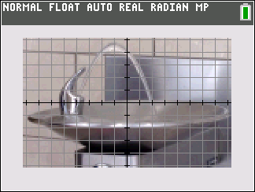

**( __ , __ )**

**(2, 0)**

**( __ , __ )**

**( __ , __ )**

***x* = −1**

1. 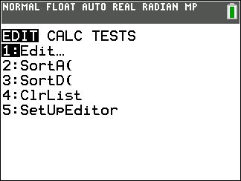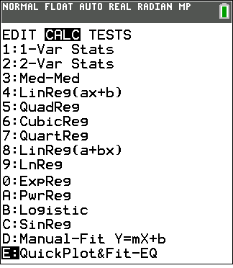The equation of the parabola can be found using analytical techniques given its zeros and additional points in factored form *y* = *a*(*x*−*r*)(*x*−*s*), but we can also use QuickPlot&Fit-EQ to create the equation as follows:  
   **a.** Press …. Use the right arrow~ and the up arrow } to select QuickPlot&Fit-EQ and press Í.

1. 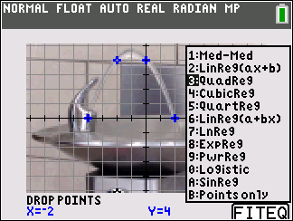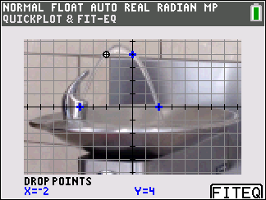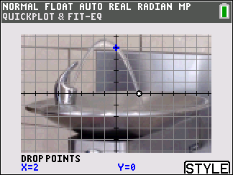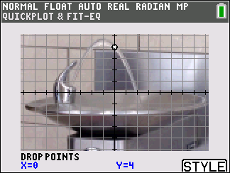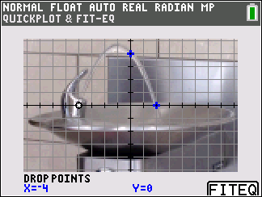Use the arrow keys to move your cursor to the four points shown in Question **1c**, pressing Í to drop points.   
   Be sure to drop points on the integer values.
2. Press the hard s key to select the FITEQ. Then select 3: QuadReg.
3. 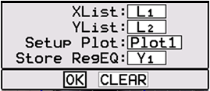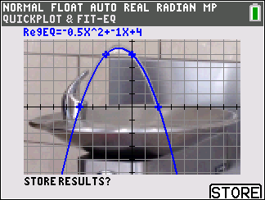Press the   
   hard s key   
   to select .
4. On the pop-up spinner select OK.   
   Press Í.
5. For this window, use what you know about quadratics to find equations in each form using the templates below.

Factored form: *y* = (*x* − )(*x* + )

Vertex form: *y* = (*x* − )2 +

If you enter these equations into Y2 and Y3, you can check your equations are equivalent by comparing coordinates in both the graphs and tables.

1. 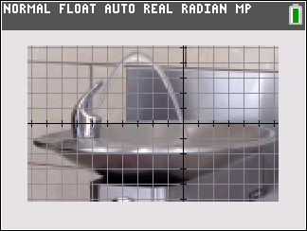Suppose we shift the axeshorizontally to the right 2 units so that the water   
   falls through the origin as in the image to the right.
2. Deselect any equations. Turn off Plot1.

* Press o and sit your cursor on top of the equals sign.
* Press Í to deselect.

**b.** Shift the axes horizontally.

* Use Xmin = −10.25, Xmax = 6.25.
* 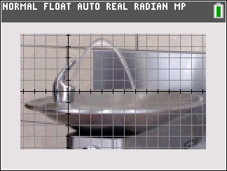Alternatively, you could also subtract 2 from Xmin and Xmax in the ZFrac1/8 window.  
    
  Report the equations of the parabola for this set of axes in both factored form and vertex form below in Question **6**.

1. Suppose we reset the window to ZoomFrac1/8, then shift the axes horizontally   
   to the left 4 units so that the water rises through the origin as shown to the right.
2. Deselect any equations as in **3a**.
3. Shift the axes horizontally.

* Use Xmin = −4.25, Xmax = 12.25.
* 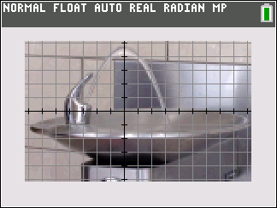Alternatively, you could also add 4 to Xmin and Xmax  
   after resetting the ZFrac1/8 window***.***  
    
  Report the equations of the parabola for this set of axes in both factored form and vertex form below in Question **6**.

1. Suppose we reset the window to ZoomFrac1/8, then shift the axes horizontally  
   so that *x* = 0 is the axis of symmetry.   
     
   **a.** Deselect any equations as in **3a**.
2. Shift the axes horizontally.
   * Use Xmin = −7.25, Xmax = 9.25.
   * Alternatively, you could also add 1 to Xmin and Xmax

in the ZFrac1/8 window.

Report the equations of the parabola for this set of axes in both factored form and vertex form below in Question **6**.

**6.** Compare the formulas in Questions **2e**, **3**, **4**, and **5**.   
Equations in original ZoomFrac1/8 window in **2c**: *f(x)* = ___(*x* − __ )(*x* + __ ) = ___(*x* + __ )2 + ___

Equations in ZoomFrac1/8 window shifted right 2 in **#3**: *y* = _________________ = ________________

Equations in ZoomFrac1/8 window shifted left 4 in **#4**: *y* = _________________ = ________________

Equations in ZoomFrac1/8 window shifted left 1 in **#5**: *y* = _________________ = ________________

1. **a.** Which choice of axes do you prefer? Why?  
   **b**. What parameters are *the same* in each of your equations? Why would this be reasonable?   
    For the parameters that are the same, indicate what each represents in terms of the graph.

***We chose this viewing window to demonstrate how QuickPlot&Fit-EQ can give us the same results as an analytical approach. When analytical techniques are less practical (we rarely get nice integer values for sample data points), QuickPlot&Fit-EQ can still be used!***

**Activity 2: Use DList to find *and* create equations**

The following growth chart for U.S. boys is available for download at <https://www.cdc.gov/growthcharts/cdc-charts.htm>  
(Similar charts are available for girls, for newborns to 2 year olds, and for other countries. We picked U.S. boys for the  
purpose of **Activity 4.**)

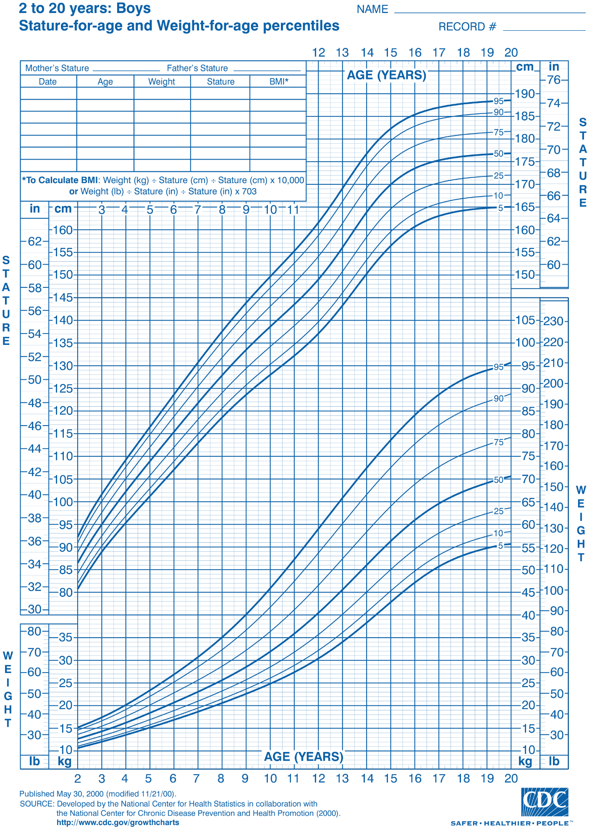

You can download the data to produce the smooth curves at <https://www.cdc.gov/growthcharts/cdc-data-files.htm>.  
See the **Appendix 2** of this handout to import a .csv file to your graphing calculator as a list or a matrix. Once it is in a list, we can send the data to a set of calculators following the steps in **Appendix 3**.   
Press … 1:Edit to view the data for a boy’s height (cm) vs age (months) in the **95th percentile**.

From the CDC Website: “1.5 months represents 1.0-1.99 months or 1.0 month up to but not including 2.0 months of age.”

1. 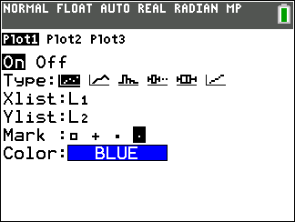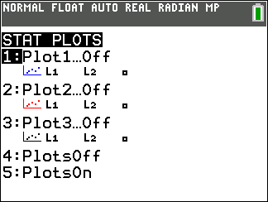Once you have the data in your TI-84CE, display a plot of age (months) in L1 and height (cm) in L2 for males in   
   the 95th percentile.

* Press y., turn off gridlines and   
  background image, and clear all   
  equations in the o menu.   
  Alternatively, perform a   
  “soft reset” as shown in the **Appendix 1**.   
  If you do a soft reset regularly, the  
  following may become familiar:   
  “ y L ¬ Á Á.”
* Press y ,.
* 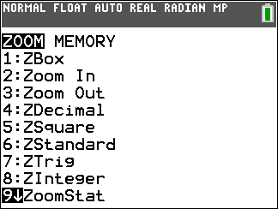Press Í to select Plot 1.
* 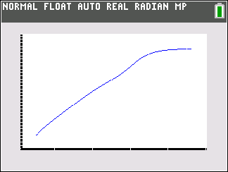Turn Plot 1 on and select a Mark.
* Press q.
* Select 9: ZoomStat.
* Press Í.

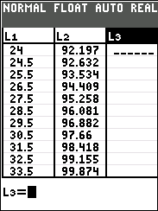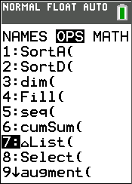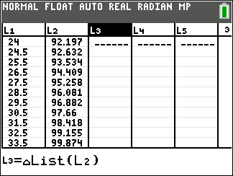When working with students, you may wish  
to ask students to manually set the window   
based on the graph on the growth chart on  
the previous page.

1. Create the list L3 = DList(L2).   
     
   Method 1: Use the Stat Editor

* Press … 1:Edit
* Sit your cursor on the top of L3.
* Press Í.
* Press y 9.
* Press the right arrow ~ to OPSand select 7:DList(
* 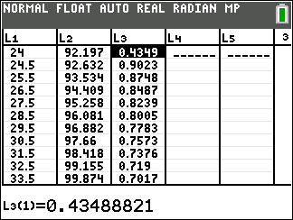Press y e to select L2.
* Press Í.  
    
  Method 2: Use the ¿ Command on the Calculator Home Screen
* Press y 5 to go to the calculator home screen.
* Press y 9. Press the right arrow ~ to OPS and select 7:DList(
* 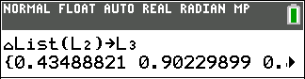Press y e ¤ to select L2. Press ¿.
* Press y f ¤ to select L3. Press Í.

1. **a.** What are the units of the data in L3?   
   **b.** Suppose we created the list L4 = DList(L1). What would be the units of the data in L4?

**c.** Suppose we created the list L5 = L3/L4. What would be the units of the data in L5? Discuss what L5 represents.

1. 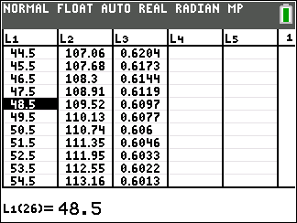From the CDC: “1.5 months represents 1.0-1.99 months or 1.0 month up to but not including 2.0 months of age.”  
   This means, for this data set, 48.5 months   
   represents the data for a 4 year old boy.  
   In the 95th percentile, how fast is a boy at that age growing?   
   Report to 2 decimal places.   
   **a.** ______ cm per month or _____ in per month or ______ ft per month.  
   **b**. ______ cm per year or _____ in per year or ______ ft per year.

TIP: As a reference, typical smart phones are about 7 – 8 cm wide or   
the length of three U.S. quarters that are placed side by side.

1. 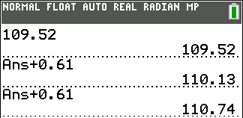The Last Answer (Ans) command allows you to reuse the result of the most recent calculation in subsequent operations. It is automatically updated with each press of the Í key. Use the calculator home screen and the last Answer command to create a recursive formula modeling the monthly growth of a boy in the 95th percentile starting at age 4.

* Press y 5 to go to the calculator home screen.
* Type 109.52 Í for the initial output.
* Press yZ Ã 0.61 Í to build the expression.
* Continue to press Í repeatedly.

Doing the above enables us to build a table of ***outputs*** on the calculator home screen.   
Wouldn’t it be awesome to include the ***inputs*** as well? See the next item.

1. To create a table on the HOME SCREEN of both inputs and outputs, use a list.

* 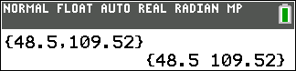Press y 5 to go to the calculator home screen if not there already.
* Press y E 48.5 ¢ 109.52 yF Í for the initial row.

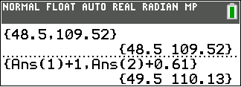

* Type the next row as shown at right. Press Í.
* 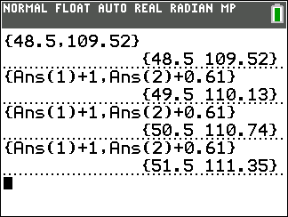****Continue to press Í repeatedly.
* Compare with   
  the data in L1 and L2.

Write this as a set of   
 recursive equations:

*h*1 *=* ________  
 *hn+*1 *= ________*

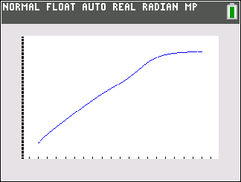

1. Press o and enter an equation that represents the monthly growth chart,   
   in cm, of a boy in the 95th percentile.
2. Report your equation: *y* = (*x* − 48.5) +
3. 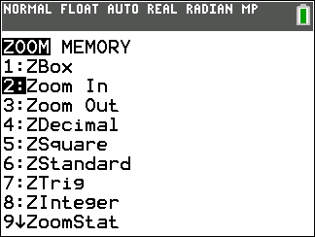Zoom in to explore the goodness of fit:

* Press q 2: Zoom In.
* 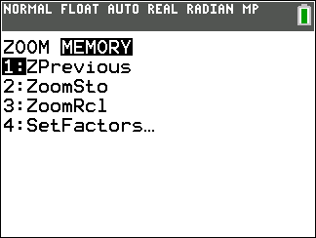Move your cursor so it’s anywhere on the scatterplot and press Í. This will be the center of the new viewing window.

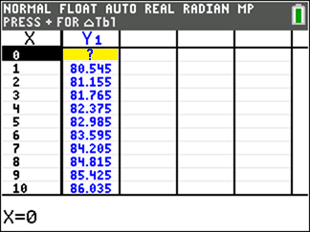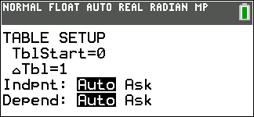 Press q 9: ZoomStat Í to return to the previous window.  
 Or you can use the right arrow and press 1: ZPrevious.  
   
   
  
  
  
  
  Press y-to make the table settings as follows:

Press y0 to get a numerical look at this model.  
  
 Use your table to complete the boxes.

Report your equation: *y* = *x* +

**c**. Discuss how good the equation fits the data by completing the boxes in the statement below with integers.  
  
 The model fits the data very well for ages years ( months)

to

years ( months).

**Activity 3: Robert Wadlow, “The Alton Giant”(1918-1940)**

**The Tallest Man Who Ever Lived**

(Guinness Book of World Records & <http://www.altonweb.com/history/wadlow/>

<https://www.youtube.com/watch?v=UqqFc7ggU40> (71 seconds)

<https://www.youtube.com/watch?v=OhtHIB-FK44> (2.5 minutes)

https://www.youtube.com/watch?v=Q8tsfEBOUP4 (32 seconds)

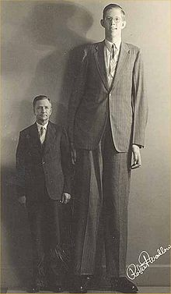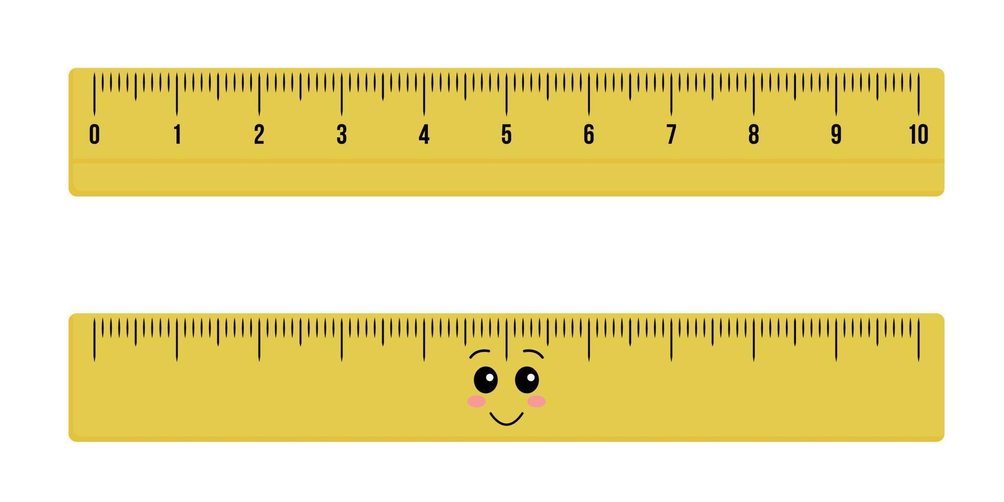

Robert Wadlow with his father. Harold Wadlow.   
Harold is 5’ 11.5”. How tall is Robert?

How old was he when this picture was taken?

Hint: Use proportional reasoning to determine his height.

Robert Wadlow was born in Alton, Ohio. According to the [altonweb website](http://www.altonweb.com/history/wadlow/), his abnormal growth rate was caused by an overactive pituitary gland that produced too much growth hormone. Because of his weight, he needed special braces on his legs. An infection caused by chafing of the braces led to an early death at age 22. It is not likely this height record will ever be broken because there now is medication to control this condition.

You can acquire the following data at <https://guinness-world-records.fandom.com/wiki/Robert_Wadlow#Height_chart>

|  |  |  |
| --- | --- | --- |
| **Age** | **Height** | **Size of** |
| Birth | 1 ft 8 in (0.51 m) | Average newborn |
| 6 months | 2 ft 10⅟2 in (0.88 m) | 2-year-old |
| 1 year | 3 ft 6 in (1.07 m) | 5-year-old |
| 18 months | 4 ft 3⅟4 in (1.30 m) | 8-year-old |
| 2 years | 4 ft 6⅟4 in (1.38 m) | 10-year-old |
| 3 years | 4 ft 11 in (1.50 m) | 12-year-old |
| 4 years | 5 ft 3 in (1.60 m) | 14-year-old |
| 5 years | [5 ft 6⅟2 in (1.69 m)](https://guinness-world-records.fandom.com/wiki/Robert_Wadlow#cite_note-:4-17) | 15-year-old |
| 6 years | 5 ft 7 in (1.70 m) | Height of average adult male (global average). |
| 7 years | 5 ft 10 in (1.78 m) | [Height of average adult male in the United States.](https://guinness-world-records.fandom.com/wiki/United_States) |
| 8 years | [6 ft 0 in (1.83 m)](https://guinness-world-records.fandom.com/wiki/Robert_Wadlow#cite_note-:5-18) | Height of average adult male in the Netherlands. |
| 9 years | [6 ft 2⅟2 in (1.89 m)](https://guinness-world-records.fandom.com/wiki/Robert_Wadlow#cite_note-:5-18) |  |
| 10 years | [6 ft 5 in (1.96 m)](https://guinness-world-records.fandom.com/wiki/Robert_Wadlow#cite_note-:6-20) |  |
| 11 years | 6 ft 11 in (2.11 m) |  |
| 12 years | [7 ft 0 in (2.13 m)](https://guinness-world-records.fandom.com/wiki/Robert_Wadlow#cite_note-21) |  |
| 13 years | [7 ft 4 in (2.24 m)](https://guinness-world-records.fandom.com/wiki/Robert_Wadlow#cite_note-:7-22) |  |
| 14 years | 7 ft 5 in (2.26 m) |  |
| 15 years | 7 ft 10 in (2.39 m) |  |
| 16 years | [8 ft 1⅟4 in (2.47 m)](https://guinness-world-records.fandom.com/wiki/Robert_Wadlow#cite_note-24) |  |
| 17 years | [8 ft 3 in (2.51 m)](https://guinness-world-records.fandom.com/wiki/Robert_Wadlow#cite_note-:8-25) |  |
| 18 years | 8 ft 4 in (2.54 m) |  |
| 19 years | [8 ft 6⅟2 in (2.60 m)](https://guinness-world-records.fandom.com/wiki/Robert_Wadlow#cite_note-:3-9) |  |
| 20 years | 8 ft 7⅟4 in (2.62 m) |  |
| 21 years | [8 ft 8 in (2.64 m)](https://guinness-world-records.fandom.com/wiki/Robert_Wadlow#cite_note-:9-26) |  |
| 22.4 years | [8 ft 11.1 in (2.72 m)](https://guinness-world-records.fandom.com/wiki/Robert_Wadlow#cite_note-27) |  |

1. 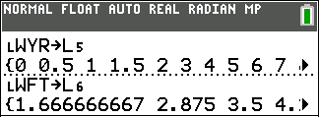The above data can be typed directly into the lists, or you can create a CSV file from the data on the website and send it to students’ calculators. We sent this data to you in list ÙWYR, years, and list ÙWFT, feet, created from the CSV file.   
   Using years and feet has an advantage of familiarity to our standard units.

For convenience, copy the data sent to you into lists L5 and L6.

1. 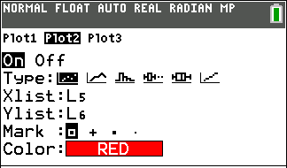Create a plot of the data in Plot 2.

* Clear all data in the Y= menu.
* Press y ,.
* Press Í to select Plot 1. Select Off to turnoff Plot1.
* 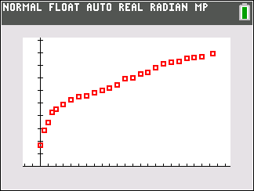Select Plot2. Select On. Then change Xlist and Ylist to L5 and L6. For Type, select the scatterplot icon.
* Select a Mark.
* Choose an appropriate Window or

Press q. Select 9: ZoomStat. Press Í.

* Adjust the window if desired so both axes are displayed.

1. From age 2 until he died at 22, the data points lie almost in a straight line. What does this imply?   
   What does this tell us about Wadlow’s rate of growth? (i.e. what function family is most representative   
   of the shape of the scatterplot?)
2. Explore all the ways can you find a linear equation that model’s Wadlow’s growth from age 2.

* algebraically using appropriate coordinates.
* using regression analysis.
* using Quickplot&Fit-EQ
* using Manual-Fit.

1. Interpret the slope of this line of best fit. What does it tell you about Robert Wadlow?
2. Use your equation to predict Wadlow’s height if he’d lived to be 25. How about 35?

1. Predict if and/or when he would reach 10 feet tall.
2. Interpret the *y*-intercept for this model. What does it imply about Wadlow? Is this a reasonable assumption?   
   If not, does it mean the model is not a good model? Why or why not?
3. Critique the claim on the Website <https://guinness-world-records.fandom.com/wiki/Robert_Wadlow> at age 13:  
   “World's tallest Boy Scout, averaging a growth of 4 inches (10 cm) per year since birth.”

**Activity 4: How Does Wadlow’s Growth Chart Compare   
to a Boy in the 95th Percentile in the United States?**

1. 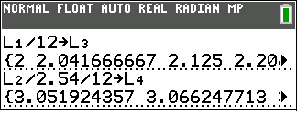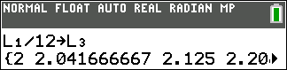To show both Wadlow’s yearly height and the height of a boy   
   in the 95th percentile, we must convert units.   
   One option is to convert L1 and L2.  
     
   **a**. Convert months in L1 to years and store in L3.   
     
     
   **b.** Convert cm in L2 to feet and store in L4.

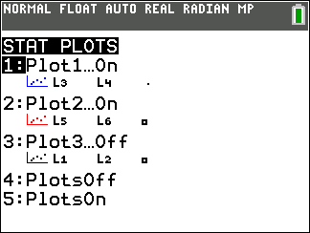   
  
  
**c.** Press y ,.

* Press Í to select Plot 1. Select On.
* Then change Xlist and Ylist to L3 and L4.
* Press q. Select 9: ZoomStat.

1. Answer the question in the title of this activity.

**Answers to Activity Questions**

**Answers to Activity 1**   
**1c**. These coordinates are shown in step **2b**.  
**2f**. *y* = −0.5(*x* − 2)(*x*+4)  
 *y* = −0.5(*x*+1)2 + 4.5  
**6.** Equations in original ZoomFrac1/8 window in **2c**: *f*(*x*)= −0.5(*x* − 2)(*x* + 4) = −0.5(*x*+1)2 + 4.5

Axes in ZoomFrac1/8 window is shifted right 2 in **#3**: *y* = −0.5(*x*)(*x* + 6) = −0.5(*x*+3)2 + 4.5 = *f*(*x*+2)

Axes in ZoomFrac1/8 window is shifted left 4 in **#4**: *y* = −0.5(*x*− 6)(*x*) = −0.5(*x*−3)2 + 4.5 = *f*(*x*−4)

Axes in ZoomFrac1/8 window is shifted left 1 in **#5**: *y* = −0.5(*x*− 3)(*x+*3) = −0.5(*x*)2 + 4.5 = *f*(*x*−1)

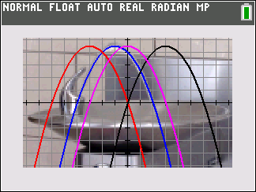

***f*(*x*)**

*f*(***x*+2**)

*f*(***x*−1**)

*f*(***x*−4**)

**7a.** The choice of axes is personal taste, but in practice, translation of the axes can significantly simplify a problem  
and its resulting equation. Typically a favorite choice is to have the vertex of the parabola located on the *y*-axis.

**7b.** Each equation has the same **leading coefficient**, −0.5. This value is the **compression factor** of the parabola.   
This is reasonable since each parabola **has the same shape**.   
In vertex form *y* = *a*(*x*−*h*)2 + *k*, each equation has the **same *k* value**, 4.5. This value is the **maximum height** of the parabola. This is reasonable since each parabola was only **translated horizontally** and not vertically

**Answers to Activity 2**  
**3a.** The data in L3 is the differences in successive heights, the units are cm.  
**3b.** The data in L4 is the differences in successive ages, the units are months  
**3c.** The data in L5 is the average rate of change of the boy’s height, in cm per month.  
**4a**. 0.61 cm per month or 0.24 inches per month or 0.02 ft per month.  
**4b**. 7.32 cm per year or 2.88 inches per year or 0.24 feet per year.  
**6.**  We can write this as a set of recursive equations: *h*1 *=* 109.52   
 *hn+*1 *= hn* + 0.61

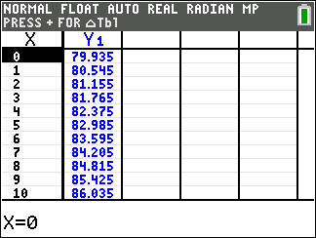**7a**. *y* = 0.61(*x* − 48.5) + 109.52

**7b.** *y* = 0.61*x* + 79.935

**7c**. The model fits the data very well for ages 3 years (36 months) to 8 years (96 months)

**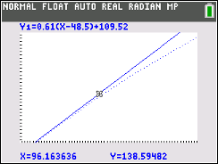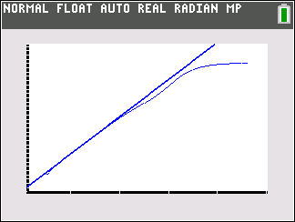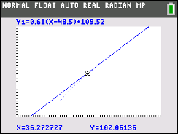**

Extrapolation of the linear model to a birth height of 79.935 cm ≈ 31.47 inches ≈ 2.6 feet would be science fiction.

**Answers to Activity 3**   
  
**3**. It implies that his growth rate is linear. It implies that he grew at a constant rate.

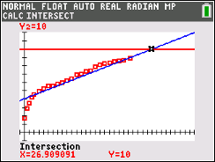**4.** algebraically, using *f*(2) and *f*(22.4), we get *f*(*x*)=0.22(*x*-2) + 4.52

**5.** Wadlow grew at an average rate of 0.22 feet per year (2.64 inches/year)

**6.** *f*(25) = 9.58 feet tall *f*(35) = 11.78 feet tall.

**7.** We can solve this graphically by graphing Y2 = 10, by adjusting the window settings and then using CALC to find the intersection of the two graphs. Using our model, Wadlow would’ve been 10 feet tall at age 26.9

Window: [-1, 36] by [-1,12]

1. 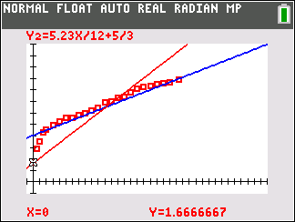The *y*-intercept of the model implies that Wadlow was 4.52 feet tall at birth. No, it is not a reasonable assumption (just ask any mother). The model is still a good model, but it applies only between ages 2 and 22. This is a great example of the dangers of using models to simulate data. We must be careful about extrapolating beyond the domain of the given data.
2. Not sure where they got this result. If we assume a linear rate of growth from 0 to 13, he grew 68 inches in 13 years. This is about 5.23 inches per year (so Guinness’s claim of 4 inches per year actually is too little). It’s important to note that at birth his height was normal (20 inches), but he grew during his first 2 years at an especially fast rate. (17 inches per year). We can create the equation of a line with slope 5.23/12 ft per year through (0, 5/3) to compare this model with the data.

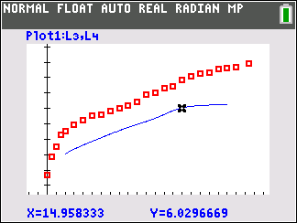  
**Answers to Activity 4**

1. Between ages 2 and 15, his growth rate is about average (note that the graphs of Wadlow and a boy in the 95th percentile are almost parallel between ages 2 and 15).

**Appendices**

**Appendix 1: Perform a “Soft Reset” on Your TI-84 Plus Family Calculator**

A“soft reset” (also called Resetting Defaults) restores your calculator to the original settings it had when you first took it out of the box, but it will not delete any stored data (equations, lists, programs, etc. )

* Mode settings
* Y= Functions off
* Plot settings off
* Viewing Window returns to standard [−10, 10] by [−10, 10]
* Format settings
* **rand** seed value set to 0

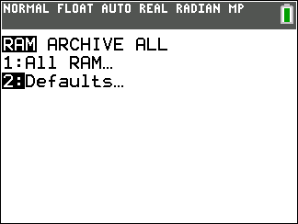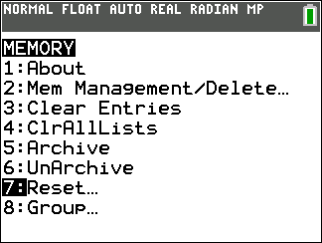Use a soft reset before beginning an activity if a previous class has used the same set of calculators.

1. Press y L .
2. Press ¬ to select **Reset…**  
     
   The three periods indicates that  
   this door has more behind it and is   
   not the end of the journey yet…
3. 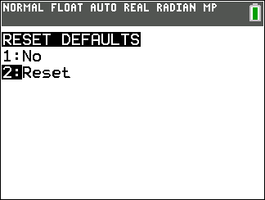Press Á to select **Defaults…**
4. Press Á to select **Reset**.

If interested in more, [here is a youtube video](https://www.youtube.com/watch?v=ZQkNsaR-dTs) about memory management.

**Appendix 2: Use TI-Connect to Import a CSV File and Convert to Lists**

You will need your standard-A to mini-B USB cable   
and TI Connect™ CE software (available for free at  
 [education.ti.com](http://education.ti.com/en/us/home)).   
  
1. Create (or download) a spreadsheet of data.   
 Be sure the following is true of your spreadsheet.

* Only decimal real numbers or integers are allowed. No complex numbers. No text in any cell.
* 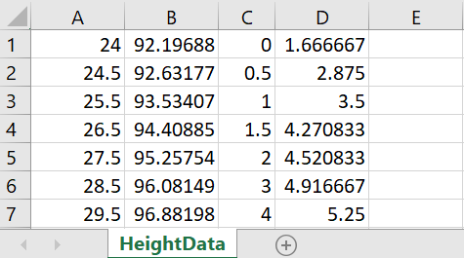No numbers can contain a comma.
* Data must start in cell A1.  
    
  **2.** Save your spreadsheet as a *.csv file.

1. Import as follows:
   * Connect the TI-84 Plus CE to the computer using the standard-A to mini-B USB cable.
   * Turn on the graphing calculator.
   * Launch the TI Connect™ CE software on your computer.
   * 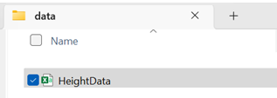Open the **Calculator Explorer** workspace.  
     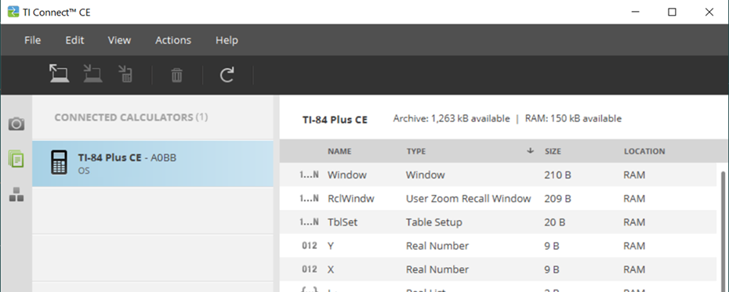
   * 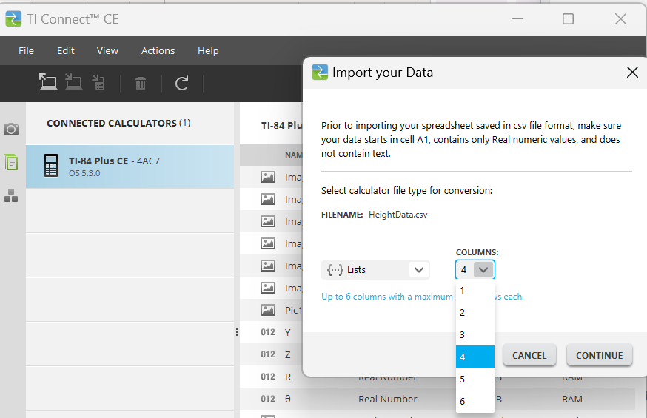Drag the spreadsheet into the **Calculator Explorer** workspace.   
     You can also import via the **Actions** > **Import Data (.csv) to List/Matrx**... menu.
   * Follow the prompts on the dialogue box   
     to specify how many columns are in the   
     spreadsheet.

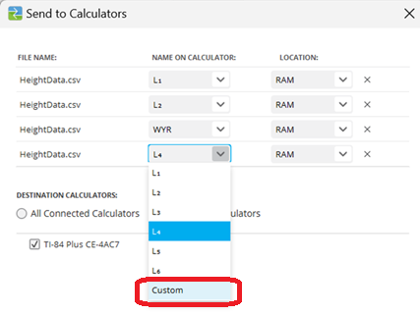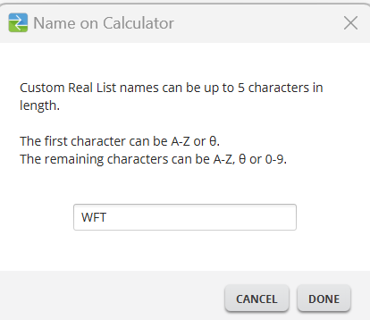

* + Decide which lists on the  
    calculator will receive   
    the data in each column.   
    You can use L1 through   
    L6 or named lists.

1. Click **Send.**

**5.** To save your lists that you created to the computer, drag the lists from the Calculator Explorer to the   
 desired computer location.

**Appendix 3: Use TI-Connect to Send Files from a Computer to a Set of Calculators**

The TI Connect™ CE software allows you to simultaneously connect multiple TI-8x graphing calculator as long as the   
calculator has a USB port. For calculators an I/O port only use TI Connect™ 4.0.

1. Connect the calculator(s) to the computer.

* Turn the calculator(s) on.
* Open the Calculator Explorer workspace. .   
  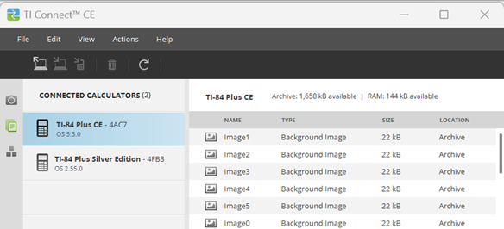
* Be sure the calculators appear in the Calculator List Panel. Notice they are not the same TI-8X model which is OK. If you don’t see a connected calculator on the Calculator List Panel, turn the calculator on.
* Be sure the Explorer Workspace icon  is selected.

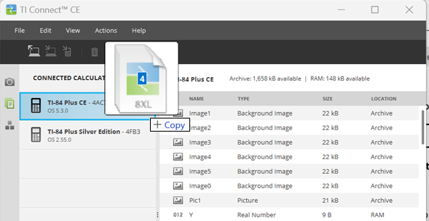

|  |
| --- |
| 1. Locate the desired file(s) on your computer.  For this workshop, we selected the four lists L1.8xl, L2.8xl, WYR.8xl, and WFT.8xl. 2. Drag the files to anywhere on the Calculator List Panel. 3. Release the mouse button when you see . |

|  |
| --- |
|  |

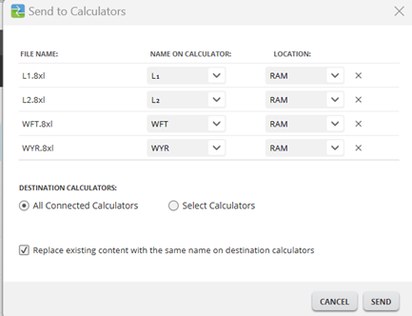

1. A dialogue box appears which enables you to   
   decide what to do with the files on the receiver’s

calculators.

1. Press **Send**.

**Appendix 4: Use Manual Linear Fit**

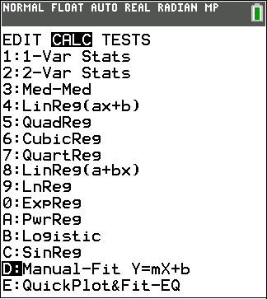Use the **Manual Linear Fit** to visually fit a linear function to a scatter plot. Some teachers have called this kind of model a“raw spaghetti” fit or an “eyeball” fit.

1. Once you have entered List data   
   and displayed the StatPlot,   
   select the Manual-Fit function.

* Press ….
* Use the right arrow~ and   
  the up arrow twice } } to   
  select **Manual-Fit Y = mX + b**
* 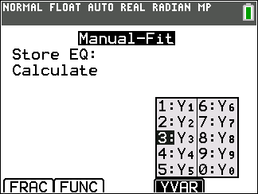Press Í.
* Press ƒa (above r ) to select an equation not in use.  
  For our example, we will select Y3.

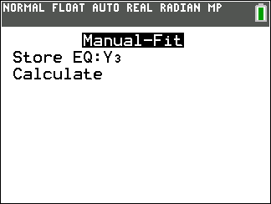

* Select **Calculate** and press Í.

1. 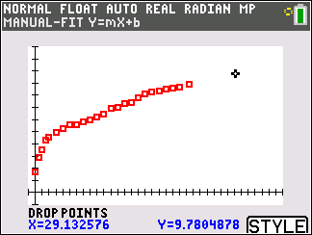You will be taken to the Graph Screen.
   * 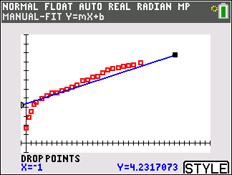Position your cursor to a point   
     on the line and press Í to   
     drop a point.
   * If you press the hard Graph key  
     you can use the pop-up spinner  
     to change the   
     for the color and thickness.
   * Position your cursor to a second   
     point on the line. Press Í to drop the second point.   
     You can adjust the line in the next step.
2. 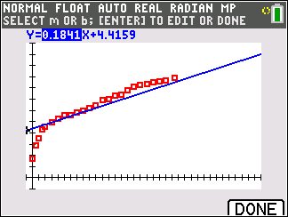The equation Y=mX+b is displayed.   
   The current value of **m** is highlighted in the equation. Notice Context Help.

* 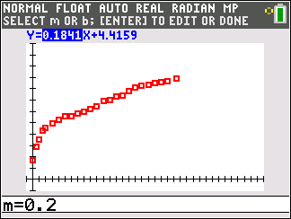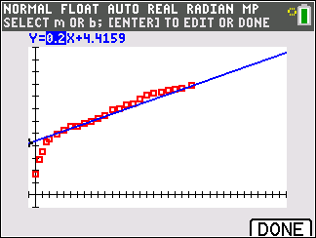Press Í and type   
  a new value of **m** if desired.
* 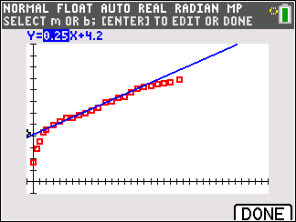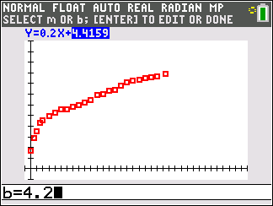Press Í to display  
  the new value of **m**.   
  The screen dynamically displays   
  the revised **m** or **b** value and   
  refreshes   
  the displayed graph.

1. Press the left | or right ~ arrow   
   keys to move from **m** to **b** and  
   adjust as in the previous steps until   
   you are satisfied. Then press the   
   hard Graph key to select   
   or press y 5 .

**Appendix 5: Data Sites for Exploration**  
  
With the help of an AI Chatbot from ChatGPT, we have [**HERE**](https://chatgpt.com/share/67e4507e-b874-8007-9936-4cb2bfcdf704) a compilation of links to sites containing real world data for exploration in middle and high school math curricula. This list is specifically for linear or exponential models, but change the prompt to find additional possibilities for activities.