Access to your Class on the eHW Website
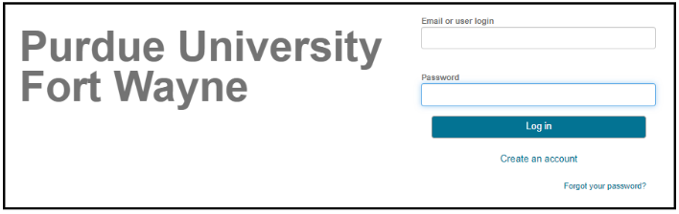
Getting to the eHW Site
To access eHW, click HERE or type https://pfw.mobius.cloud/login/ in your Web Browser.
Already Have an Account?
If you have already had previous access to Möbius,
enter your email and password to login.
If you forgot your password,
click on the words Forgot your password.
You will be prompted for the email
for your account, to which a
system generated password will be sent.
Once you login again you can change it
by clicking on your name in the top right corner and then click on Password Update.
Need an Account?
If you have not already had previous access
to Möbius, complete the following steps.
- Click on “Create an account.”
- If necessary, accept the terms of use.
- Complete the information (First Name, Last Name, Email, Password, Confirm Password).
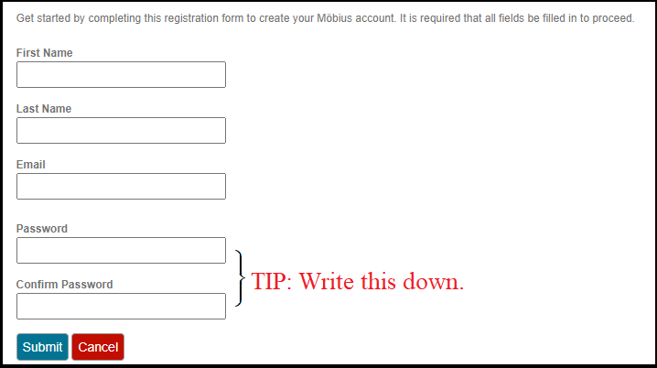
- Click or push Submit.
- You will receive an email to the address you provided above.
Confirm your email within 24 hours to complete the registration.

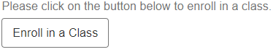
To access your section, push the button Enroll in a Class.
Select the course section, then push Enroll.
If you do not have a current license or your previous license expired, then once you login and complete the registration you will be presented with two possible choices.
You can click on the link that says temporary license or the button that says Pay Now.
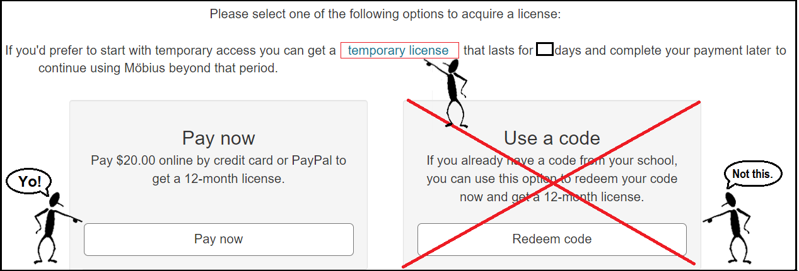
- For a Temporary License, please enter your email address, and then click on Pay later.
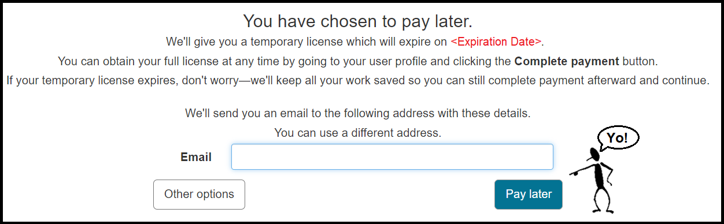
- If you click on Pay now you will be asked to enter your payment information.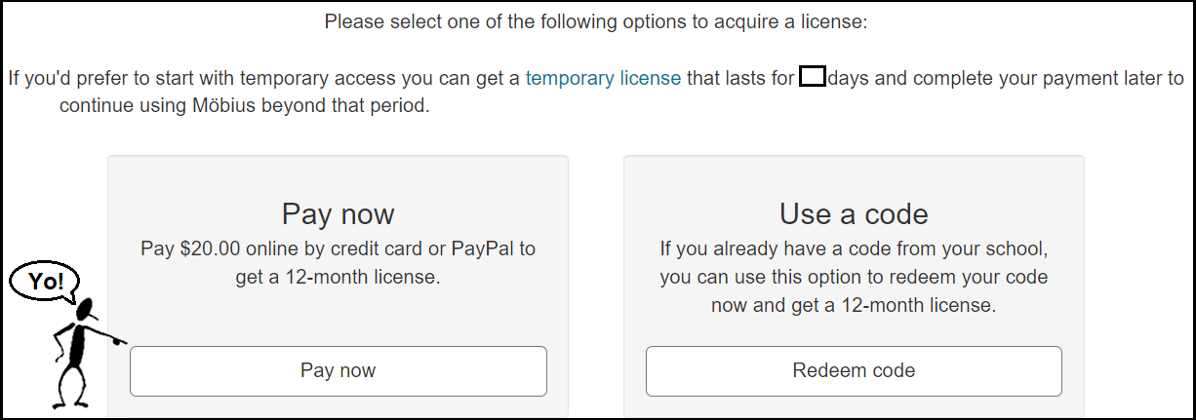

After clicking Pay now, follow the prompts to select your country and select Other for your state. (Indiana is not listed. The ones that are listed will charge you more.)
Click on one of the buttons to pay digitally through PayPal button or a Debit or Credit Card.
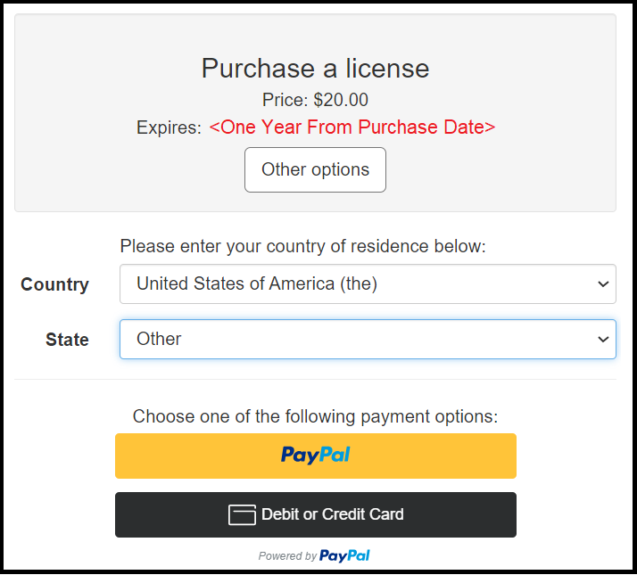
When paying by Debit or Credit Card, please be extra careful your email address is correct.
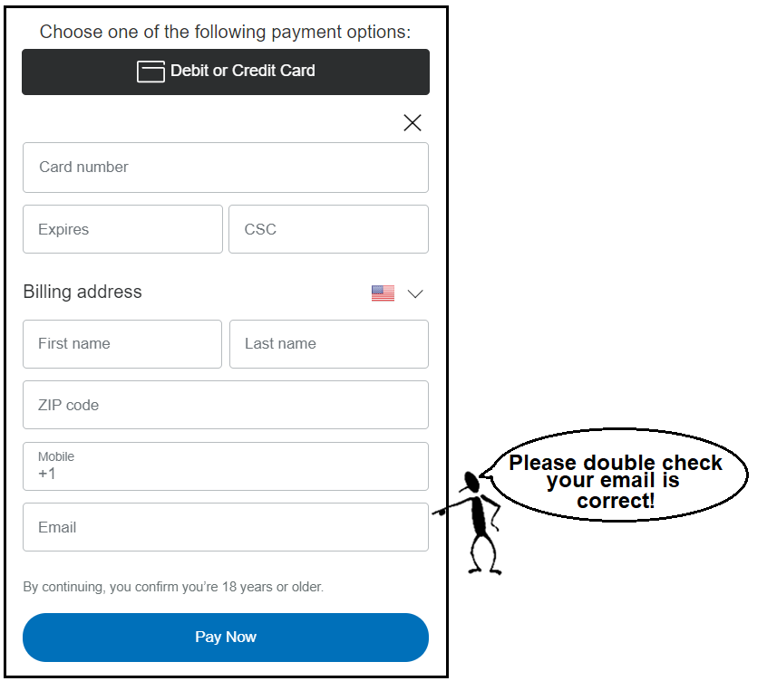

Troubleshooting – If the Purchase Is Unsuccessful
If you encounter errors, contact DigitalEd customer service at
1-833-450-2211 or email support@digitaled.com.
1. If you own a credit card and the purchase is not successful, call your credit card company.
The credit card company may have stopped the purchase to protect you,
thinking your card was stolen. Möbius is a purchase from Canada,
so it is not unreasonable that this small purchase may be suspicious to them.
2. Most debit cards are accepted but a small number have been known to have issues. You may try to call customer service at 1-833-450-2211 to give them your card number over the phone. If you do not have a credit card, then you could
- find someone who has a credit card and pay them cash to purchase the code on your behalf;
- go to http://www.paypal.com/ to set up a way to digitally transfer funds from a bank account.
3. In addition to contacting DigitalEd customer service at support@digitaled.com or calling
1-833-450-2211, you can also email ehwtechsupport@pfw.edu and describe the problem.

