Quarkles and Plumbdads Exercise

**For this exercise, assume that quarkles/plumbdads are observable, meaningful physical properties.** Abbey and Bernard are trying to determine if a relationship exists between “plumbdads” and “quarkles” (which are measured in units of mimfs and maloneys respectively). The equipment they have allows them to vary the plumbdads in 1 mimf increments. Abbey and Bernard then produce the following table and graph by varying the number of plumbdads (keeping all other variables the same throughout the experiment) and recording the measured number of quarkles. Due to the precision of the equipment, each quarkle measurement may be off by as much as 0.15 maloneys.

|  |  |
| --- | --- |
| Plumbdads (mimfs) | Quarkles (maloneys) |
| 0 | 0.00 ± 0.15 |
| 1 | 2.01 ± 0.15 |
| 2 | 4.10 ± 0.15 |
| 3 | 6.05 ± 0.15 |

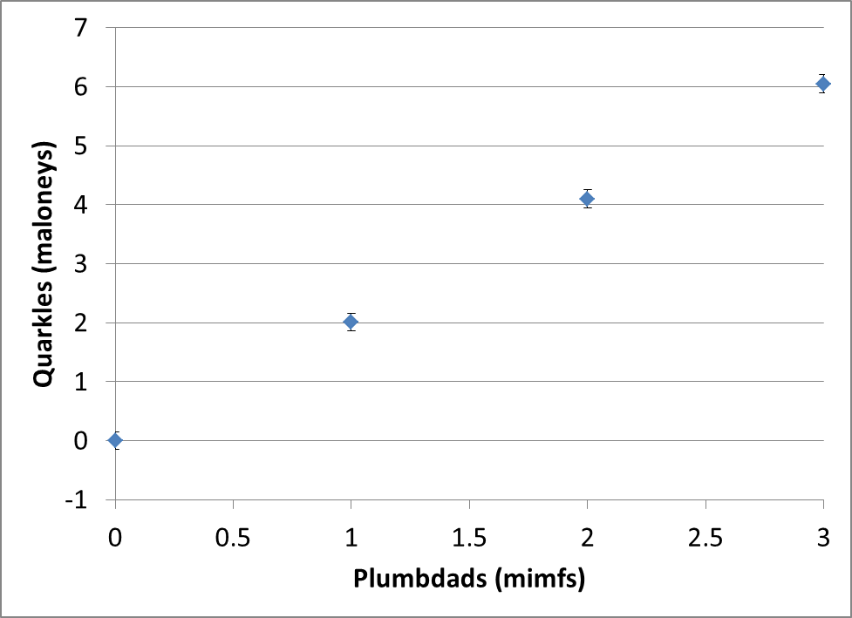

1. Figure out a mathematical relationship (i.e., a model) that predicts the quarkles amount for a given plumbdad amount. Make an argument that your model is a good representation of the known data at this time. (If you are stuck, what value of quarkles would you predict if you started with a plumbdad amount of 1.5 mimfs? If you can make a prediction, explain what you did to make that prediction.)
2. Bernard explains to Abbey that he is a former Rhodes Scholar and has studied abroad. He has taken advanced courses in mathematics and this enabled him to develop a different relationship between quarkles and plumbdad. Bernard explains that if we plug in the number of plumbdads (in mimfs) into the equation shown below, it then gives us the number of quarkles in maloneys (make sure you use the “degree” mode for calculating the sine). For convenience, Bernard added his formula result to the data table and graph.



|  |  |  |
| --- | --- | --- |
| Plumbdads (Mimfs) | Quarkles (Maloneys) | Bernard’s formula result (Maloneys) |
| 0 | 0.00 ± 0.15 | -0.000010 |
| 1 | 2.01 ± 0.15 | 2.010019 |
| 2 | 4.10 ± 0.15 | 4.099990 |
| 3 | 6.05 ± 0.15 | 6.049600 |

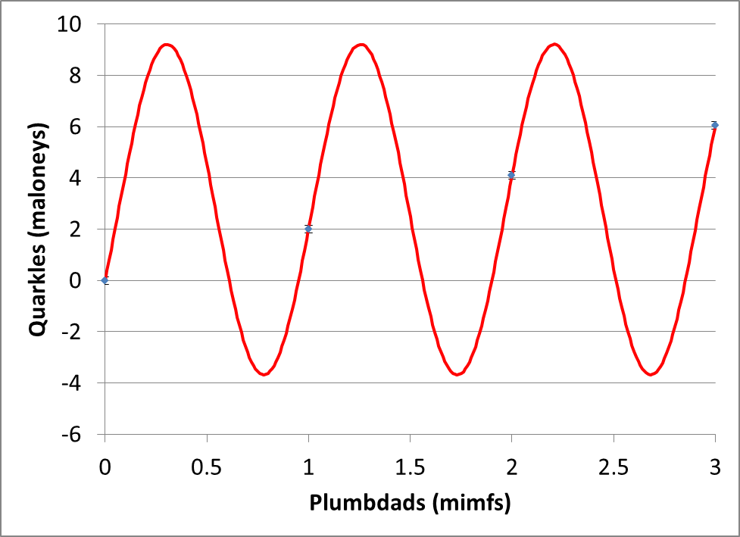

Given that we only have four measurements, which mathematical model do you believe is the best choice for researchers at this time: yours or Bernard’s? Explain your reasoning.

1. Abbey goes back to the lab, and she decides to get data for a different range of plumbdad values. By taking more measurements, she discovers that when 10 mimfs and 20 mimfs are used, the quarkle measurements are 20.90 ± 0.15 maloneys and 42.01 ± 0.15 maloneys respectively. When these new findings are presented to Bernard, he says that he now has an improved mathematical model. It’s now,



where plumbdads are entered in units of mimfs and the equation gives quarkles in units of maloneys. Then Bernard plots all of the known data with his old and new mathematical models and adds to the former table.

|  |  |  |  |
| --- | --- | --- | --- |
| Plumbdads(mimfs) | Quarkles (maloneys) | Bernard’s First Model  (maloneys) | Bernard’s New Model  (maloneys) |
| 0 | 0.00 ± 0.15 | -0.000001 | 0.076496 |
| 1 | 2.01 ± 0.15 | 2.010012 | 2.039681 |
| 2 | 4.10 ± 0.15 | 4.099995 | 4.037483 |
| 3 | 6.05 ± 0.15 | 6.050003 | 6.066636 |
| 10 | 20.90 ± 0.15 | 4.823279 | 20.86468 |
| 20 | 42.01 ± 0.15 | 1.456419 | 42.03084 |

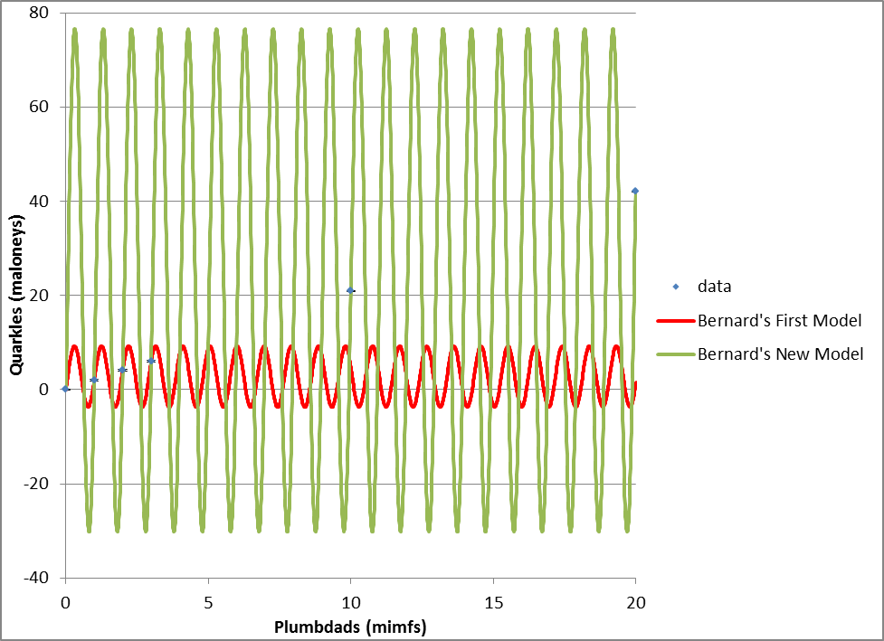

Consider Bernard’s new model, his former model, and your model. Given the new data (what is known at this point in time), which mathematical model do you believe is the best choice for researchers? Explain your reasoning.

1. At this point, Abbey states her opinion. *“I don’t like either of Bernard’s models because they seem overly complicated. Bernard also completely changed most of the numbers in his model because of the new measurements which didn’t seem legitimate to me. Here’s what I think. When I looked at the first four measurements, I thought the best model was*

*.*

*With the new measurements, I now think the best model is*

**.”

What do you think about Abbey’s opinion? Clearly express your thoughts.

1. Upon hearing Abbey’s opinion, Bernard begins to defend his methods. He says, “*Abbey, you complained when I changed the numbers in my model, but now you have done the same thing*.” Does Bernard have a reasonable point of contention with Abbey’s statement? Explain your thinking.
2. Abbey is motivated to show Bernard’s new model is not correct. What can she do to disprove his new model?
3. Abbey also wants everyone to accept her model: **

Suppose she now gets 25 additional data values that support her model and finds no values that contradict her model. Bernard then modifies the values in his equation so that it also adequately fits all of the known data. What do you think about Bernard’s approach to finding a mathematical model (he’s now up to three models)? Clearly express your thoughts.

1. Given that Bernard’s latest model also fits the data, how many more measurements must Abbey make before she can conclusively prove her model is right (with 100% certainty)? Explain.
2. Abbey is planning to make more measurements (beyond the 25+ measurements she already has). She is going to tell you the number of plumbdads and you need to predict the resulting number of quarkles. Which model would you use to do this and how confident would you be in that prediction? Explain.