Magister mē vocat _________________________(acc.)
Lingua Latīna - Capitulum III - Exercitia 3-5
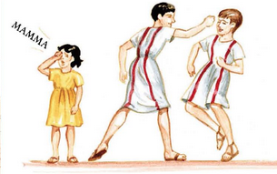
Exercitium 3
1. Iūlia cant_____, et Mārcus eam puls_____.
2. Iam Iūlia nōn cant_____, sed plōrat.
3. Iūlia Aemiliam nōn vid_____; Iūlia Aemiliam voc_____.
4. Aemilia ven_____ et interrog_____: “Ubi est Iūlius?”
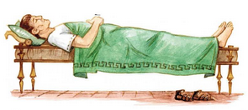
5. Mārcus respond_____: “Pater dorm_____.”
6. Quīntus Iūlium voc_____.
7. Iūlius dorm_____ neque Quīntum aud_____.
8. Mārcus rīd_____, quia Iūlius nōn ven_____.
9. Aemilia Mārcum verber_____.
Exercitium 4
audit, cūr, dormit, eam, eum, hīc, improbus, interrogat, neque, probus, quia, respondet, tē, verberat
1. Aemilia Quīntum ______________________ [←→ respondet]: “Quis mē vocat?”
2. Quīntus ______________________ [←→ interrogat]: “Iūlia _________ [←→ mē] vocat.”
3. Aemilia ______________________ [←→ respondet] : “_________ [←→ quia] Iūlia plōrat?”
4. Quīntus ______________________ [←→ interrogat]: “Iūlia plōrat, ______________________ [←→ cūr] Mārcus ______________________ [ : Iūliam] pulsat.”
5. Aemilia: “Mārcus puer ______________________ [←→ probus] est! Ubi est Iūlius?”
6. Quīntus: “Pater nōn __________ ____________, sed Mārcus ______________________ est.”
7. Quīntus Iūlium vocat; Iūlius ______________________ [: Quīntum] nōn ______________________.
8. Mārcus: “Pater ______________________ neque tē audit.”
9. Iūlius Quīntum nōn audit ______________________ [ = et nōn] venit.
10. Aemilia Mārcum ______________________ : tux tax!
11. Mārcus plōrat. Iūlius Mārcum ___________________ ; iam Iūlius nōn ______________________[ = zzz].
12. Mārcus nōn puer ______________________[←→ improbus], sed puer improbus est.
Nōmen discipulī probī est __________________________________
Lingua Latīna - Capitulum III
Exercitium 5
Exemplum: Cūr Iūlia cantat? Iūlia cantat quia laeta est.
1. Cūr Mārcus Iūliam pulsat?
__________________________________
2. Cūr Iūlia plōrat?
__________________________________
3. Cūr Mārcus rīdet?
__________________________________
4. Cūr Iūlia nōn pulsat Mārcum?
__________________________________
5. Cūr Aemilia venit?
__________________________________
6. Cūr Iūlius Quīntum nōn audit?
__________________________________
7. Cūr Mārcum verberat Aemilia?
__________________________________
8. Cūr Mārcus plōrat?
__________________________________
9. Cūr venit Iūlius?
__________________________________

