Example 19.1: An eight-lane divided highway is to be constructed on a new alignment. Traffic volume forecasts indicate that the average annual daily traffic (AADT) in both directions during the first year of operation will be 12,000, with the following vehicle mix and axle loads.
Passenger cars (2000 Ib/axle) = 50%
2-axle single-unit trucks (6000 Ib/axle) = 33%
3-axle single-unit trucks (10,000 Ib/axle) = 17%

The vehicle mix is expected to remain the same throughout the design life of the pavement. If the expected annual growth rate is 4% for all vehicles, determine the design ESAL, given a design period of 20 years. The percent of traffic on the design lane is 45%, the pavement has a terminal serviceability index ($p_{t}$) of 2.5 and NS of 5.
Example 19.2: Figure 19.8 shows roadbed soil resilient modulus $M_{r}$ for each month estimated from laboratory results correlating $M_{r}$ with moisture content. Determine the effective resilient modulus of the subgrade.

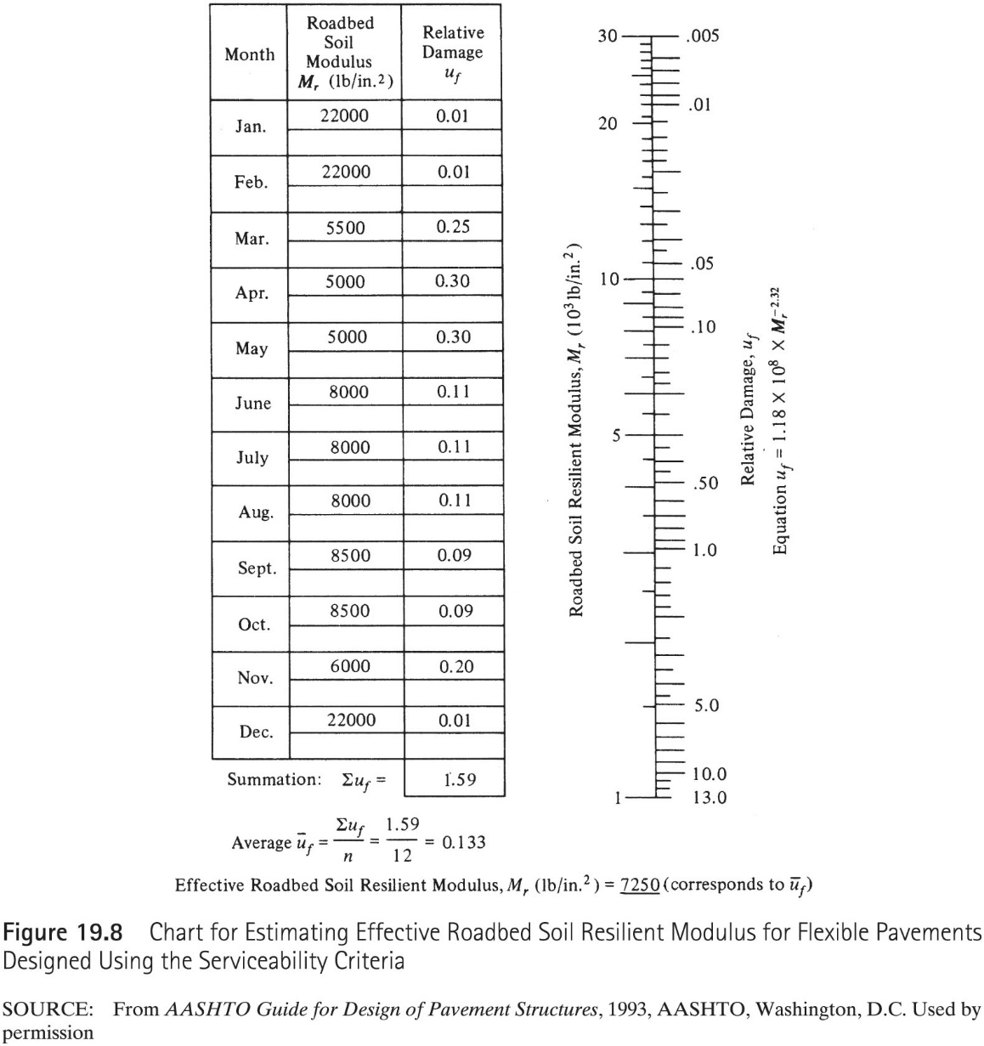
Example 19.3: A flexible pavement for an urban interstate highway is to be designed using the 1993 AASHTO guide procedure to carry a design ESAL of 2x10⁶. It is estimated that it takes about a week for water to be drained from withing the pavement, and the pavement structure will be exposed to moisture levels approaching saturation for 30 % of the time. The following additional information is available:
Resilient modulus of asphalt concrete at 68⁰F=450,000 Ib/in²
CBR value of base course material = 100, $M_{r}$ =31,000 Ib/in²
CBR value of subbase course material = 22, $M_{r}$ =13,500 IB/in²
CBR value of subgrade material = 6
Determine a suitable pavement structure, $M_{r}$ of subgrade = 6x1500 Ib/in2 = 9000 Ib/in²
Example 20.1: Determine the tensile stress imposed by a semicircular wheel load of 900 Ib imposed during the day and located at the edge of a concrete pavement with the following dimensions and properties: a) by using the Westergaard equation and b) by using the Ioannides equation.
Pavement thickness = 6 in.
$μ=0.15$
E=5x10⁶ Ib/in²
K=130 In/in³
Radius of loaded area = 3 in.

