Example 12.1: A travel survey produced the data shown in Table 12.1. Twenty households were interviewed. The table shows the number of trips produced per day for each of the households (number 1 through 20), as well as the corresponding annual household income and the number of automobiles owned. Based on the data provided, develop a set of curves showing the number of trips per household versus income and auto ownership.

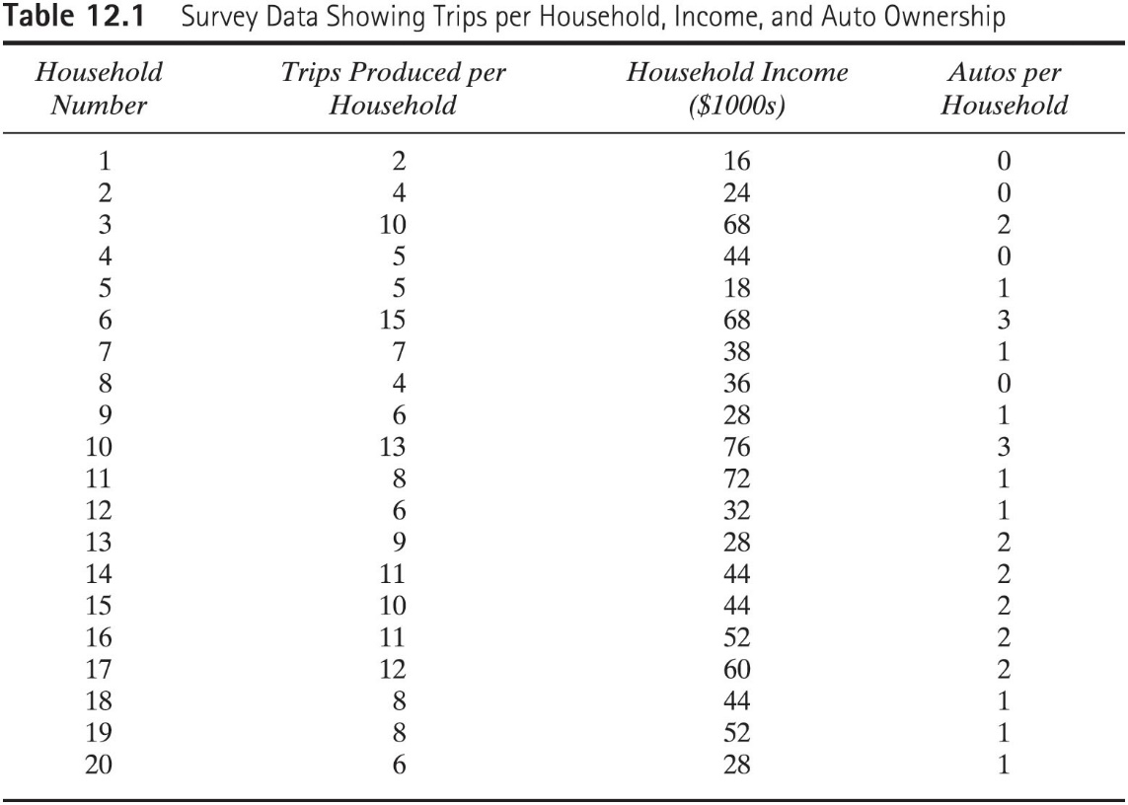

Example 12.2: Consider a zone that is located in a suburban area of a city. The population and income data for the zone are as follows:

Number of dwelling units:60
Average income per dwelling unit: $44,000

Determine the number of trips per day generated in this zone for each trip purpose, assuming that the characteristics depicted in Figures 12.2 through 12.5 apply in this situation. The problem is solved in four basic steps.

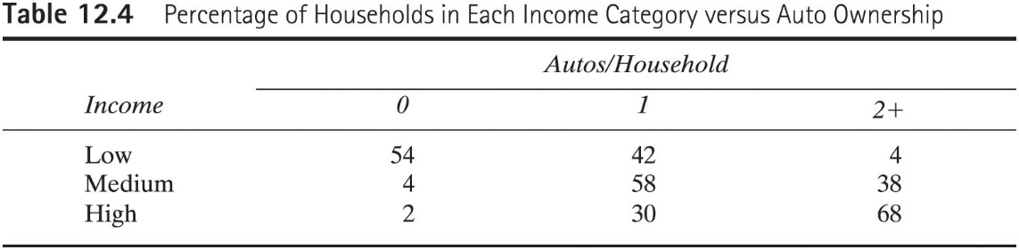

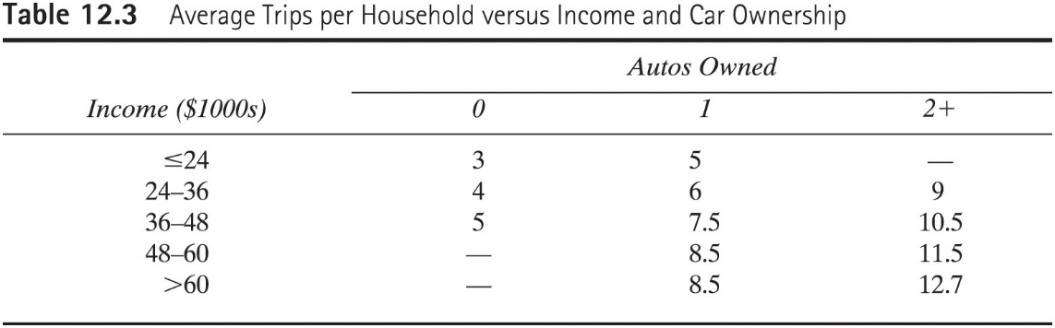

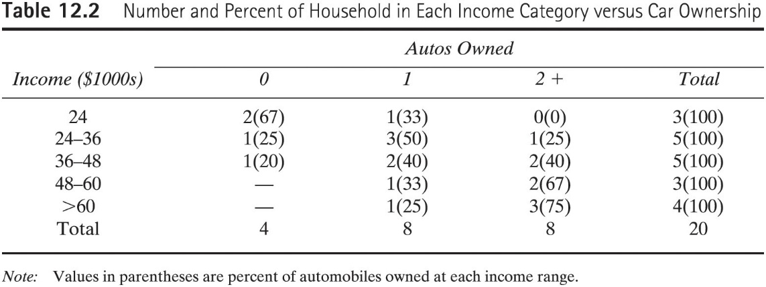

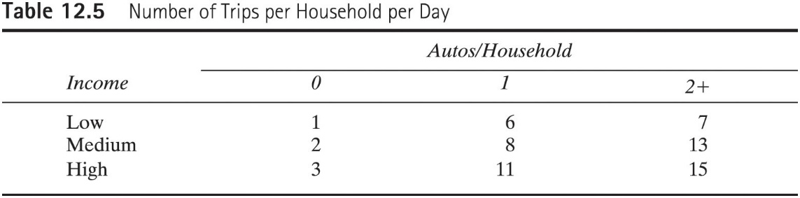

Example 12.3: A commercial center in the downtown contains several retail establishments and light industries. Employed at the center are 220 retail and 650 nonretail workers. Determine the number of trips per day attracted to this zone.

Example 12.4: To illustrate the application of the gravity model, consider a study area consisting of three zones. The data have been determined as follows: the number of productions and attractions has been computed for each zone by methods described in the section of trip generation, and the average travel times between each zone have been determined. Both are sown in Tables 12.9 and 12.10. Assume K_{ij} is the same unit value for all zones. Finally, the F values have been calibrated as previously described and are shown in Table 12.11 for each travel time increment. Note that the intra-zonal travel time for zone 1 is larger than those of most other inter-zone times because of the geographical characteristics of the zone and lack of access within the area. This zone could represent conditions in a congested downtown area.

Determine the number of zone-to-zone trips through two iterations.

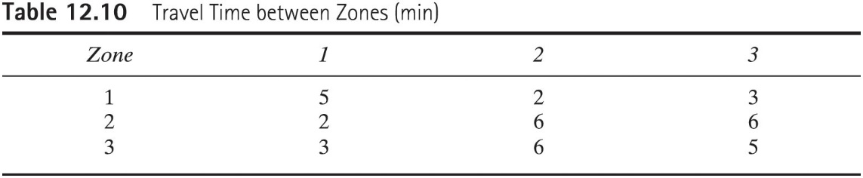

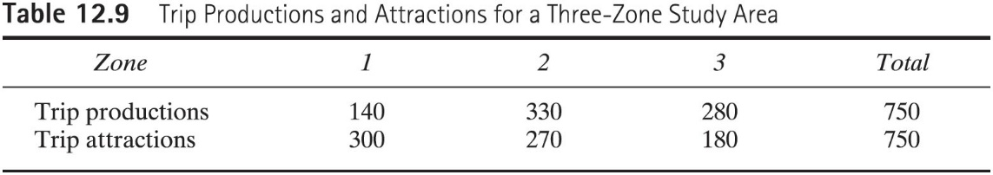

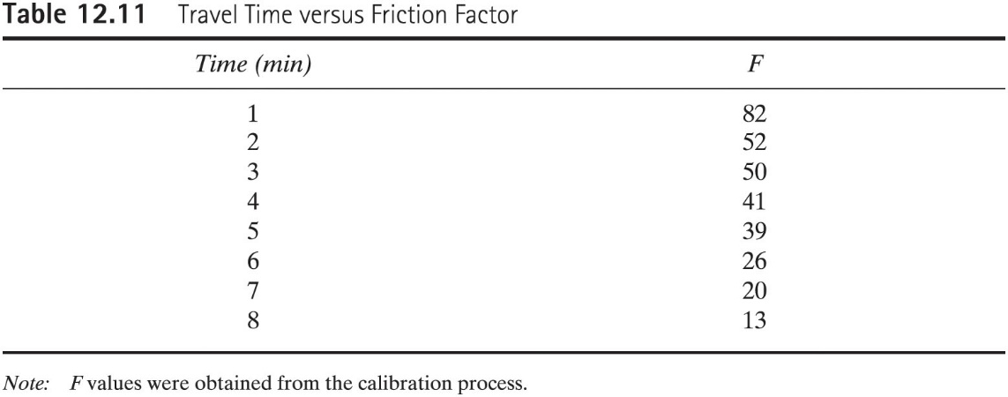

Example 12.8: Determine the number of transit trips per day in a zone, which has 5000 people living on 50 acres. The auto ownership is 40% zero autos per household and 60% one auto per household.

Example 12.9: The total number of productions in a zone is 10,000 trips/day. The number of households per auto is 1.8, and residential density is 15,000 persons/square mile. Determine the percent of residents who can be expected to use transit.

Example 12.11: The utility functions for auto and transit are as follows.
Auto: $U_{A}=0.46-0.35T_{1}-0.08T_{2}-0.005C$
Transit:$U_{T}=-0.07-0.05T_{1}-0.15T_{2}-0.005C$

Where, $T_{1}=Travel time, min;T_{2}=waiting time, min;$C=cost (cents)

The travel characteristics between two zones are as follows:

Auto transit
T1 20 30
T2 8 6
C 320 100

Example 12.19: The links that are on the minimum path for each of the nodes connecting node 1 are shown in Table 12.23. As shown is the number of auto trips between zone 1 and all other zones. Calculate the number of trips that should be assigned to each link of those that have been generated in node 1 and distributed to nodes 2 through 16.

