This handout can be downloaded at: http://users.pfw.edu/lamaster/technology/

MORE TIPS AND TRICKS FOR THE TI-84 PLUS FAMILY
T3IC International Virtual Conference, by Webinar -- March 14, 2020
John LaMaster, National T³ Instructor  Purdue University at Fort Wayne  Department of Mathematical Sciences  Fort Wayne, IN 46805-1445  lamaster@pfw.edu 260-481-5430 | Stuart Moskowitz, National T³ Instructor  Humboldt State University  Happy $π$ Day !  Department of Mathematics, Retired  Arcata, CA 95521  stuart@humboldt.edu 707-502-0363
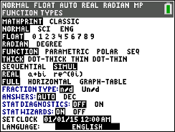
- Calculator should be fully charged or with fresh batteries on exam day.
(FnInt will devour battery power gluttonously.)
- To speed up graphing, press MODE > Simultaneous graphing
- 84CE Only: To speed up graphing, Press 2nd ZOOM [Format] and select
Off for Detect Asymptotes.
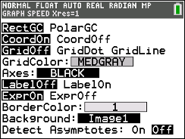
- Use the shortcut menus ALPHA f1 through f4.
- 84CE Only: ALPHA X gives the fraction template .
- Common error: If a graph of a trig function is behaving spooky,
make sure your mode is correct.
- Use the table settings or the context to get the window settings
Xmin, Xmax, Ymin Ymax.
- Any contents of Y1 through Y0 can be copied elsewhere by pressing 2nd RCL Y1.
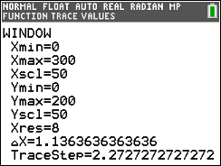
- On Home Screen press the up arrow to select previous entries.
Then press ENTER to copy them to the command line for editing.
On an entry line, 2nd goes to the end and 2nd goes to the front.
On TRACE, 2nd or 2nd moves left or right every 5 steps.
- To graph every other 8 pixels i.e., especially if graphing FnInt,
press WINDOW and make Xres = 8.
You can do this with any function for that matter.
The graph will have low resolution but it does not affect the 2nd CALC answers (Zero, Intersect, etc.)
Alert to teachers: The TI-Smartview Emulator runs at a much faster speed than the calculator.
- Don’t ever keep anything stored in X. It is refreshed every time you press GRAPH and will be lost.
Use X STO ALPHA A
- When using 2nd CALC (Zero, Intersect, Max, Min) you need only care that x value shows in the window. No need to fuss about Ymin or Ymax.
- When using 2nd CALC Intersect you can type in the Guess. Similarly for Zero, Max, Min, , you can type in Left Bound, Right Bound, etc. Usually just press ENTER for the Guess.
- The last entry can be copied anywhere (in particular, the Y= menu) by pressing 2nd ENTER.
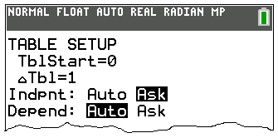
- Press ON to abort any process.
Pressing ENTER will pause it and ENTER again will resume it.
- When using a table to evaluate FnInt, press 2nd WINDOW [TBLSET].
It is helpful to deselect the FnInt funtion in Y= first,
then delete any values of x in the table, then select the FnInt function.
The larger x, the longer the FnInt will take to evaluate.
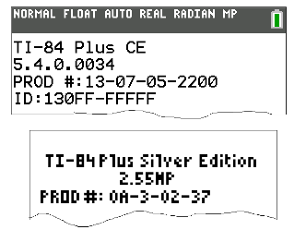
- Do all calculator models in a classroom have the latest operating system?
Press 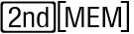 (above key), then select 1:About to see your OS version.
The latest OS releases are: TI-84 Plus CE: 5.4.0 TI-84 Plus: 2.55MP
For more tips see our handout How to Update Your TI-84 Plus CE Classroom Solution.
To update your TI-84 Plus to 2.55MP, contact 1-800-TI-CARES or John or Stuart for help.
These handouts can be downloaded at: http://users.pfw.edu/lamaster/technology/
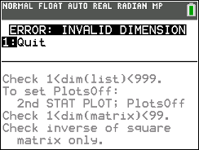
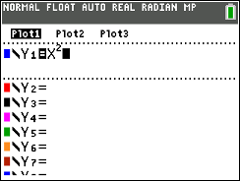
- Common error: When you press GRAPH
if you see INVALID DIM, deselect a Plot.

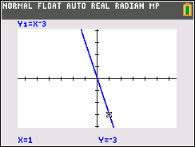
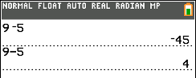
- Common Error: Negation and Subtraction symbols do not look alike or act alike! The negation symbol is shorter and higher than the subtraction symbol.

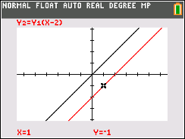
- Composition of functions vs multiplication of functions. Y1(X) means f(x). If you want Y1 times (x-2), then type Y1*(x-2)

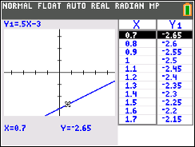
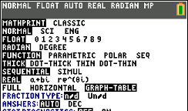
- Trace with GRAPH-TABLE split screen enabled (in MODE menu) to connect numbers, visuals, and expressions (an “algebra big idea”) all at once.

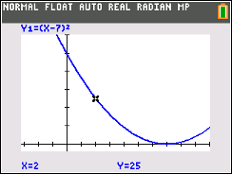
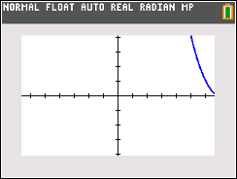
- ZoomIn, ZoomOut, and ZoomDecimal are too limiting! Create your own “friendly windows” (where you can choose “nice” values for tracestep and see important parts of your function. This requires understanding how a function is plotted across the screen and that there are 132 tracestep increments between Xmin and Xmax.
Y1=(X-7)² in
[-3.2,10,1] by [-4.1,60,10]
[Xmin,Xmax,Xscl] by [Ymin,Ymax,Yscl]

Y1=(X-7)² in ZoomDecimal Window
$TraceStep=\frac{Xmax-Xmin}{132}$

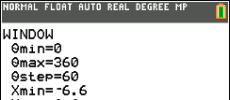
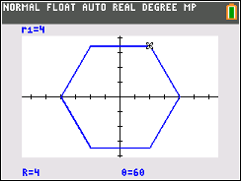
- In Polar MODE, turn circles into polygons by manipulating θ-step (in the WINDOW menu). Select Polar Graphing and Degrees in the MODE menu. Select Polar coordinates in the FORMAT menu.

