A PRE-CALCULUS ART PROJECT

An Introduction to Computer Graphic Design

Draw a flag or a logo or a house or write your name or ???

**Using Basic Graphs and Transformations to Draw Pictures**

The objective of this project is to use your calculator to draw a picture that incorporates many of the “basic graphs” that we have studied in class as well as your knowledge of transformations (vertical shifts, vertical stretches and shrinks, horizontal shifts).

**Here is a list of the Basic Graphs that you can/must use:**

1. y = mx + b linear

2. y = c horizontal line

3.  absolute value

4.  parabola (quadratic)

5.  cubic

6.  hyperbola (rational)

7.  square root (radical)

8. semicircle and/or circle (top, bottom, both) with center at (h,k)

9.  greatest integer (step) ---- on calculator: Y1=int(X)

10.  cube root

11. exponential (“easy chair”)

12. *y = log (x)* logarithmic

13. *y = sin(x)* sine

14. *y = cos(x)* cosine

15. *y = tan(x)* tangent

**Requirements:**

1 Your picture must contain at least one semi-circle or circle and at least one exponential function.

2. 2 different “Basic Graphs” makes you eligible for up to 7 points

3. 3 different “Basic Graphs” makes you eligible for up to 8 points

4. 6 or more equations with at least one circle, one exponential and one trigonometric graph) along with at least one use of **lists** for multiple graphs within one equation, and 2 different **graph styles**, makes you eligible for 9 or 10 points

5. You must use some sort of transformation on at least half of your equations

6. You must use ***restricted domains*** (for example: Y1= 2x+3; -2<x<5 on at least half of your graphs

7. Your picture must be recognizable by me (your instructor)

8. You will store your artwork as a **GraphDataBase (GDB)**. This will enable you to use your calculator for other things and then you can recall it at any time.

**You will turn In ONE of the following, along with showing me the finished artwork on your calculator.** (this means you cannot have somebody else turn it in for you):

1. A “hand drawn” approximate sketch of your picture, a sentence describing the picture, a list of all the functions (equations) exactly as you typed them into the Y= menu, and your WINDOW settings (xmin, xmax, ymin, ymax).
2. A printout of a screenshot of the picture directly from the calculator, a sentence describing your picture, and screenshots of the Y= menu and WINDOW menu. (this requires a Calculator-to-Computer cable and TI-Connect Software (free). The software is loaded on the computers in all campus labs. I have cables to loan you.
3. See me during office hours and I will download your GDB to my computer. Nothing else needed



**TIPS for Graphing Calculator Art Work**

Besides an understanding of functions and transformations of functions, several special calculator features and “tricks” are required for this activity:



* Piecewise defined functions to restrict the domain of each graph
* Lists for graphing more than one equation per line
* GraphStyles for shading and animating your artwork.
* Graph Data Bases (GDB) for saving and storing your artwork.

The following instructions are specific to the TI-84Plus and TI-84CE. If you have a TI-83, 89, TI-Nspire or another brand, then you will need to make some modifications. Calculator guidebooks are available for borrowing (see me in my office) as well as online at education.ti.com (go to the “Downloads” menu and look for Guidebooks).

**1 PieceWise Defined Functions and Restricted Domain**

Each curve in your artwork is to be defined by an equation. But many of your curves will have endpoints, so the domain needs to be restricted. The newest OS allows us to enter piecewise functions using a format similar to how we write it with paper and pencil. Each Piecewise function can have from one up to five pieces. Find the Piecewise command in the Math submenu of the Math menu. Then use Boolean Test functions in order to restrict the domain.

All this can be accomplished on older TI calculators by using Boolean Test functions and multiplying or dividing by 0.

Boolean tests are evaluated as “1” if true, and “0” if false. So if you want to plot the graph of y=x2 but only when x is between 0 and 3, then consider the following:

Y=(X2)/(X>0 and X<3)

If x is less than 0, the inequality statement is false, therefore we’re dividing x2 by 0, so it’s undefined.

If x is between 0 and 3, the inequality statement is true, therefore we’re dividing x2 by 1, so it’s y=x2.

If x is greater than 3, the inequality statement is false. We’re dividing x2 by 0, so it’s undefined.

Since y=x2 is defined only when x is between 0 and 3, this is the only part of the graph that’s plotted.

**2 Lists**

The Y= menu has lines for 10 equations. But, with lists used as coefficients, it’s possible to graph more than one equation per line. Consider the following equation:

Y=X+{-2,0,2} will plot the graphs of Y=X+-2, Y=X+0 and Y=X+2

Multiple lists can be used in one equation. Be sure each list has the same number of elements.

Y={1,2}X+{0,1} will plot the graphs of Y=X and Y=2X+1

1. 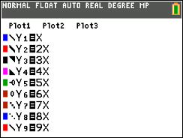**GraphStyles**

|  |  |
| --- | --- |
| In the Y= menu, move the cursor to the left of the equation. Pressing ENTER opens a menu that lets you change the line color and the line style (thin, thick, shaded above, shaded below, a ball with a plain path following, a ball without any path following, big dots, small dots). Be sure to move to OK and press ENTER before exiting this menu. Try out these different styles to see the effects of each. All the different icons appear in figure 1. | figure 1 |

|  |
| --- |
| **4 Graph Data Base (GDB)**  After completing your picture, store all the settings as a graph data base (GDB). Much simpler than a program, the GDB stores all your equations from the Y= menu, the WINDOW settings, and all the graph FORMAT settings (from both the FORMAT and MODE menus).  Find the GDB command in the STO submenu of the DRAW menu. Choose StoreGDB to save your settings. Then, at any time, choose RecallGDB to bring back your settings. The GDB variable names are each of the digits 0-9. Get the variable names from the GDB submenu of the VARS menu, or simply type the digit on the keyboard (figure 3).  Press 2nd DRAW > > for this menu. |

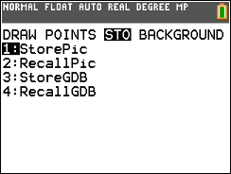

figure 2

figure 3

**EXAMPLES**

**EXAMPLE 1 – *MY LOGO***

The following screen shots show what was saved in the “graph data base” (GDB) that draws my initials. The Piecewise command is found near the bottom of the Math submenu of the Math menu. For the screenshots in this example, we use MathPrint. But if the entries are too long to be displayed in full, then the older Classic style uses wraparound for text so that long entries are visible.

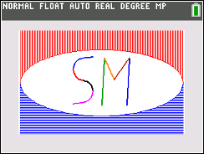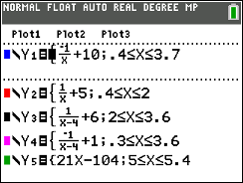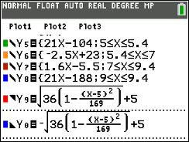

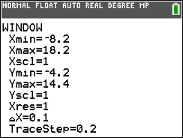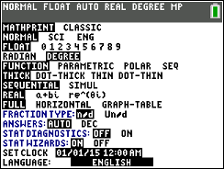

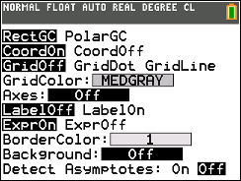

WINDOW: note that Xmax-Xmin=26.4, which makes TraceStep “friendly”

MODE:MathPrint is selected

FORMAT: axes and detect asymptotes are off

Note the GraphStyles used in Y9 and Y0. The first shaded graph will be vertical lines. The second shaded graph will be horizontal lines. If there’s more shaded graphs, the lines would be diagonal.

**EXAMPLE 2: Roller Coaster**

This example is much more interesting when actually viewed on a TI-84CE. The animated GraphStyle in Y5 creates a ball that appears to move along its sinusoidal path. For the screenshots here, we use Classic in order to see each function in whole.

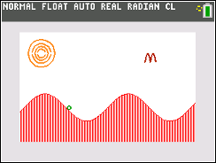

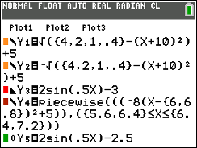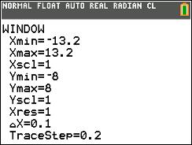

**EXAMPLE 3: Spider for the TI-84 Plus**

This example is included for those who are using the Black and White TI-84. The pixel dimensions are different; note the difference between Xmin and Xmax is 18.8, which is exactly 1/5 of 94 (the number of pixel steps from the left hand side of the screen to the right side. Also, there’s no Piecewise Function, so Boolean logic is required in order to restrict the domain. The screenshots of the Y= menu are shown in Classic mode because it’s larger than MathPrint and it has text that wrapsaround so each function can be seen in one screen even if it’s too long to fit in one line.

