Zackry Bodine
Dr. Fleming
Chaucer
12/07/19
Graduate Student’s Unessay Essay: Art Inspired by The Canterbury Tales
The idea for this project is to examine the certain stories in Geoffrey Chaucer’s magnificent work The Canterbury Tales, and approach the project in the same vein as artist Makoto Fujimura’s works interpreting the four Gospels by emphasizing emotive elements within the work. The medium of painting was chosen because, as the artist and author Wasily Kandinsky explains, “Painting has two weapons at her disposal: 1. Colour. 2. Form. Form can stand alone as representing an object (either real or otherwise) or as a purely abstract limit to a space or a surface. Colour cannot stand alone; it cannot dispense with boundaries of some kind” (Kandisky 28). With the style of painting chosen for the project, the art becomes a vehicle for the latter as form is replaced by color and its restrictions.
The emphasis here is on the emotion that each tale evokes within the artist to create the piece because abstract painting, with its lack of definitive line, merely suggests a temporal truth. These abstractions with splashes of color cannot definitively state anything, otherwise they would provide clarity of both subject matter and overall message. Though it is not explicitly clear, the art, through color and the multi-faceted entry points into the piece as icon is because of its lack of a focal point, and therefore captures a truth about reality that one can enter into. This is what art critic and poet Yves Bonnefoy said, that, “the lure of painting – its eclipsing of the everyday world, its suppression of time, its mimetic reconstruction of the real – is its truth, one that reflects and represents the tenuous relationship of art to the world” (Bonnefoy 14).
The project consists of four paintings done with acrylic paint on canvas, each depicting some aspect of The Canterbury Tales that deals with universal themes that Chaucer presents in the overall message of the tales. I have focused on three sections within the book that I believe best exemplify the themes of story, faith, and that which is hidden.
The largest painting out of the group is modeled after the general prologue. It is here where the most obvious but probably the most ignored theme of The Canterbury Tales is expressed. It is one of community, as a group of absolute strangers gather together and bond over a shared quest to go on a pilgrimage. Their desires and personalities may all be different, but they all can come together and bond over the power of stories.
This power is not something the author takes lightly when explaining his character’s role in sharing the tales. He considers his high office of storyteller a responsibility and holy act by evoking Christ and Plato to justify his “retelling”, “Crist spak hymself ful brode in hooly writ, / And wel ye woot no vileynye is it. / Eek Plato seith, whoso kan hym rede, / The wordes moote be cosyn to the dede” (GP ll. 739-742). If one were to glance into the center right of the painting, in the mass of greens and yellows, one would see the outline of a figure with its arm raised. That is the figure of Chaucer the character, not the man, who is surrounded by several ominous figures represented in red. Those figures are the people he spends the entirety of the general progue describing, explaining “the cause / Why that assembled was this compaignye” (GP l. 716-717). The details in the General Prologue that the Chaucer character provides of “Th' estaat, th' array, [and] the nombre” (GP l. 716) of the people in tavern inform the overall color choices for the paintings.
The idea for the color choices of the General Prologue painting comes from the lines after
“The Chaucer” provides every character description. He states:
But now is tyme to yow for to telle
How that we baren us that ilke nyght,
Whan we were in that hostelrie alyght;
And after wol I telle of our viage
And al the remenaunt of oure pilgrimage. (GP ll. 720-724)
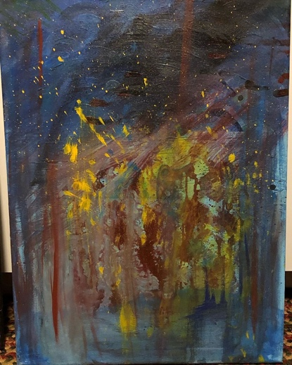
The reader is informed that Chaucer and the group had spent the night at the tavern before heading out on their quest. In figure 1, you can see that in top third of the painting, it is dark, almost a dreary night skyline. The bottom third is airy and ethereal. This is because the top third is setting the time, it is night. The middle section is Chaucer and company in the tavern with Chaucer pointing while several figures surround him. The bottom third is airy because it symbolizes the unknown journey ahead.
Figure 1: The General Prologue
The colors chosen for the piece on the General Prologue are blue, red, black, yellow, and green. Each color has a significant or specific function based on the Spiritual theory of color put forth by Kandinsky in his book Concerning the Spiritual in Art. He claims that, “Shades of color, like those of sound, are of a much finer texture and awake in the soul emotions too fine to be expressed in words” (Kandinsky 41). The colors used for the General Prologue piece are modeled after Makoto Fujimura’s painting “Olana – Matthew Six.” I believe that Fujimura’s piece masters the blend of color and theme because of its use of blue and red.
Blues and reds are hard to balance and produce a reflective tone without cheapening the art or pandering to the audience. Kandinsky explains:
The power of profound meaning is found in blue, and first in its physical movements (1) of retreat from the spectator, (2) of turning in upon its own center. The inclination of blue to depth is so strong that its inner appeal is stronger when its shade is deeper. Blue is the typical heavenly color. The ultimate feeling it creates is one of rest. (Kandinsky 38).
I am not saying that my pieces are able to employ this well, but I am saying that the art did guide me through in reflecting upon the text. Each of the following pieces reflects upon the spirit of the tale or ideas presented throughout the book and utilize art theories presented by Kandinsky and Bonnefoy.
In the Wife of Bath’s Prologue and Tale, the reader is given a depiction of a heavier set lady obsessed with sex, marriage, power, and who has had a harder life. Her tale is filled with dark and mystical elements, like that of a “land fulfild of fayerye” (WBT l. 859) and an “incubus” (WBT 880) which the Wife of Bath describes as a priest with evil motives. The descriptions that the character provides of backstory and of the characters within her tale, created a multivocality where people can see this either as a tale of proto-feminist empowerment or of a sinister regression into subjugation. This ability to craft a story that some could see as progressive and others as regressive inspired me to craft this piece through the lens of another medium that is also accused of this regressive/progressive nature, heavy metal and punk rock. The overall aesthetic of this piece is inspired by album covers like The Misfits “American Psycho” record and Disturbed’s album mascot along with elements of the General Prologue.
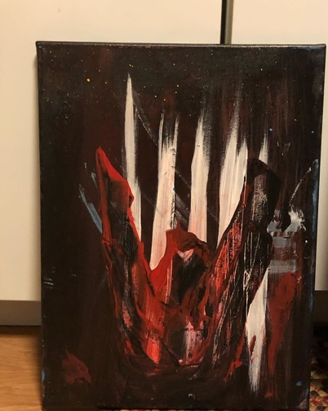
Chaucer describes Alison, the Wife of Bath, in the General Prologue as, “Boold was hir face, and fair, and reed of hewe” (GP l. 458) and of having “Hir hosen weren of fyn scarlet reed” (GP l. 456). This red hue has carried over into every popular rendition of the character. The Ellesmere manuscript, for example, has her depicted as having a red dress-like top with blue bottoms, a while shawl, and a black hat.
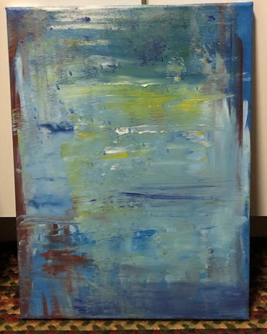
My painting of the Wife of Bath (figure 2), is a combination of the popular imagination and the dark subject matter of her tale with a shapeshifting witch and rape. The image of the hooded figure is a stand in for both the Wife of Bath and the old witch. She has her arms upraised to indicate power, aggression, or the conjuring of a spell or, of a spooky exclamation while telling the tale. Behind her is five white lines that signify that, “Housbondes at chirche dore she hadde fyve,” (GP 460) as Chaucer informs us in the General Prologue. She is positioned in front of them implying that she is both overcoming and haunted by them.
Figure 2: Wife of Bath
One of the elements that “haunted” me when reading was the religious writings in The Canterbury Tales. As a Christian, it was refreshing to see the “sacred” and the “profane” side-by-side. The words sacred and profane are in quotes here because I come from a tradition where, “Art is art; painting is painting; music is music; a story is a story. If it's bad art, it's bad religion, no matter how pious the subject” (L’Engle 5). Or to put it another way, everything originates from the sacred, and everything that is good in the world is a product of the Divine upholding and sustaining it. In other words, nothing is secular, everything is spiritual. This idea leads to the next two paintings which examine these themes in less of a concrete manner as the last two.
Figure 3: Reflection on the Spiritual in The Canterbury Tales
The Reflection on the Spiritual in The Canterbury Tales (figure 3), is inspired by the tales of the Nun’s Priest, The Parson, The Prioress, and the Tale of Melibee. Each of these stories contain some form of discourse that attempts to work out how religious life looks in everyday medieval life. Each in their own way comes to some form of doxology, or concluding praise to the Divine. The approach to this painting was modeled after the German artist Gerhard Richter, especially his abstract paintings from his 1999 to 2004 period. I am inspired by creators making something new or putting their own spin on things.
Figure 4: Reflections on Retractions and Sex
Geoffrey Chaucer creates something new and also refurbishes old stories in The Canterbury Tales. At the very end, Chaucer attempts a doxology that is commonly called “Chaucer’s Retractions.” I found this very interesting to create something and then attempt to explain and apologize for some aspects of it. I created the fourth piece Reflections of Retractions and Sex (figure 4) as a way ponder over how a work can cover itself in suggestive material and then attempt to “white out” and return the work to a “pure” religious text. The painting is inspired by the minimalist white paintings of Agnes Martin or Robert Ryman. It is white paint overlaying a white canvas. It could be white-out. It could be “fluids.” It could represent purity or impurity based on the color white and the texture being imperfect. It is a work that raises questions like, “Is it finished?” which appears to also happen when certain critics read aspects of The Canterbury Tales.
These works of art are my reflections upon the story elements, religious elements, and sexual or fearful elements of The Canterbury Tales. Chaucer crafted an expansive world that contains so much inspiration for further works, but this is all I could get within the deadline for the class. It truly helped me examine the tales in a new and insightful way.

Works Cited
Bonnefoy, Yves. The Lure and the Truth of Painting: Selected Essays on Art. Ed. Richard Howard. Stamelman. Chicago: U of Chicago, 1995.
Chaucer, Geoffrey. The Canterbury Tales. Edited by Jill Mann, Penguin Books, 2005.
Kandinsky, Wassily. Concerning the Spiritual in Art. Trans. Michael Sadleir. New York: Dover Publications, 1977.
L'Engle, Madeleine. Walking on Water: Reflections on Faith and Art. Convergent Books, 2016.

