Average Android, iOS smartphone data use across Tier 1 wireless carriers, through October
Read more: Average Android, iOS smartphone data use across Tier 1 wireless carriers, through October - FierceWireless http://www.fiercewireless.com/special-reports/average-android-ios-smartphone-data-use-across-tier-1-wireless-carriers-thr#ixzz2Ewg8kbA7
Subscribe: http://www.fiercewireless.com/signup?sourceform=Viral-Tynt-FierceWireless-FierceWireless

How much data does the average smartphone user consume?
It's a critical question for both users and the carriers that provide service--and it's a moving target. As users embrace a widening array of high-powered data services, wireless carriers are concurrently working to increase the data speeds available to their subscribers. The result is a situation where users have more services at their fingertips available at faster speeds.
The question is also relevant at a time when wireless carriers are testing new data billing schemes. AT&T Mobility (NYSE:T) and Verizon Wireless (NYSE:VZ) are working to transition customers onto shared data plans; meanwhile, Sprint Nextel (NYSE:S) and T-Mobile USA are offering unlimited smartphone data offerings.
With all this in mind, FierceWireless teamed with NPD Connected Intelligence to publish the results of the firm's SmartMeter surveying software. NPD's SmartMeter software is installed on around 1,200 smartphones (participants are provided "incentives" to install the software on their phones). NPD for the past several months has tracked cellular data usage on Android phones, and now counts around 200 iPhones to its survey base.
We realize that a sample size of 200 iPhones, spread across a number of wireless carriers, is not ideal. However, we decided to include this information to allow you, the reader, to make your own decision on whether it's useful or not. Feel free to take it or leave it. NPD is working to increase its iPhone sample size.
The below data shows average Android smartphone cellular data use during the past seven months, broken down by wireless carrier, and iPhone data use from September (with 100 iPhones) and October (with 200 iPhones):
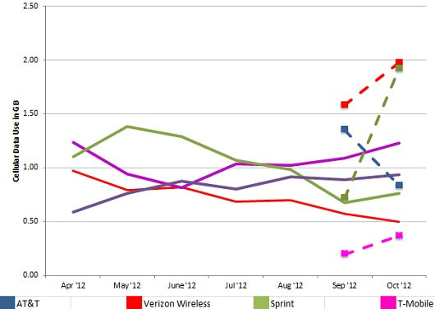
Solid Lines represent Android data. Dashed Lines with square markers represent iOS/iPhone data.
The raw data (measurements are GB per month):
ANDROID | Apr '12 | May '12 | June '12 | Jul '12 | Aug '12 | Sep '12 | Oct '12
Verizon Wireless | 0.97 | 0.79 | 0.82 | 0.69 | 0.70 | 0.57 | 0.50
T-Mobile | 1.23 | 0.94 | 0.82 | 1.03 | 1.02 | 1.09 | 1.23
Sprint | 1.10 | 1.38 | 1.29 | 1.07 | 0.98 | 0.68 | 0.76
AT&T | 0.59 | 0.76 | 0.88 | 0.80 | 0.91 | 0.89 | 0.94

APPLE | Apr '12 | May '12 | June '12 | Jul '12 | Aug '12 | Sep '12 | Oct '12
Verizon Wireless |  |  |  |  |  | 1.58 | 1.98
T-Mobile |  |  |  |  |  | 0.19 | 0.37
Sprint |  |  |  |  |  | 0.72 | 1.92
AT&T |  |  |  |  |  | 1.35 | 0.83
Let us know what you think in the comments!
Read more: Average Android, iOS smartphone data use across Tier 1 wireless carriers, through October - FierceWireless http://www.fiercewireless.com/special-reports/average-android-ios-smartphone-data-use-across-tier-1-wireless-carriers-thr#ixzz2Ewg8kbA7
Subscribe: http://www.fiercewireless.com/signup?sourceform=Viral-Tynt-FierceWireless-FierceWireless

