World's First Smartphone for the Blind, Made in India
Times of India (04/19/13) Chitra Unnithan
National Institute of Design post-graduate student Sumit Dagar has led the development of a smartphone for the visually impaired. The prototype features a touchscreen that converts text and pictures into Braille and raised patterns. "We have created the world's first Braille smartphone," Dagar says. "This product is based on an innovative touchscreen, which is capable of elevating and depressing the contents it receives to transform them into touchable patterns." The device uses Shape Memory Alloy technology, which is based on the concept that metals remember their original shape, or expand and contract to their original shape after use. The smartphone's screen has a grid of pins that move up and down as needed. The grid also has a Braille display, where pins come up to represent a character or letter. The screen itself can elevate and depress the contents to form patterns in Braille. "The response during the test has been immense. It comes out as a companion more than a phone to the user," Dagar says. "We plan to do more advanced versions of the phone in the future."
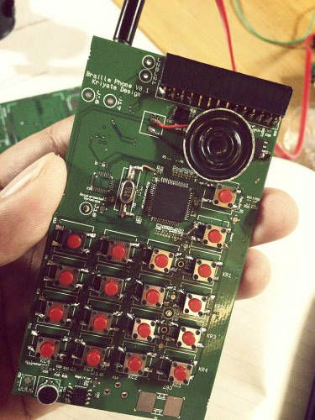

World's first smartphone for the blind, made in India
Chitra Unnithan, TNN Apr 19, 2013, 03.25AM IST
AHMEDABAD: The world's first smartphone for blind people is here. Soon, they will be able to read SMSes and emails on this phone, which converts all text into Braille patterns.
"We have created the world's first Braille smartphone," says its innovator, Sumit Dagar, whose company is being incubated at the Centre for Innovation Incubation and Entrepreneurship, located in IIM Ahmedabad campus. "This product is based on an innovative 'touch screen' which is capable of elevating and depressing the contents it receives to transform them into 'touchable' patterns," he says.
Dagar, who is a post-graduate from the National Institute of Design (NID), says he was motivated to develop the device when he realised that so far, technology was only serving the mainstream and ignoring the marginalised. He is collaborating with IIT Delhi on making the prototype, which is currently being tested at L V Prasad Eye Institute in Hyderabad.
"The response during the test has been immense. It comes out as a companion more than a phone to the user. We plan to do more advanced versions of the phone in the future," Dagar adds.
Dagar started the project three years ago while studying interaction designing at NID. After working with a couple of companies, he gave up his job to concentrate on his technology, formed a team of six people and started his venture, Kriyate Design Solutions. Currently, the venture is being funded by Rolex Awards under its Young Laureates Programme, in which they select five people from across the world every two years and fund their projects.
How it works
Â· The smartphone uses Shape Memory Alloy technology, based on the concept that metals remember their original shapes, i.e. expand and contract to its original shape after use.
Â· The phone's 'screen' has a grid of pins, which move up and down as per requirement. The grid has a Braille display, where pins come up to represent a character or letter.
Â· This screen will be capable of elevating and depressing the contents to form patterns in Braille.
Â· All other elements are like any other smartphone.

Robot Hands Gain a Gentler Touch
Harvard University (04/18/13) Caroline Perry
http://www.seas.harvard.edu/news-events/press-releases/robot-hands-gain-a-gentler-touch
Harvard University researchers have developed TakkTile, an inexpensive tactile sensor for robotic hands that they say is sensitive enough to turn any machine into a dexterous manipulator. “Despite decades of research, tactile sensing hasn’t moved into general use because it’s been expensive and fragile," says TakkTile co-creator Leif Jentoft. "The traditional technology also uses very specialized construction techniques, which can slow down your work. Now, Takktile changes that because it's based on much simpler and cheaper fabrication methods." TakkTile is designed to give commercial inventors, teachers, and robotics enthusiasts access to high-end technology. TakkTile features a tiny barometer which senses air pressure and adds a layer of vacuum-sealed rubber to it, protecting it from as much as 25 pounds of direct pressure. The sensor enables robots to know what they are touching. During testing, a TakkTile-equipped robot was able to pick up a balloon without popping it and pick up a key and use it to unlock a door. "Not everyone has the bandwidth to do the research themselves, but there are plenty of people who could find new applications and ways of using this," says TakkTile co-creator Yaroslav Tenzer.
Providing Robotic Carers and Smart Systems for the Elderly
CORDIS News (04/18/13)
http://cordis.europa.eu/fetch?CALLER=EN_NEWS&ACTION=D&SESSION=&RCN=35660
European researchers continue to improve and fine-tune an automated carer system for the elderly to make it useful, acceptable, and fun to use. Launched in December 2009, the Mobiserv project consists of a robot companion, wearable smart clothes, and a smart home environment. The robot is designed to serve as a social carer that can remind older adults to eat, drink, take medicines, exercise, and do certain activities, such as call or visit someone if they have not communicated with anyone else for a while. The smart clothes can monitor vital signs or sleeping patterns, and detect falls. The smart home environment uses smart sensors, optical recognition units, and home automation elements to detect eating and drinking patterns, activity patterns, and dangerous situations, among other things. The researchers have scheduled extensive user-evaluation studies for April through June, and they plan to present and demonstrate the project and its companion robot at several events in Europe from June to August.

