Everyone is quitting FaceBook!
http://www.vice.com/read/dislike-why-everyone-is-quitting-facebook
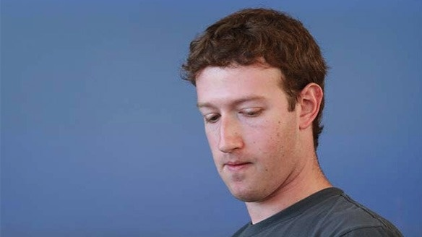
On a day when Wall Street darling Apple hit new highs, making it the most valuable company ever (not adjusted for inflation), ex-darling Facebook continues to reach record lows. After its controversial IPO, Mark Zuckerberg has been unable to convince investors of a brighter future. It’s not just Wall Street that remains flocking to the exits, the company has been leaking high-level execs since it went public. The site is also shedding users. Despite robust international growth, Facebook lost 6 million U.S. users in May.
Now, with the three-month investor lock-up period over — the period in which pre-IPO shareholders are barred from selling a certain chunk of their shares — the company is losing one of its largest and most notable shareholders. PayPal co-founder and early Facebook investor (he famously paid $500,000 in 2004 for a 10.2 percent stake) Peter Thiel on Monday sold another 20 million shares, nearly his entire stake. Along with the proceeds of the initial IPO, Thiel has netted himself a tidy $1 billion for his troubles.
That investors are cashing out after one of the most hyped IPOs in history is only natural but the velocity of the selling belies a lack of confidence in Zuckerberg to fulfill Facebook’s lofty promises. Thiel isn’t just any old investor. He sits on the board and has privileged insight into the future of the company. And this is only beginning for Facebook’s Wall Street woes. It faces three more “lock-up” expirations by year end with the biggest in November, when a further 1.32 billion shares could flood the market eclipsing last week’s 271 million share window, which seems paltry by comparison.
Read the rest over at Motherboard.
By Alec Liu 8 months ago Tags: facebook, IPO, social, media, mark, zuckerberg

